**Cadmus Financial Corporation**

A Project submitted to the

**Yashwantrao Chavan Maharashtra Open University, Nashik.**



In partial fulfilment of the requirements for the degree of

**Bachelor Of Computer Application (B.C.A)**

**Atharva Institute of Information Technology**



**Under the guidance of**

**Mrs. Shilpa Mistry**

**By**

**SHARVIL RAKESH RANE PRN: 2020017000507847**

**2022-23**

**CERTIFICATE OF EVALUATION**

This is to certify that the undersigned have assessed and evaluated the project work titled **“Cadmus Financial Corporation”** submitted by the following student.

**Student’s Name PRN Number**

**SHARVIL RAKESH RANE 2020017000507847**

The project report has been (accepted) for the partial fulfilment of the Bachelors of Computer Application Program.

**Signature of the examiner:** _______________

**Name of the examiner:** ________________

**Stamp of the study centre**

**CERTIFICATE OF COMPLETION**

This is to certify that the team of the following students of **B.C.A** have completed the Project Work titled **“CADMUS FINANCIAL CORPORATION”** under my guidance and supervision. The project report has been written according to the guidelines given by the Yashwantrao Chavan Maharashtra Open University.

**Student’s Name PRN Number**

**SHARVIL RAKESH RANE 2020017000507847**

**Signature of the Study Signature of the Guide**

**Centre Coordinator**

**Name of the Study Name of the Guide**

**Centre Coordinator**

**Stamp of the study centre**

**ACKNOWLEDGEMENT**

I would like to take this opportunity to thank the people who directly or indirectly enabled to work on this project.

At the outset, I would like to thank the entire staff of Atharva Institute of Information technology, both the teaching and non-teaching staff for their continuous and unrelenting efforts in helping us with our project. Without them, these efforts would have not given us expected results.

I would like to thank to my project internal guide **Mrs**. **Shilpa Mistry** for constant support and the knowledge that she has shared with me for her guidance and support in completing my project.

I would also like to thank **Mrs. Aarti Oberoi (Centre Head)** and **Mr. Ashok Yadav (Co-ordinator)**. Their unwavering dedication and profound experience have played a pivotal role in motivating and inspiring me to achieve greater heights.

Last but certainly not least, I would like to express my sincere and heartfelt gratitude to all the teachers and friends who have played a significant role in assisting me throughout this project. Their support, guidance, and contributions have been invaluable.

I express my honest gratitude. Thank you.

SHARVIL RAKESH RANE.

**SYNOPSIS**

Cadmus Financial Corporation is an optimized banking management system. This Banking Management System project is a comprehensive software solution designed to streamline and automate various banking operations, ensuring efficiency, accuracy, and enhanced customer experience. This project aims to provide a robust platform for managing banking activities, such as account management, transaction processing, customer relationship management, and employee management, loan application processing and much more.

The primary objective of the Banking Management System is to develop a user-friendly and secure system that enables banks to optimize their operations, improve customer service, and maintain effective management of financial transactions. The project aims to create a centralized platform that integrates various banking processes, ensuring smooth workflows, reducing manual efforts, and minimizing errors.

The solution enables banks to improve services, cut costs, and consolidate processes. By integrating various banking operation into a single platform, the bank can simply automate manual processes and eliminate redundant tasks. With minimum administrative overhead, banks can instead focus on their customers and demands.

By offering a comprehensive software solution that improves productivity, accuracy, and customer satisfaction, this project seeks to completely revamp banking operations.

**DECLARATION**

I hereby declare that the project entitled, **“CADMUS FINANCIAL CORPORATION”** done at **ATHARVA INSTITUE OF INFORMATION TECHNOLOGY,** has not been in any case duplicated to submit to any other university for the award of any degree. To the best of my knowledge other than me, no one has submitted to any other university.

The project is done in partial fulfilment of the requirements for the award of the degree of **BACHELOR OF COMPUTER APPLICATION (B.C.A)** to be submitted as final semester project as part of our curriculum.

**TABLE OF CONTENTS**

Contents

1.0 Introduction 1

1.1 Background 1

1.2 Problem Statement 2

1.3 Project Scope 3

1.4 Objective 3

1.5 Features 4

2.0 Tools & Technologies Used 6

2.1 Languages Used 6

2.2 Tools Used 8

2.3 Hardware & Software Requirements 10

3.0 Software Development Life Cycle (SDLC) 11

3.1 Overview of Incremental Model 11

3.2 Phases of Incremental Model 12

4.0 Design Phase 13

4.1 Entity Relationship Model 13

4.2 Flowchart 15

4.3 Use Case Diagram 19

4.4 Entity Relationship Diagram 21

4.4 Data Dictionary 25

4.5 Gantt Chart 34

5.0 Screen Dumps 35

6.0 Coding 68

6.1 Setup Files 68

6.2 Configuration Files 81

6.3 Miscellaneous Files 84

6.4 Models 87

6.5 Repositories 114

6.6. Helpers 131

6.7 Controllers 136

6.8 Static Resources 174

6.9 Views (JSP) 183

7.0 Testing 221

7.1 Unit Testing 221

7.2 Integration Testing 221

7.3 System Testing 221

7.4 Acceptance Testing 222

7.5 Regression Testing 222

8.0 Future Enhancements 223

8.1 Automated KYC 223

8.2 Fraud Detection Model 223

8.3 Integrating Real World Monetary Transactions 223

9.0 Conclusion 224

10.0 Bibliography 225

# 1.0 Introduction

The Banking Management System is a complex software solution developed to help banks and financial institutions manage and optimise their operations. With ever-increasing client demands and the complexity of banking processes, an efficient and integrated system is critical for the seamless operation of banking operations. The following section provides a quick overview of the Banking Management System.

## 1.1 Background

A bank is a type of financial institution that accepts deposits, disburses loans, clears checks, pays interest at set rates, and frequently serves as a middleman in financial transactions. Additionally, it offers its clients other financial services.

Earlier, banking operations relied heavily on paper-based documentation, manual record-keeping, and physical branch visits for transactions. However, with the emergence of computer technology, banks began exploring ways to leverage technology to improve their operations.

The advent of computer networks, database systems, and software applications enabled the automation of various banking processes. Banks started adopting core banking systems to handle their daily needs. These early systems laid the foundation for the more sophisticated banking management systems we see today.

Over time, advancements in computing power, data storage, and networking capabilities facilitated the development of more comprehensive and integrated banking management systems. Today, banking management systems have become vital tools for banks to streamline their operations, improve customer service, and achieve operational efficiency.

## 1.2 Problem Statement

The current banking system is slow because every task is carried out by a person, making it unfair to compare a computer's processing speed to that of a human. Since there will be more transactions as there are more clients, the complexity of the system will expand as well. Everything must be logged into a file for future reference, which is difficult in the case of an offline banking system.

Every day, millions of transactions are carried out by hundreds of banks, and thousands of people use the banking system in their daily lives. We know that as the number of users rises, we will need more banks and personnel, which will result in more manual labour and an increase in dangerous and less safe bank deposits. A sophisticated computerised banking system would eliminate the need for more branches, minimise labour requirements, and allow for the automatic storage of the vast majority of data in the banking server.

With the banking management system in place, any virtual transaction can be completed by a user at any time, any place, and within the shortest amount of time possible.

Flaws of the existing banking system:

* Less security of customer and bank information.
* Demands additional manpower and physical labour.
* It will take much longer time and extra resources to do all the manual entering and editing.
* There is no disaster protection for paper documents.
* There is no information backup.

Optimization of the proposed banking management system:

* Increased security by integrating a layer of authentication and authorization.
* Requires minimal manpower.
* Ease the data entry and editing concerns.
* Minimal focus on resources necessary for the maintenance of data.
* Comparatively reliable, adaptable and efficient.
* There will be an automatic backup mechanism in place for the client and bank information, ensuring that the data is protected from many types of disasters.

## 1.3 Project Scope

The scope of a Banking Management System is extensive, encompassing various aspects of banking operations and providing a comprehensive solution for efficient management.

Following are some key components that fall within the scope of a banking system:

1. **Creating New Bank Accounts:** Customers can use the application to open 2 types of accounts: Savings Accounts and Business Accounts. It alleviates the need for the customer to physically visit the bank to open/use these accounts.
2. **Transaction Processing:** The system enables seamless and secure processing of various banking transactions, such as deposits, withdrawals, fund transfers, payments. It ensures accurate and efficient transaction handling while maintaining transaction history for record-keeping purposes.
3. **Loan Management:** The system provides functionalities for loan mechanism. The customer can apply for 3 different types of loan i.e., Home Loan, Personal Loan, Gold Loan.
4. **Back-Office Operations:** The system supports back-office operations, including customer management, employee management, account management, analytics, document repository, application processing, loan ledgers, etc. It automates routine tasks, reduces manual errors, and improves operational efficiency.

## 1.4 Objective

When it comes to handling money or valuable assets, it eventually becomes a critical issue for the service provider, the client, and their degree of trustworthiness. The bank management system comes into the picture here as it is one of the most intricate systems that cover all of the aforementioned duties.

This lessens the need for manual labour and ensures that automated operations are error-free because they can only operate in accordance with programming, as opposed to manual tasks where human error is always a possibility.

Because there won't be any physical files or data sheets to manage, the work will not only be easier but also completed at a much faster rate thanks to the platform and system. With increased customer transparency and quick service, it will naturally win the trust of customers. The information about the customer will be just a few clicks away.

Instead of waiting in long queues, the customer can benefit from the seamless transaction of the online banking system. The consumer can benefit from the smooth transactions of the online banking system where they have constant access to their bank accounts rather than standing in long queues. Additionally, because all transactions are processed quite swiftly, you can access your money more quickly.

The system is designed to integrate with existing banking infrastructure in the future, such as core banking systems, payment gateways, and third-party applications. It aims to provide a scalable and flexible platform that can adapt to changing business requirements, accommodate future growth, and integrate with emerging technologies.

## 1.5 Features

The following are the main components of the banking management system:

1. **Customer:** Customers are the bank's primary source of income. As a standard procedure, banks investigate potential clients to make sure they are trustworthy and credible individuals with whom to enter into relationships. When someone opens a bank account, begins making deposits, or uses another service, they are considered a customer. The account enables the client to utilise the services offered by the bank. Every customer has a unique account number, and the bank will use an email and password to identify the customer. Customers may have the following types of accounts:

* Savings Accounts
* Business Account

Utilities of the customer:

* Register with the bank
* Login with email and password
* Enter and upgrade personal information
* Deposit & withdraw money
* View their account balance
* Apply for a loan
* Transfer money and much more

1. **Employee:** A qualified employee will always be needed for the proper management of events. Employees are the foundation of any bank. The employee on the premises will handle any issues or difficulties faced by the customers. The employees will also guide and assist the customers in fulfilling their needs.
2. **Admin:** A bank administrator will have complete administrative rights and powers over the system. The bank's administrator can set restrictions and rules, grant access to services, and oversee numerous branches. A bank manager is responsible for overseeing all aspects of the business, including customer management, employee management, branch management, transaction management, loan application management, etc.

Utilities of the admin:

* Login with an identification number, email and password
* Review transactions of the customers
* Approve loan applications
* Monitor the system

# 2.0 Tools & Technologies Used

The creation of the Banking Management System involved a wide array of tools and technologies that played an instrumental role in shaping the success of the system. The following section explores all the tools and technologies used in order to implement this project.

## 2.1 Languages Used

**FRONT END**

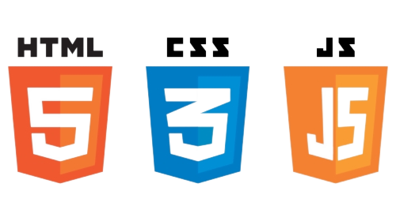

**HTML**, short for Hypertext Markup Language, is a cornerstone of the World Wide Web. It is a markup language that web developers use to create the structure and layout of web pages. HTML uses tags to define and organize the various elements within a webpage, such as headings, paragraphs, images, links, forms, and more. It uses a straightforward syntax that consists of opening and closing tags to enclose elements.

HTML is often used in conjunction with **CSS** (Cascading Style Sheets) and to create visually appealing websites. CSS is responsible for styling the elements defined in HTML. CSS allows web developers to separate the design and structure of a website, making it easier to maintain and update. With CSS, you can change the background colour of a page, adjust the size and font of text, create borders around images and much more.

**JavaScript** is a versatile programming language that adds interactivity and dynamic functionality to web pages. It is commonly used for client-side web development, meaning it runs directly in the web browser of the user, allowing websites to respond to user actions and provide a more engaging experience. It allows developers to create dynamic elements that can update in real-time, respond to user clicks, validate forms, display pop-ups, and much more.

**Bootstrap** is an open-source tool kit for developing with HTML, CSS and JS. It helps your quickly prototype your ideas or build entire apps with attractive CSS, responsive grid systems, extensive prebuilt components, etc.

**BACK END**

|  |  |  |
| --- | --- | --- |
|  | JSP file format symbol - Free interface icons |  |

**Spring Boot** is a powerful framework that simplifies the process of building robust and scalable web applications. It's like a toolbox filled with helpful tools and features that make developing web applications easier and more efficient. It provides a set of preconfigured components and sensible defaults, allowing you to focus on building your application's unique features. It automates many tedious tasks that developers often encounter, such as setting up the web server, managing dependencies, and handling database connections.

**JSP** **(Java Server Pages)** is a technology that allows developers to create dynamic web pages using Java. It's like having the ability to embed Java code directly into your web pages, making them more interactive and flexible. With JSP, one can write Java code directly within the HTML pages to handle these dynamic aspects.

**Java** is a widely used programming language known for its versatility, reliability, and platform independence. It was first introduced by Sun Microsystems (now owned by Oracle) in the mid-1990s and has since become one of the most popular languages in the world. One of the key strengths of Java is its object-oriented programming (OOP) approach.

The **Java Mail API** is a powerful tool that allows Java developers to send, receive, and manipulate email messages programmatically. It provides a set of classes and methods that simplify the process of integrating email functionality into Java applications. The JavaMail API abstracts the underlying email protocols, such as SMTP (Simple Mail Transfer Protocol) for sending emails and POP3 (Post Office Protocol) or IMAP (Internet Message Access Protocol) for receiving emails.

**MySQL** is a widely used open-source relational database management system (RDBMS) that allows you to efficiently store, manage, and retrieve structured data. It provides a reliable and scalable solution for applications that require persistent storage of data. MySQL supports the SQL (Structured Query Language) language, which is a standard language for managing relational databases. SQL allows to create, modify, and query databases using commands such as SELECT, INSERT, UPDATE, and DELETE.

## 2.2 Tools Used

|  |  |  |
| --- | --- | --- |
|  |  | MySQL Workbench | GPL, Oracle | Logiciel libre, Logiciel |
|  |  |  |
|  |  | Github Logo - Free social media icons |

**Visual Studio Code (VS Code)** is a lightweight and versatile code editor developed by Microsoft. It's designed to provide a rich and productive environment for developers to write, debug, and manage their code. It is mainly used to produce front end content.

**IntelliJ IDEA** is a powerful and widely used integrated development environment (IDE) created by JetBrains. It is specifically designed to enhance developer productivity and streamline the software development process. IntelliJ IDEA provides a comprehensive set of tools and features to support various programming languages and frameworks. It is mainly used to work with Spring Boot.

**MySQL Workbench** is a powerful visual tool for database design, development, and administration. It provides a comprehensive and user-friendly interface for working with MySQL databases. MySQL Workbench is developed by Oracle and is available for Windows, macOS, and Linux. It is mainly used to carry out RDMBS operations.

**WampServer** is a popular software stack that allows developers to set up a local web development environment on their windows computers. It provides an all-in-one solution for running Apache, MySQL, and PHP, collectively known as the AMP stack, on a Windows operating system. It is mainly used to connect to the MySQL server.

**hMailServer** is a free and open-source mail server software designed for Windows operating systems. It provides a reliable and customizable solution for setting up and managing email servers. hMailServer allows you to host your own email domain, enabling you to send, receive, and manage email accounts within your organization or for personal use. It is mainly used to create company domain.

**GitHub** is a web-based platform that provides a centralized repository for version control and collaboration on software development projects. It offers a range of features and tools designed to streamline the development process and enable collaboration among developers. It is mainly used as a backup storage.

## 2.3 Hardware & Software Requirements

**Hardware Requirement**

|  |  |
| --- | --- |
| Processor | A multi-core processor (e.g., Intel Core i5 or higher) with a clock speed of 2.5 GHz or more |
| Memory (RAM) | Minimum 8 GB RAM, although 16 GB or more is recommended. |
| Storage (ROM) | 1TB SSD recommended but HDD can also be used |

**Software Requirement**

|  |  |
| --- | --- |
| Operating System | Windows, macOS, or Linux. |
| Java Development Kit | JDK 11 or JDK 17 |
| Build Tool | Maven |

# 3.0 Software Development Life Cycle (SDLC)

The Software Development Life Cycle (SDLC) is a systematic approach used by software development teams to plan, design, build, test, and deploy software applications. It provides a structured framework for managing the entire process of software development from conception to delivery. The following section explains the SDLC process.

## 3.1 Overview of Incremental Model

The Incremental Model is an iterative and incremental software development approach that breaks down the software development process into smaller, more manageable increments. It involves delivering functional subsets of the software in successive iterations, with each increment building upon the previous one. This model allows for early and frequent delivery of working software, providing benefits such as faster time to market and the ability to gather user feedback throughout the development process.

In the Incremental Model, the entire software development life cycle is divided into multiple increments or iterations. Each increment consists of requirements gathering, design, implementation, testing, and deployment activities, but focuses on delivering a specific set of functionalities. The development team completes these activities for each increment before moving on to the next one.

The Incremental Model is particularly useful in projects where requirements are not fully known or may evolve over time. It allows for flexibility and adaptability to changing requirements, while still providing early deliverables and opportunities for feedback. However, it requires effective planning, coordination, and collaboration among team members to ensure smooth integration of the increments and maintain overall system integrity.

Advantages of Incremental Model:

* Errors are easy to be recognized.
* Easier to test and debug.
* More flexible.
* Simple to manage risk because it handled during its iteration.
* The Client gets important functionality early.

## 3.2 Phases of Incremental Model

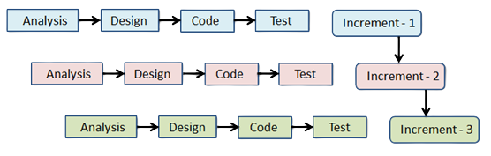

**Requirement analysis:** In the first phase of the incremental model, the product analysis expertise identifies the requirements. And the system functional requirements are understood by the requirement analysis team. To develop the software under the incremental model, this phase performs a crucial role.

**Design & Development:** In this phase of the Incremental model of SDLC, the design of the system functionality and the development method are finished with success. When software develops new practicality, the incremental model uses style and development phase.

**Implementation:** Implementation phase enables the coding phase of the development system. It involves the final coding that design in the designing and development phase and tests the functionality in the testing phase. After completion of this phase, the number of the product working is enhanced and upgraded up to the final system product

**Testing:** In the incremental model, the testing phase checks the performance of each existing function as well as additional functionality. In the testing phase, the various methods are used to test the behavior of each task.

# 4.0 Design Phase

The design phase is a crucial stage in the software development life cycle where the overall structure and architecture of the software system are planned and defined. It involves translating the requirements gathered in the previous phases into a detailed blueprint for the software solution. The following section visualizes the schema of the system.

## 4.1 Entity Relationship Model

**Customer side ERM**

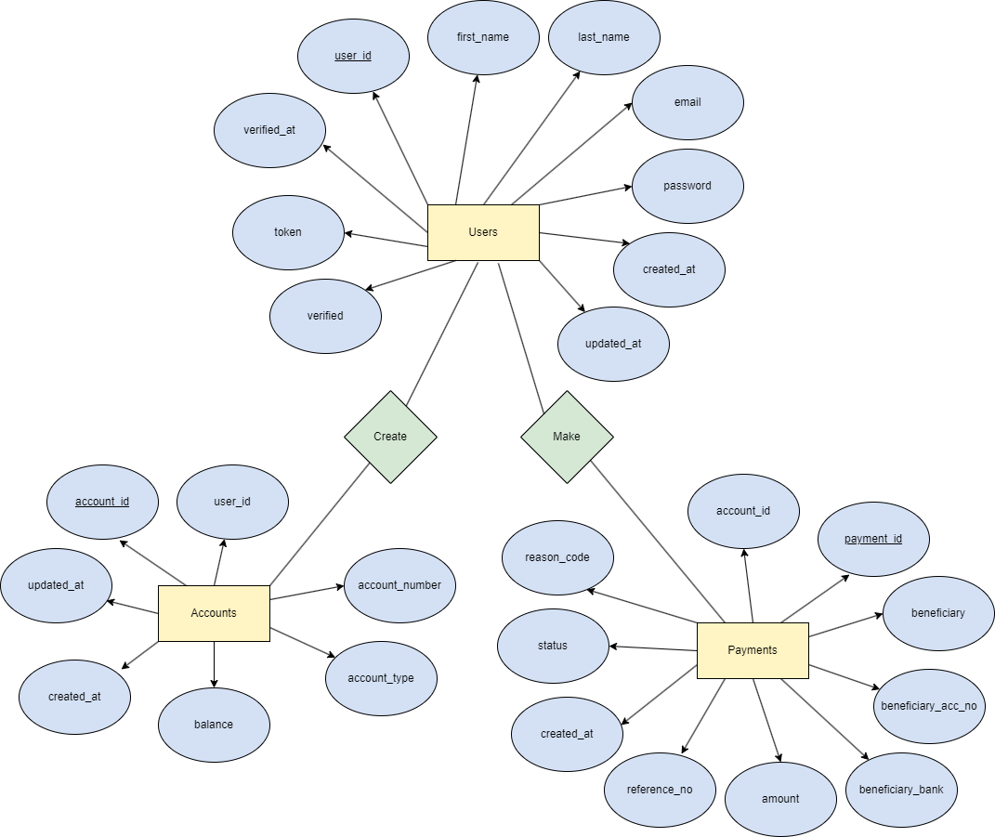

**Admin Side ERM**

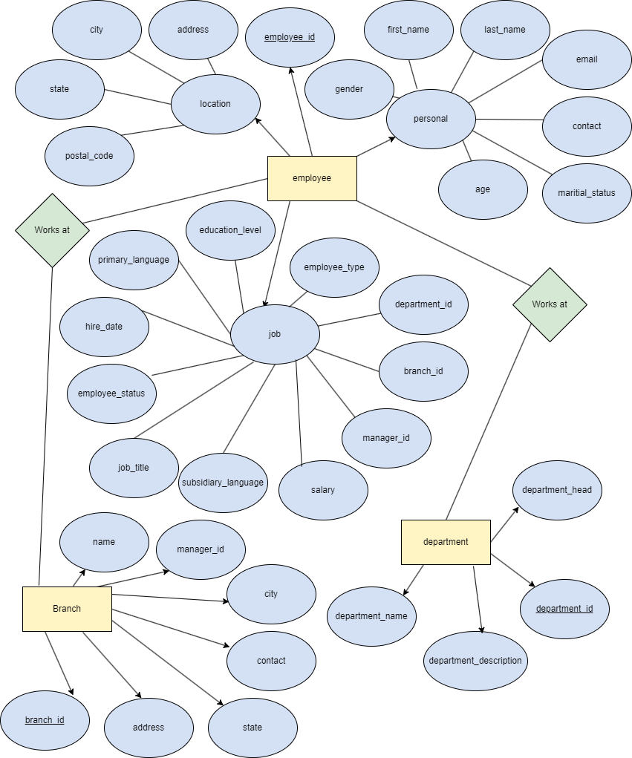

## 4.2 Flowchart

**Customer Side Flowchart**

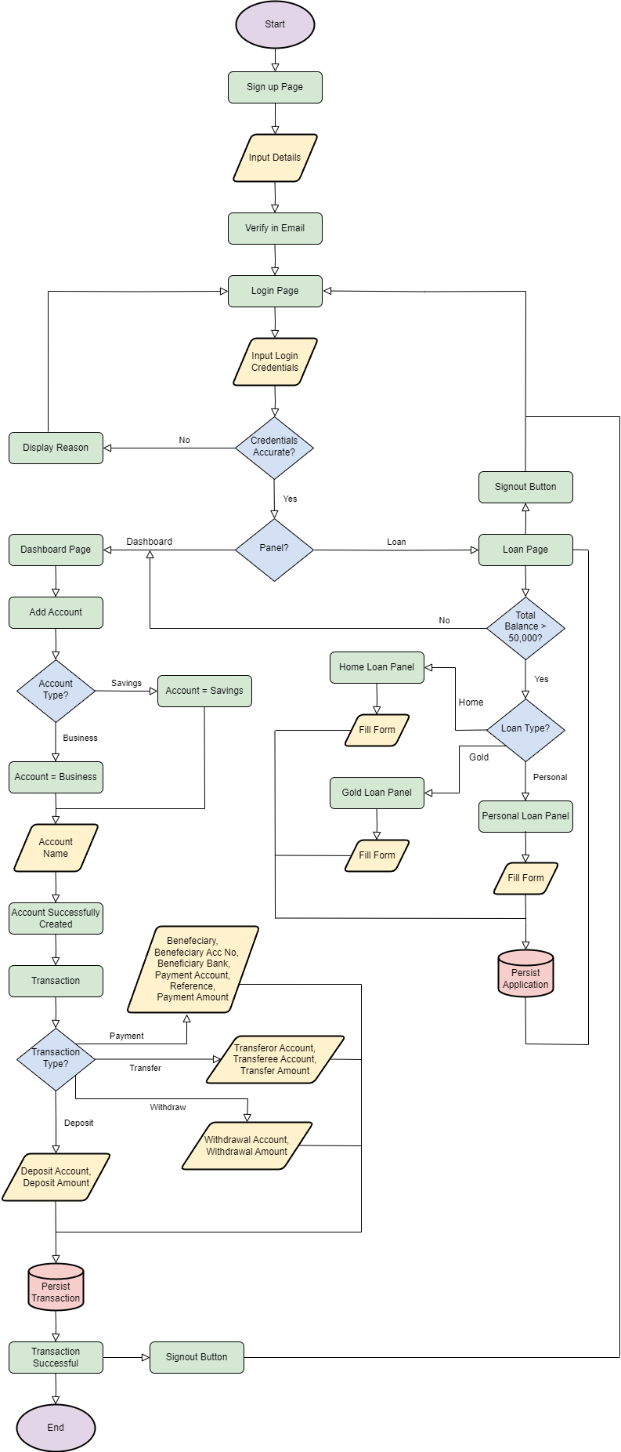

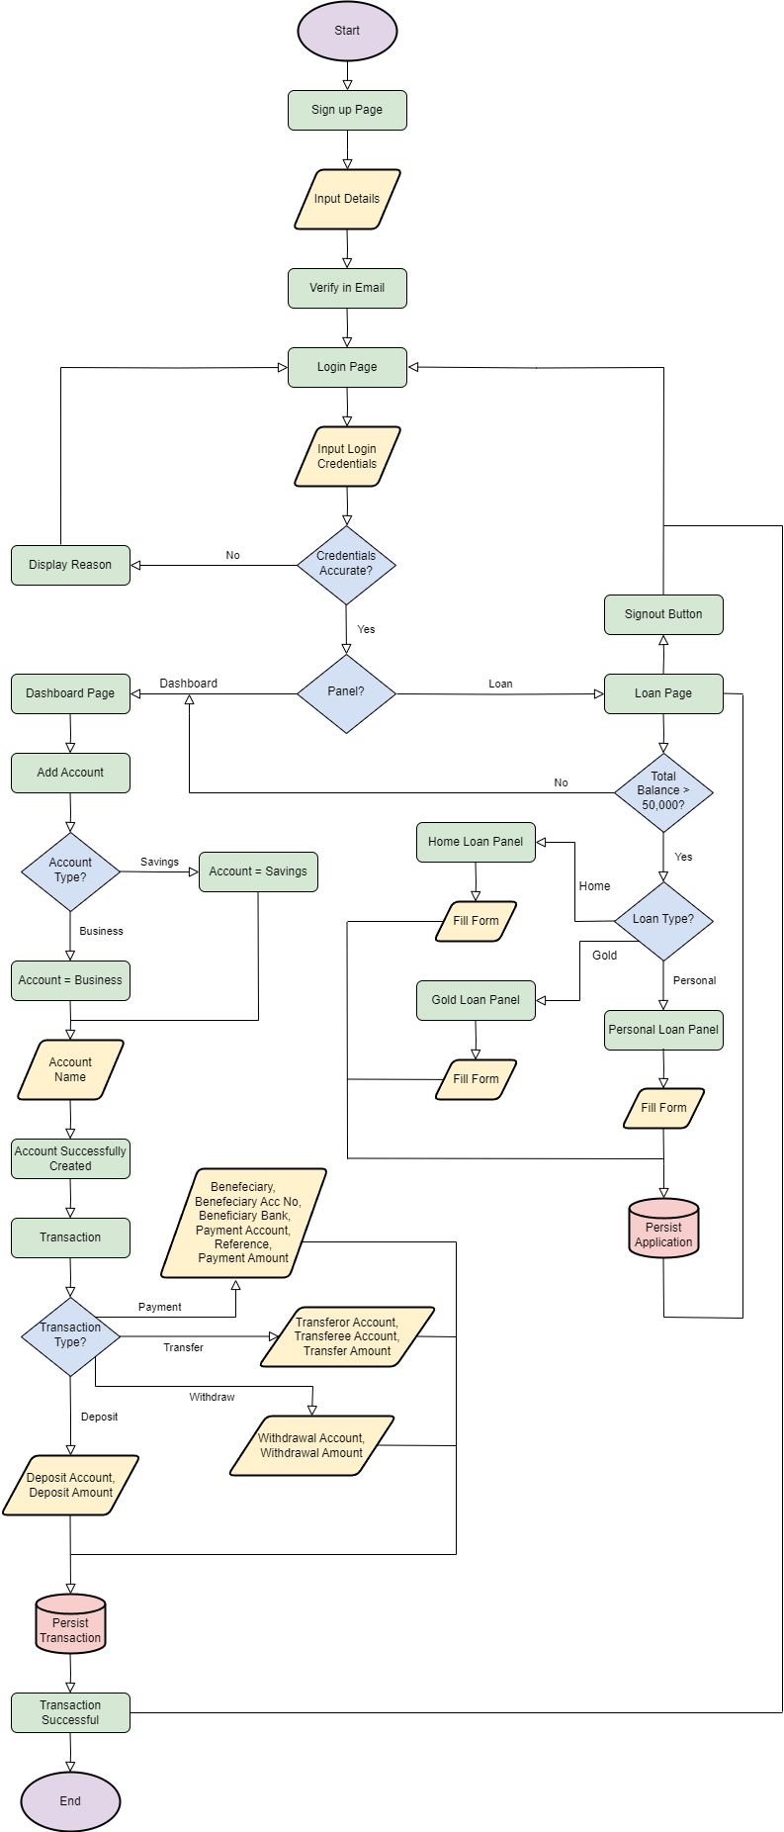

**Admin Side Flowchart**

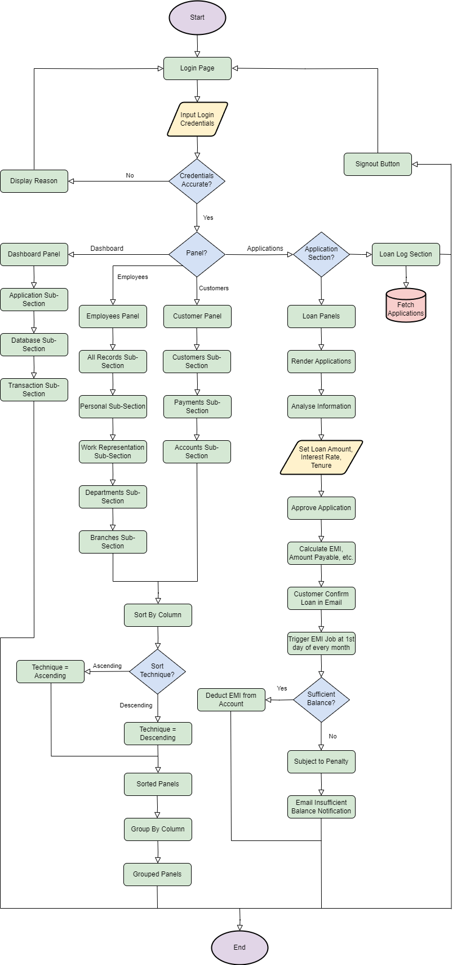



## 4.3 Use Case Diagram

**Front-End**

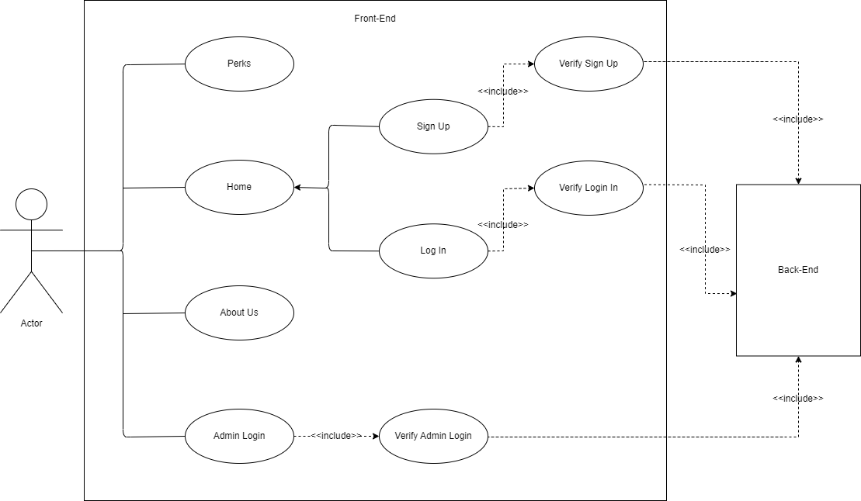

**Back-End**

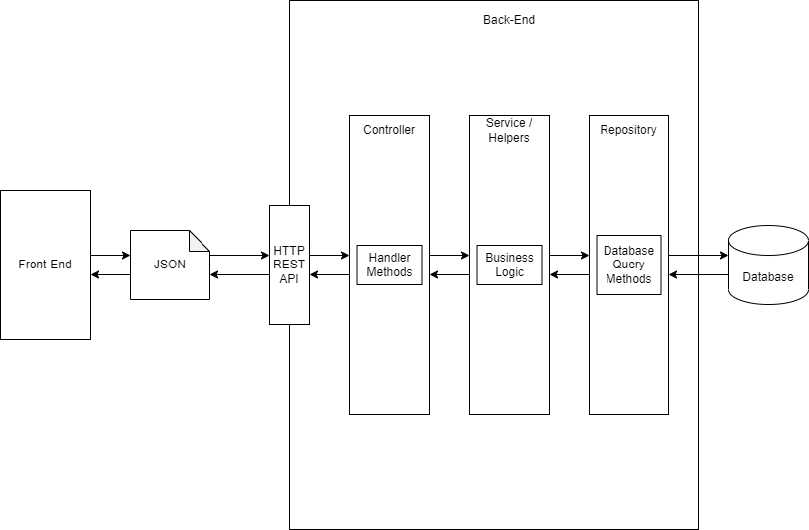

## 4.4 Entity Relationship Diagram

**Overview**

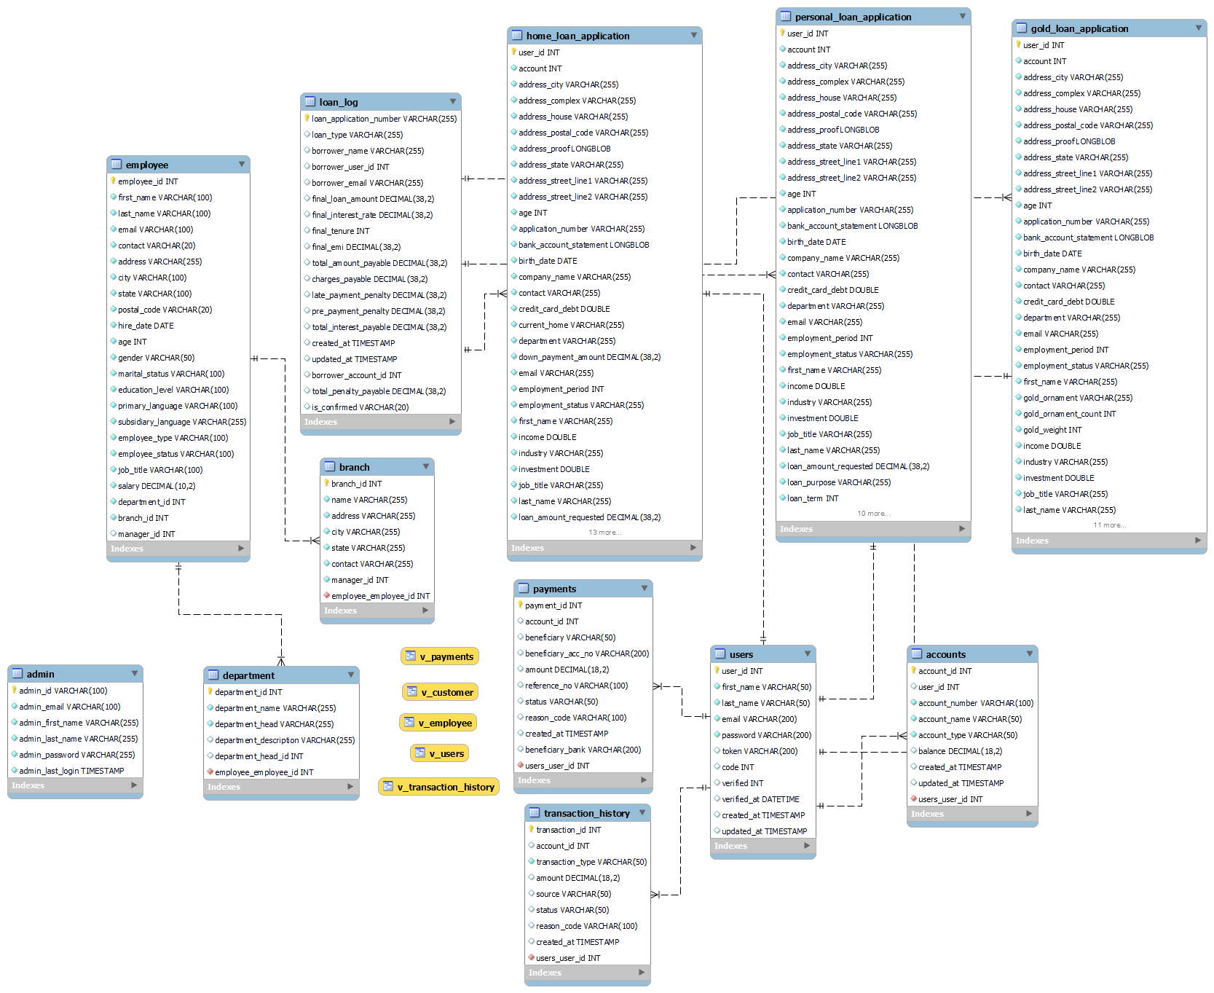

**User Section**



**Employee Section**



**Loan Section**



## 4.4 Data Dictionary

**Accounts Table**

|  |  |  |
| --- | --- | --- |
| **Field Name** | **Data Type** | **Extra** |
| account_id | INT | Primary Key, Auto Increment |
| user_id | INT | Foreign Key |
| account_number | VARCHAR(100) | - |
| account_name | VARCHAR(50) | - |
| account_type | VARCHAR(50) | - |
| balance | DECIMAL(18,2) | Default = 0.00 |
| created_at | TIMESTAMP | - |
| updated_at | TIMESTAMP | Current Time |

**Admin Table**

|  |  |  |
| --- | --- | --- |
| **Field Name** | **Data Type** | **Extra** |
| admin_id | VARCHAR(100) | Primary Key |
| admin_email | VARCHAR(100) | - |
| admin_first_name | VARCHAR(255) | - |
| admin_last_name | VARCHAR(255) | - |
| admin_password | VARCHAR(255) | - |
| admin_last_login | TIMESTAMP | - |

**Branch Table**

|  |  |  |
| --- | --- | --- |
| **Field Name** | **Data Type** | **Extra** |
| branch_id | INT | Primary Key, Auto Increment |
| name | VARCHAR(255) | - |
| address | VARCHAR(255) | - |
| city | VARCHAR(255) | - |
| state | VARCHAR(255) | - |
| contact | VARCHAR(255) | - |
| manager_id | INT | Foreign Key |

**Admin Table**

|  |  |  |
| --- | --- | --- |
| **Field Name** | **Data Type** | **Extra** |
| department_id | INT | Primary Key, Auto Increment |
| department_name | VARCHAR(255) | - |
| department_head | VARCHAR(255) | - |
| department_description | VARCHAR(255) | - |
| department_head_id | INT | Foreign Key |

**Employee Table**

|  |  |  |
| --- | --- | --- |
| **Field Name** | **Data Type** | **Extra** |
| employee_id | INT | Primary Key, Auto Increment |
| first_name | VARCHAR(100) | - |
| last_name | VARCHAR(100) | - |
| email | VARCHAR(100) | - |
| contact | VARCHAR(20) | - |
| address | VARCHAR(255) | - |
| city | VARCHAR(100) | - |
| state | VARCHAR(100) | - |
| postal_code | VARCHAR(20) | - |
| hire_date | DATE | - |
| age | INT | - |
| gender | VARCHAR(50) | - |
| marital_status | VARCHAR(100) | - |
| education_level | VARCHAR(100) | - |
| primary_language | VARCHAR(100) | - |
| subsidiary_language | VARCHAR(255) | - |
| employee_type | VARCHAR(100) | - |
| employee_status | VARCHAR(100) | - |
| job_title | VARCHAR(100) | - |
| salary | DECIMAL(10,2) | - |
| department_id | INT | Foreign Key |
| branch_id | INT | Foreign Key |
| manager_id | INT | Foreign Key |

**Gold Loan Application Table**

|  |  |  |
| --- | --- | --- |
| **Field Name** | **Data Type** | **Extra** |
| user_id | INT | Primary Key |
| account | INT | - |
| address_city | VARCHAR(255) | - |
| address_complex | VARCHAR(255) | - |
| address_house | VARCHAR(255) | - |
| address_postal_code | VARCHAR(255) | - |
| address_proof | LONGBLOB | - |
| address_state | VARCHAR(255) | - |
| address_street_line1 | VARCHAR(255) | - |
| address_street_line2 | VARCHAR(255) | - |
| age | INT | - |
| application_number | VARCHAR(255) | Unique |
| bank_account_statement | LONGBLOB | - |
| birth_date | DATE | - |
| company_name | VARCHAR(255) | - |
| contact | VARCHAR(255) | - |
| credit_card_debt | DOUBLE | - |
| department | VARCHAR(255) | - |
| email | VARCHAR(255) | - |
| employment_period | INT | - |
| employment_status | VARCHAR(255) | - |
| first_name | VARCHAR(255) | - |
| gold_ornament | VARCHAR(255) | - |
| gold_weight | INT | - |
| income | INT | - |
| industry | DOUBLE | - |
| investment | VARCHAR(255) | - |
| job_title | DOUBLE | - |
| last_name | VARCHAR(255) | - |
| loan_purpose | VARCHAR(255) | - |
| marital_status | VARCHAR(255) | - |
| proof_of_identity | VARCHAR(255) | - |
| religion | LONGBLOB | - |
| salary | VARCHAR(255) | - |
| salary_slip | DOUBLE | - |
| work_mode | LONGBLOB | - |
| approved | VARCHAR(255) | no |
| confirm | VARCHAR(50) | no |

**Home Loan Application Table**

|  |  |  |
| --- | --- | --- |
| **Field Name** | **Data Type** | **Extra** |
| user_id | INT | Primary Key |
| account | INT | - |
| address_city | VARCHAR(255) | - |
| address_complex | VARCHAR(255) | - |
| address_house | VARCHAR(255) | - |
| address_postal_code | VARCHAR(255) | - |
| address_proof | LONGBLOB | - |
| address_state | VARCHAR(255) | - |
| address_street_line1 | VARCHAR(255) | - |
| address_street_line2 | VARCHAR(255) | - |
| age | INT | - |
| application_number | VARCHAR(255) | Unique |
| bank_account_statement | LONGBLOB | - |
| birth_date | DATE | - |
| company_name | VARCHAR(255) | - |
| contact | VARCHAR(255) | - |
| credit_card_debt | DOUBLE | - |
| current_home | VARCHAR(255) | - |
| department | VARCHAR(255) | - |
| down_payment_amount | DECIMAL(38,2) | - |
| email | VARCHAR(255) | - |
| employment_period | INT | - |
| employment_status | VARCHAR(255) | - |
| first_name | VARCHAR(255) | - |
| income | DOUBLE | - |
| industry | VARCHAR(255) | - |
| investment | DOUBLE | - |
| job_title | VARCHAR(255) | - |
| last_name | VARCHAR(255) | - |
| loan_amount_requested | DECIMAL(38,2) | - |
| marital_status | VARCHAR(255) | - |
| motto_purchase | VARCHAR(255) | - |
| proof_of_identity | LONGBLOB | - |
| purchase_price | DECIMAL(38,2) | - |
| religion | VARCHAR(255) | - |
| salary | DOUBLE | - |
| salary_slip | LONGBLOB | - |
| sell_current | VARCHAR(255) | - |
| work_mode | VARCHAR(255) | - |
| approved | VARCHAR(50) | no |
| confirm | VARCHAR(50) | no |

**Loan Log Table**

|  |  |  |
| --- | --- | --- |
| **Field Name** | **Data Type** | **Extra** |
| loan_application_number | VARCHAR(255) | Primary Key |
| loan_type | VARCHAR(255) | - |
| borrower_name | VARCHAR(255) | - |
| borrower_user_id | INT | - |
| borrower_email | VARCHAR(255) | - |
| final_loan_amount | DECIMAL(38,2) | - |
| final_interest_rate | DECIMAL(38,2) | - |
| final_tenure | INT | - |
| final_emi | DECIMAL(38,2) | - |
| total_amount_payable | DECIMAL(38,2) | - |
| charges_payable | DECIMAL(38,2) | - |
| late_payment_penalty | DECIMAL(38,2) | - |
| pre_payment_penalty | DECIMAL(38,2) | - |
| total_interest_payable | DECIMAL(38,2) | - |
| created_at | TIMESTAMP | Current Time |
| updated_at | TIMESTAMP | Current Time |
| borrower_account_id | INT | - |
| total_penalty_payable | DECIMAL(38,2) | 0.00 |
| is_confirmed | VARCHAR(20) | no |

**Payments Table**

|  |  |  |
| --- | --- | --- |
| **Field Name** | **Data Type** | **Extra** |
| payment_id | INT | Primary Key, Auto Increment |
| account_id | INT | Foreign Key |
| beneficiary | VARCHAR(50) | - |
| beneficiary_acc_no | VARCHAR(200) | - |
| amount | DECIMAL(18,2) | - |
| reference_no | VARCHAR(100) | - |
| status | VARCHAR(50) | - |
| reason_code | VARCHAR(100) | - |
| created_at | TIMESTAMP | - |
| beneficiary_bank | VARCHAR(200) | - |

**Personal Loan Application Table**

|  |  |  |
| --- | --- | --- |
| **Field Name** | **Data Type** | **Extra** |
| user_id | INT | Primary Key |
| account | INT | - |
| address_city | VARCHAR(255) | - |
| address_complex | VARCHAR(255) | - |
| address_house | VARCHAR(255) | - |
| address_postal_code | VARCHAR(255) | - |
| address_proof | LONGBLOB | - |
| address_state | VARCHAR(255) | - |
| address_street_line1 | VARCHAR(255) | - |
| address_street_line2 | VARCHAR(255) | - |
| age | INT | - |
| application_number | VARCHAR(255) | Unique |
| bank_account_statement | LONGBLOB | - |
| birth_date | DATE | - |
| company_name | VARCHAR(255) | - |
| contact | VARCHAR(255) | - |
| credit_card_debt | DOUBLE | - |
| department | VARCHAR(255) | - |
| email | VARCHAR(255) | - |
| employment_period | INT | - |
| employment_status | VARCHAR(255) | - |
| first_name | VARCHAR(255) | - |
| income | DOUBLE | - |
| industry | VARCHAR(255) | - |
| investment | DOUBLE | - |
| job_title | VARCHAR(255) | - |
| last_name | VARCHAR(255) | - |
| loan_amount_requested | DECIMAL(38,2) | - |
| loan_purpose | VARCHAR(255) | - |
| loan_term | INT | - |
| marital_status | VARCHAR(255) | - |
| proof_of_identity | LONGBLOB | - |
| religion | VARCHAR(255) | - |
| salary | DOUBLE | - |
| salary_slip | LONGBLOB | - |
| work_mode | VARCHAR(255) | - |
| approved | VARCHAR(50) | no |
| confirm | VARCHAR(50) | no |

**Transaction History Table**

|  |  |  |
| --- | --- | --- |
| **Field Name** | **Data Type** | **Extra** |
| transaction_id | INT | Primary Key, Auto Increment |
| account_id | INT | Foreign Key |
| transaction_type | VARCHAR(50) | - |
| amount | DECIMAL(18,2) | - |
| source | VARCHAR(50) | - |
| status | VARCHAR(50) | - |
| reason_code | VARCHAR(100) | - |
| created_at | TIMESTAMP | - |

**Users Table**

|  |  |  |
| --- | --- | --- |
| **Field Name** | **Data Type** | **Extra** |
| user_id | INT | Primary Key, Auto Increment |
| first_name | VARCHAR(50) | Foreign Key |
| last_name | VARCHAR(50) | - |
| email | VARCHAR(200) | Unique |
| password | VARCHAR(200) | - |
| token | VARCHAR(200) | - |
| code | INT | - |
| verified | INT | - |
| verified_at | DATETIME | - |
| created_at | TIMESTAMP | - |
| updated_at | TIMESTAMP | Current Time |

**Customer View**

|  |  |  |
| --- | --- | --- |
| **Field Name** | **Data Type** | **Extra** |
| user_id | INT | - |
| name | VARCHAR(101) | - |
| email | VARCHAR(200) | - |
| created_at | TIMESTAMP | - |
| updated_at | TIMESTAMP | Current Time |
| verified_at | DATETIME | - |
| account_count | BIGINT | - |

**Employee View**

|  |  |  |
| --- | --- | --- |
| **Field Name** | **Data Type** | **Extra** |
| employee_id | INT | - |
| Name | VARCHAR(201) | - |
| age | INT | - |
| job_title | VARCHAR(100) | - |
| hire_date | DATE | - |
| department_name | VARCHAR(255) | - |
| branch_name | VARCHAR(255) | - |

**Payment View**

|  |  |  |
| --- | --- | --- |
| **Field Name** | **Data Type** | **Extra** |
| payment_id | INT | - |
| account_id | INT | - |
| user_id | INT | - |
| beneficiary | VARCHAR(50) | - |
| beneficiary_acc_no | VARCHAR(200) | - |
| beneficiary_bank | VARCHAR(200) | - |
| amount | DECIMAL(18,2) | - |
| status | VARCHAR(50) | - |
| reference_no | VARCHAR(100) | - |
| reason_code | VARCHAR(100) | - |
| created_at | TIMESTAMP | - |

**Transaction History View**

|  |  |  |
| --- | --- | --- |
| **Field Name** | **Data Type** | **Extra** |
| transaction_id | INT | - |
| account_id | INT | - |
| user_id | INT | - |
| transaction_type | VARCHAR(50) | - |
| amount | DECIMAL(18,2) | - |
| source | VARCHAR(50) | - |
| status | VARCHAR(50) | - |
| reason_code | VARCHAR(100) | - |
| created_at | TIMESTAMP | - |

**Users View**

|  |  |  |
| --- | --- | --- |
| **Field Name** | **Data Type** | **Extra** |
| user_id | int | - |
| name | varchar(101) | - |
| email | varchar(200) | - |
| account_count | bigint | - |

## 4.5 Gantt Chart

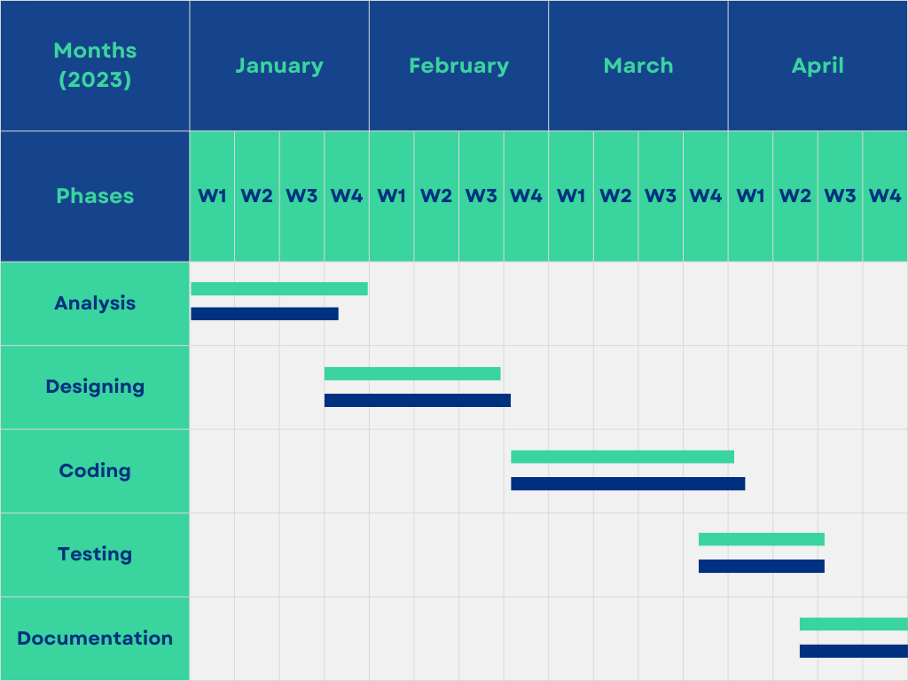

**Graphical Symbols**

|  |  |
| --- | --- |
| **Symbol** | **Description** |
|  | Estimated Date |
|  | Time Taken |

# 5.0 Screen Dumps

Screen Dumps are a valuable tool for capturing and documenting visual representations of computer screens, applications, etc. The following section displays snapshots of the Banking Management System as various screenshots.

**Landing Page**

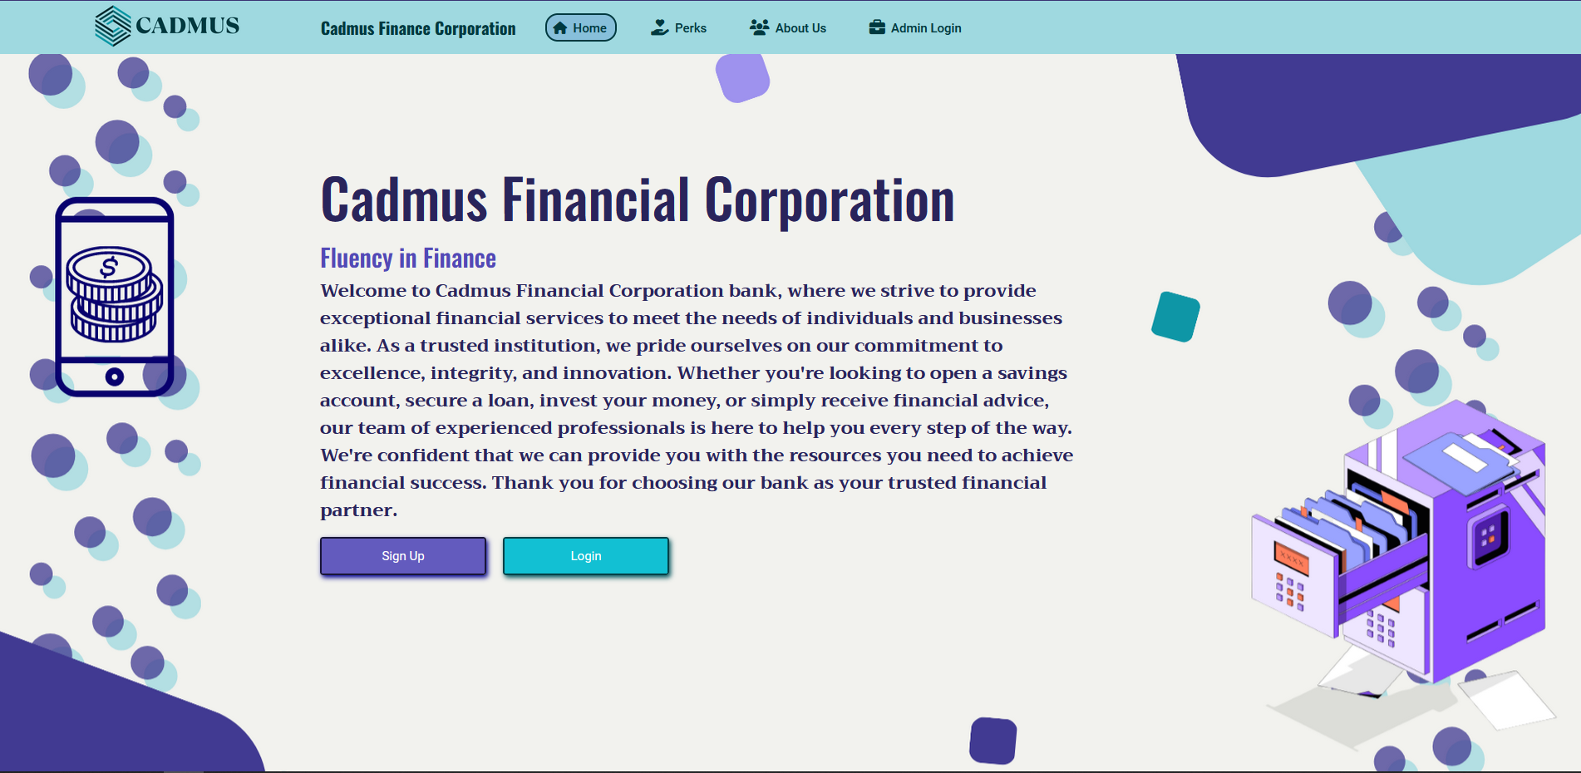

**Perks Page**

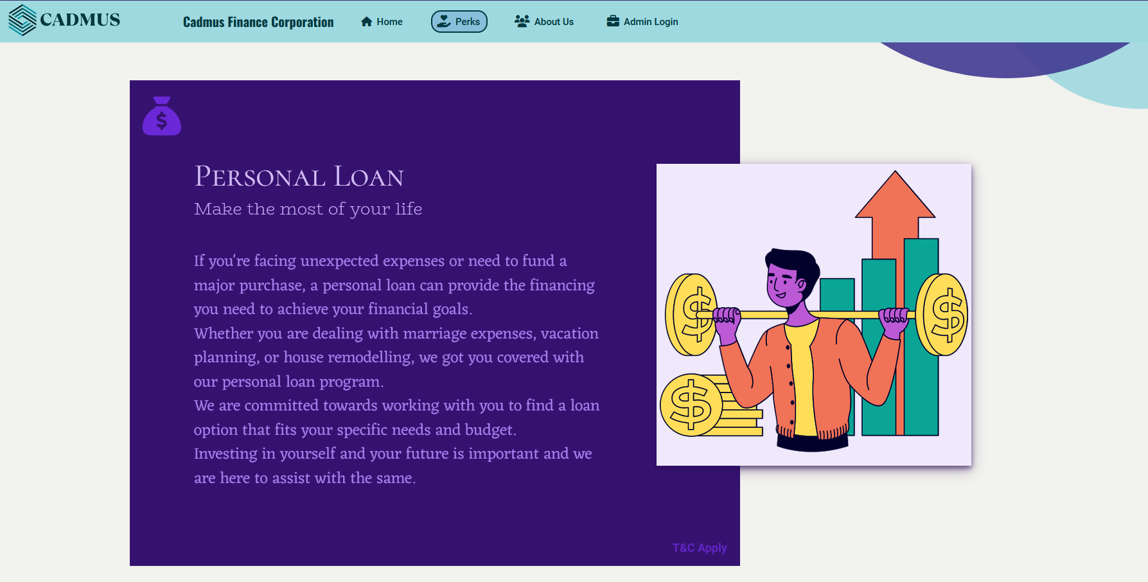

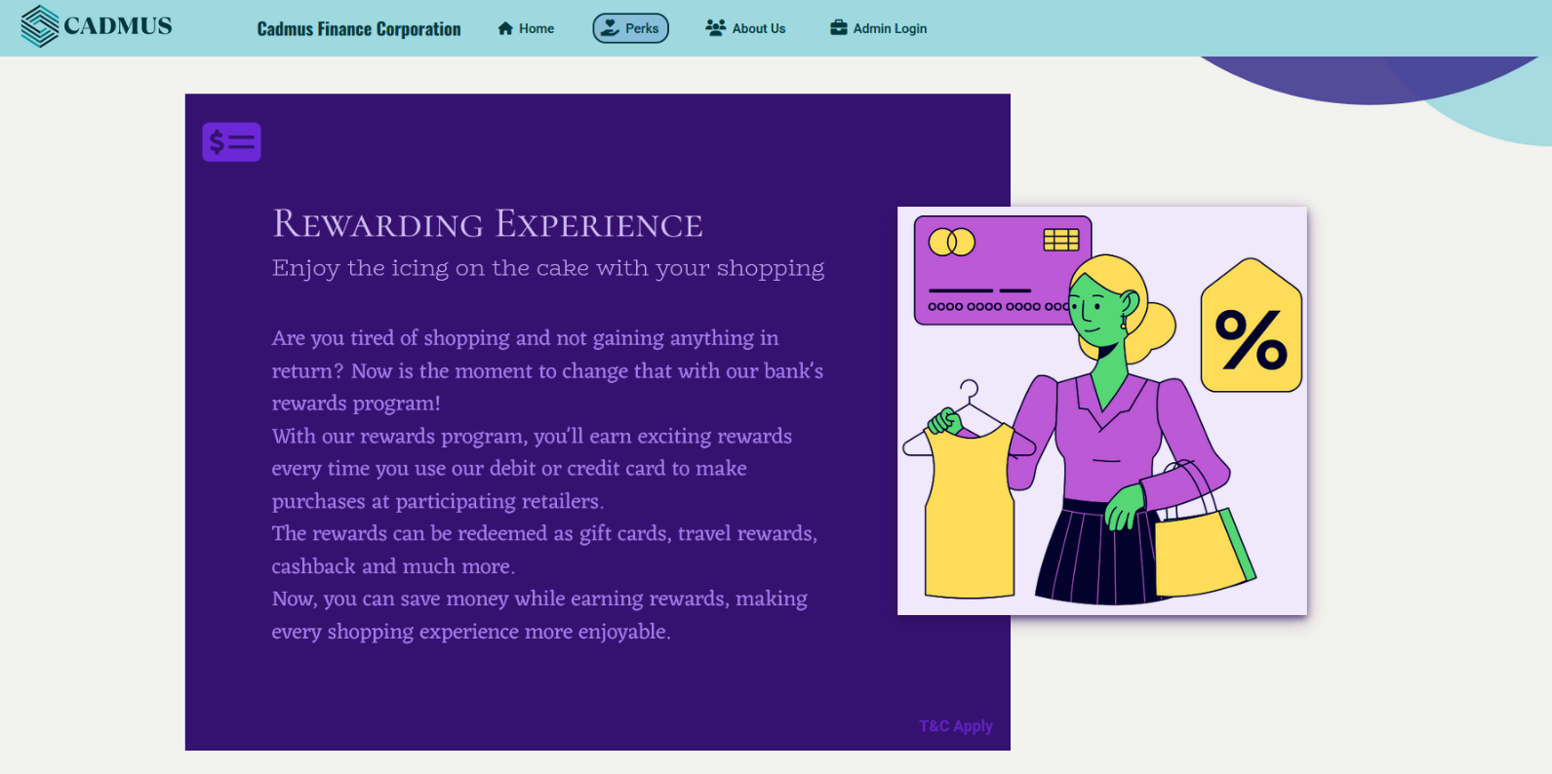

**About Us Page**

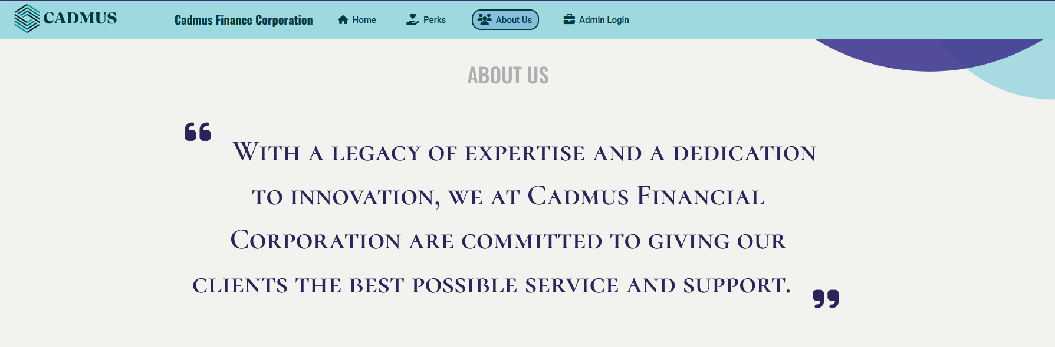

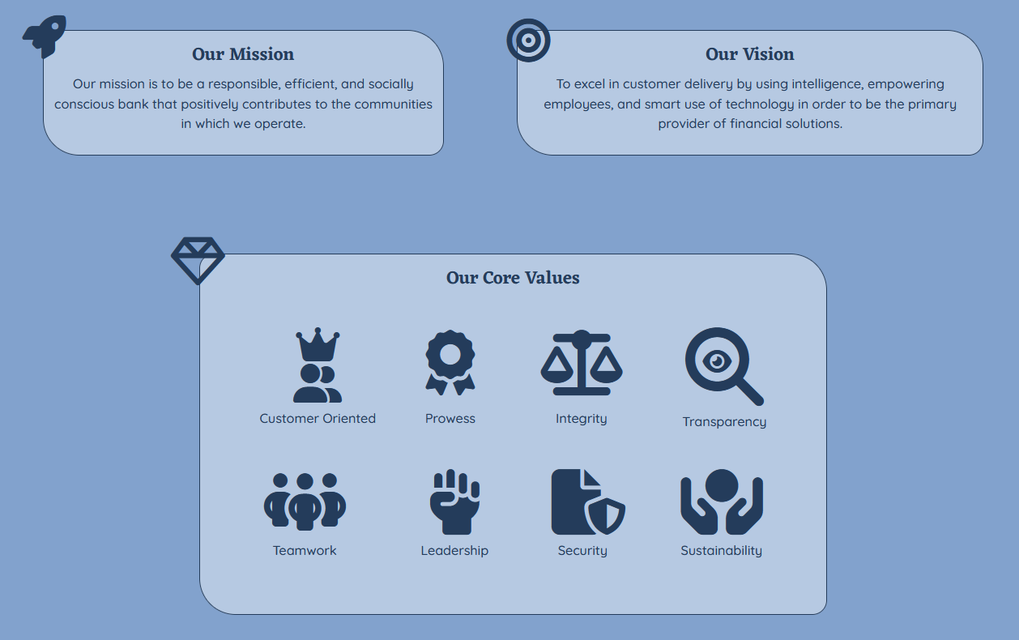

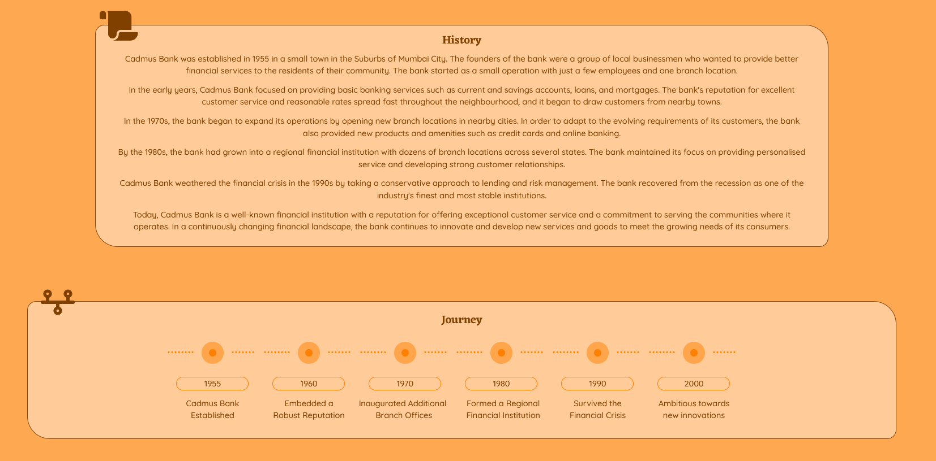

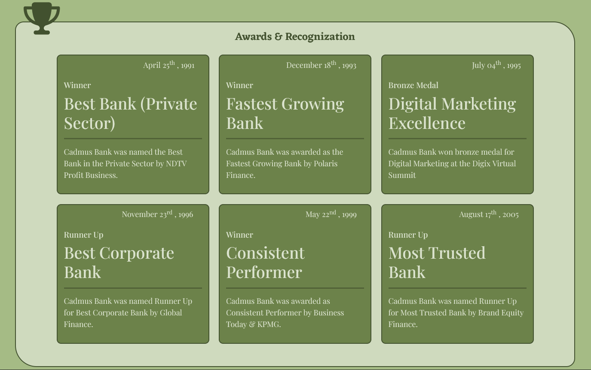

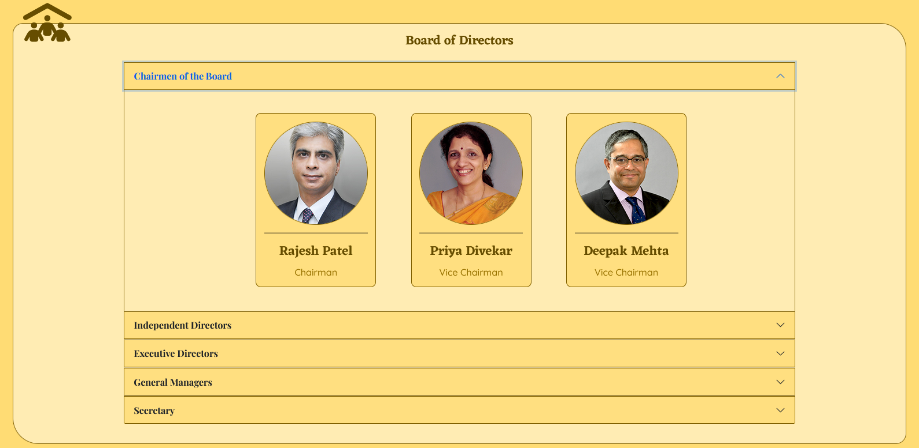

**Admin Login Page**

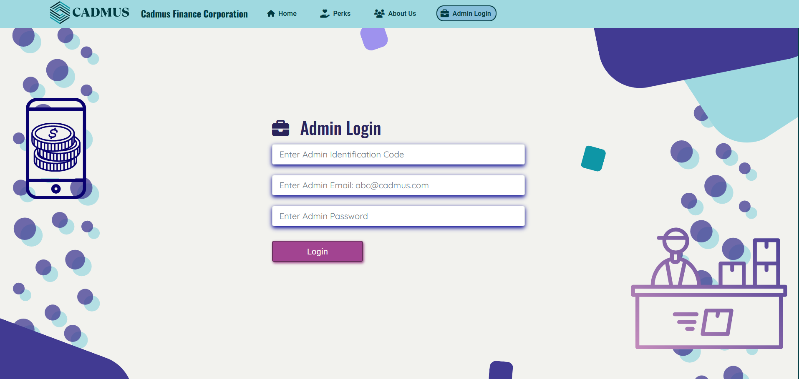

**Sign Up Page**

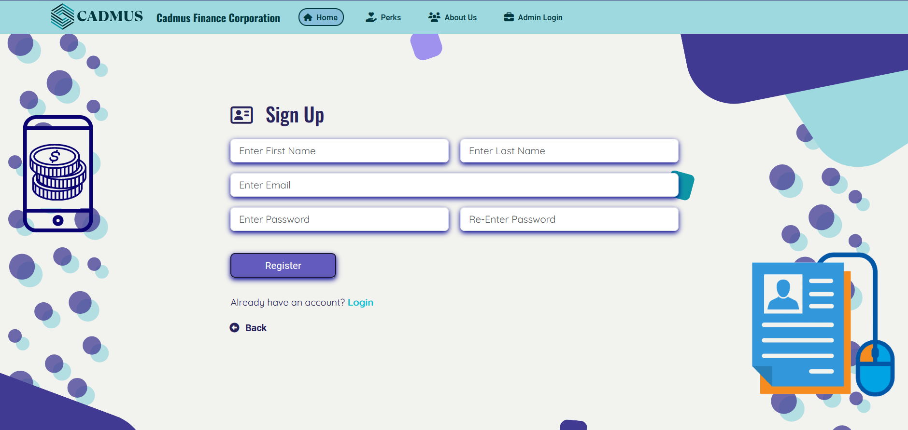

**Login In Page**

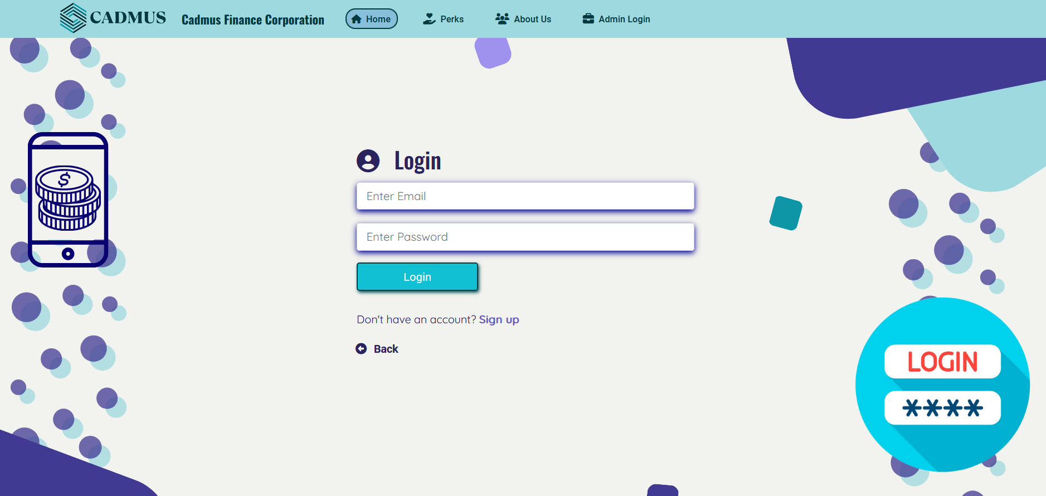

**Customer Dashboard (No Account) Page**

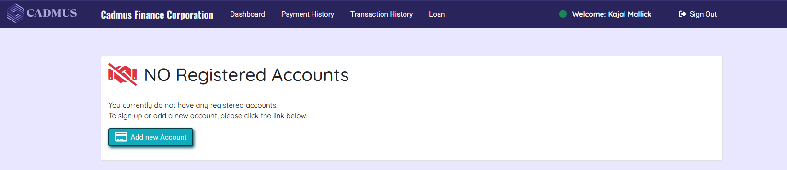

**Create Account Offcanvas**

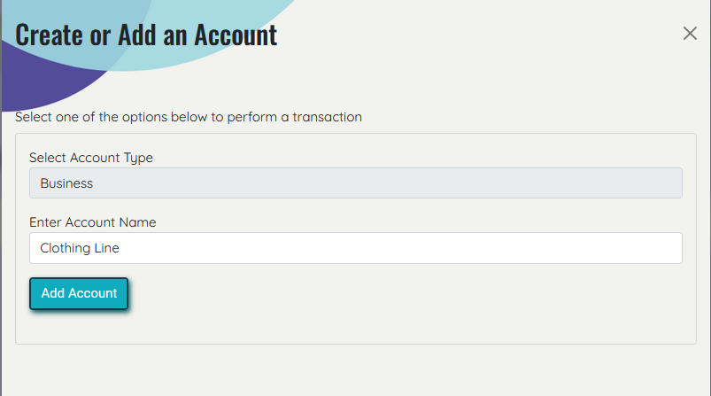

**Customer Dashboard (Account Added) Page**

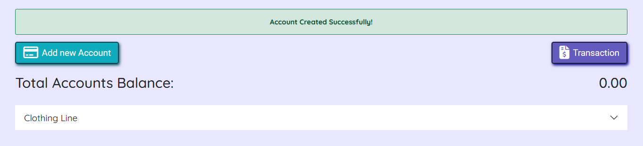

**Customer Dashboard (Multiple Accounts) Page**

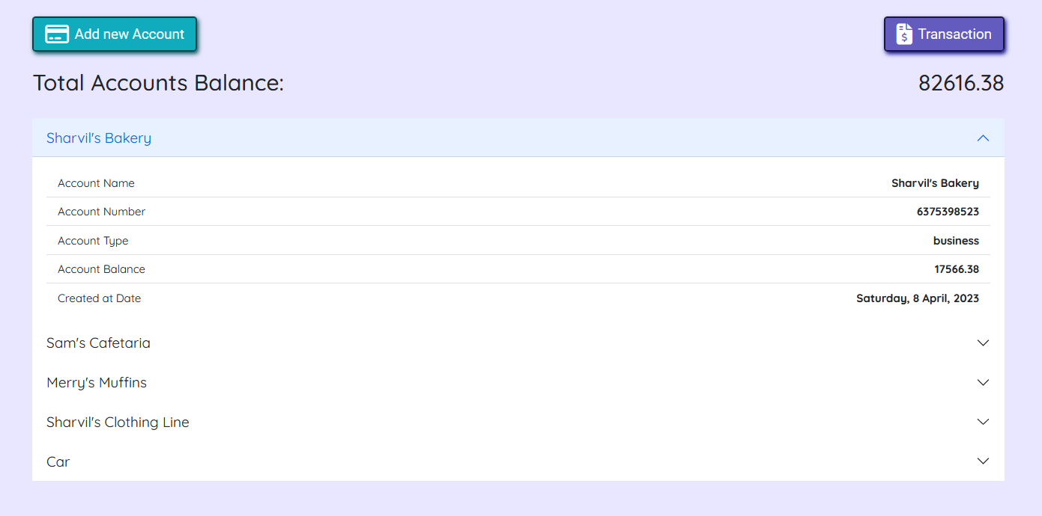

**Transaction - Payment Offcanvas**

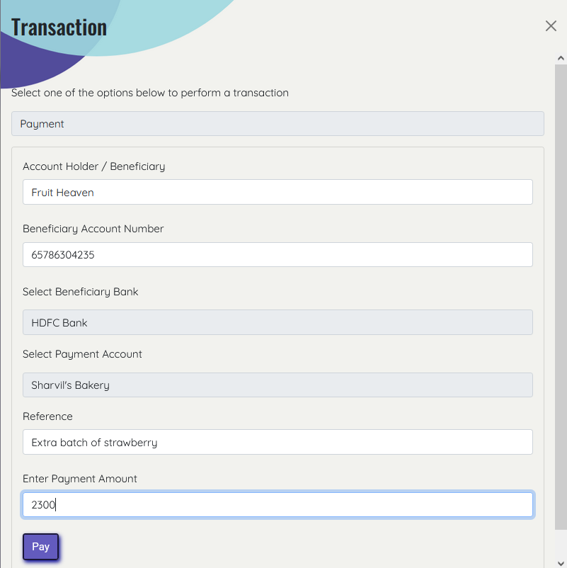

**Payment Transaction Successful Page**

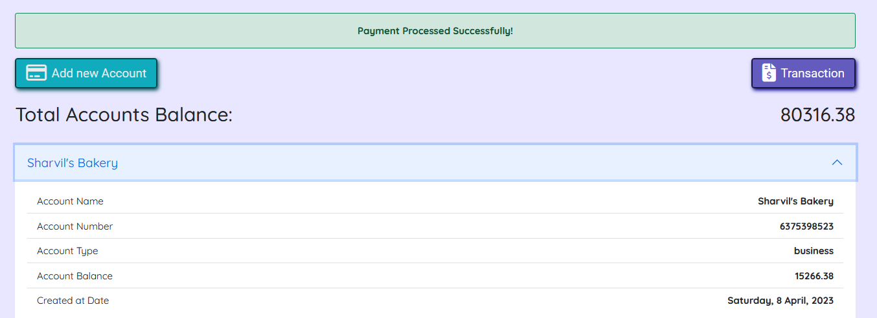

**Transaction - Transfer Offcanvas**

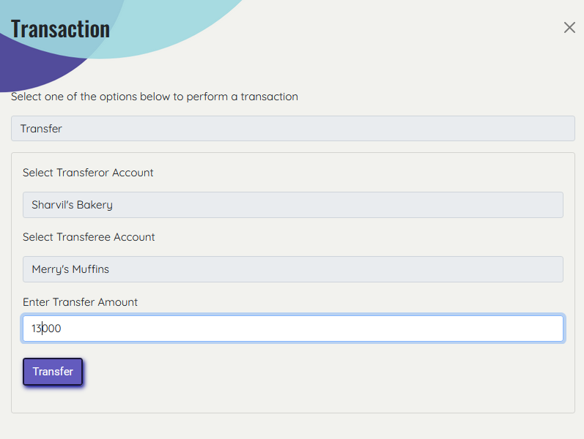

**Transfer Transaction Successful Page**

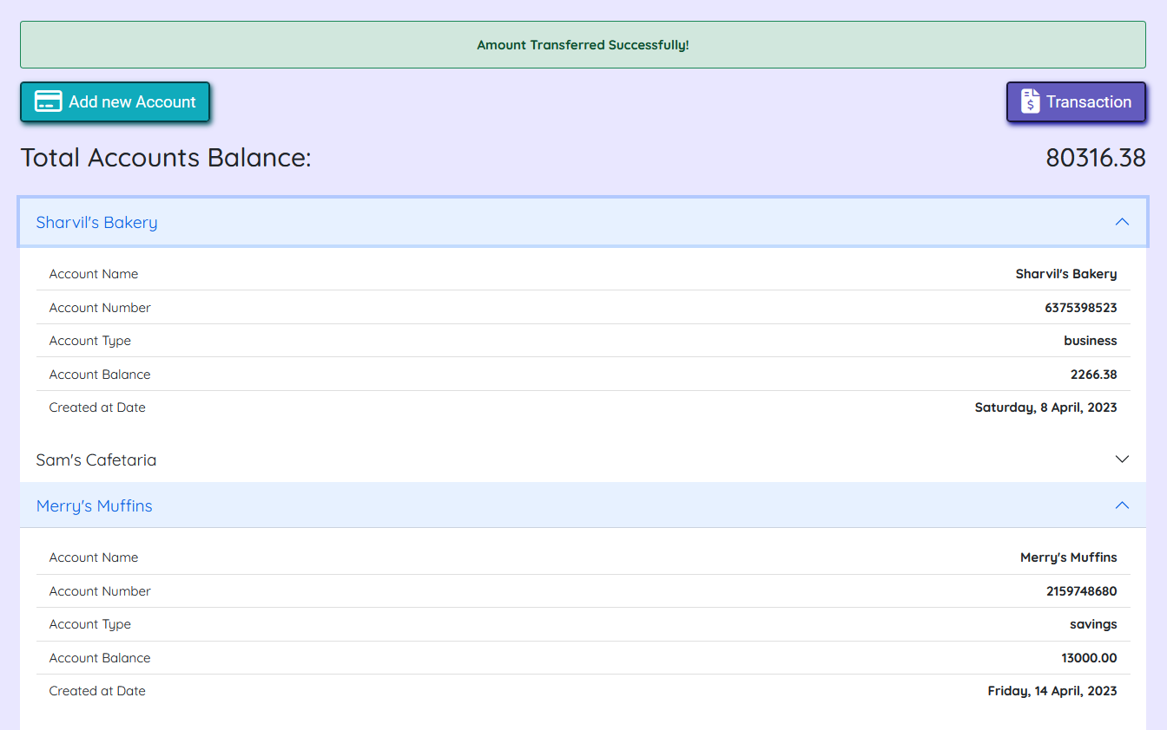

**Deposit Transaction Offcanvas**

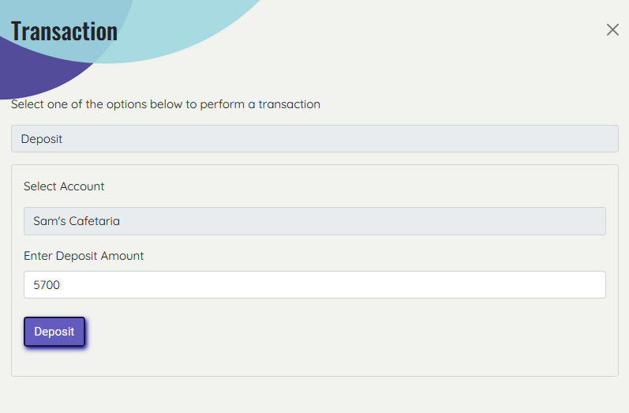

**Deposit Transaction Successful Page**

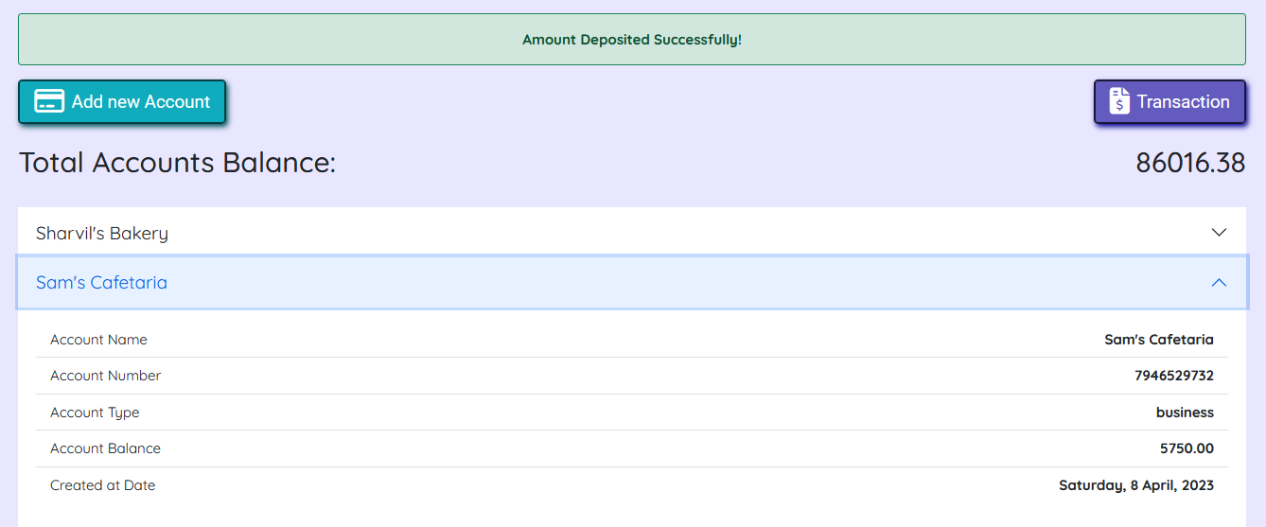

**Withdraw Transaction Offcanvas**

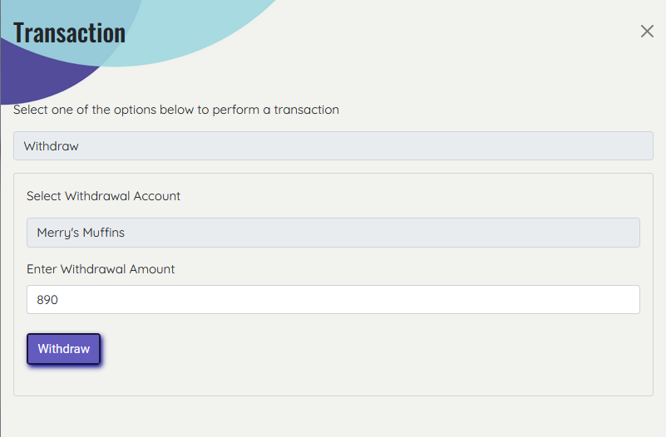

**Withdraw Transaction Successful Page**

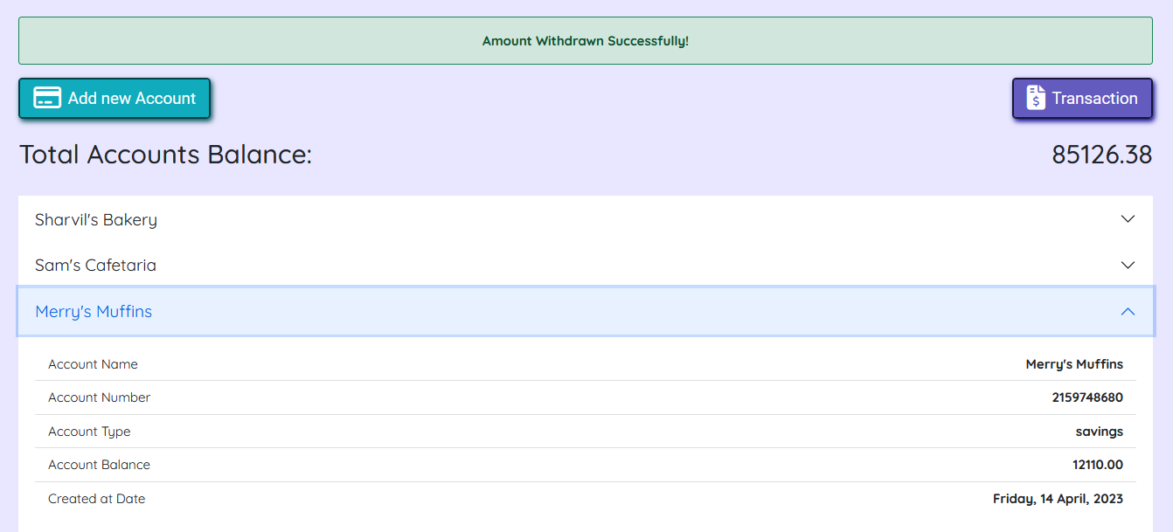

**Payment History Panel Page**

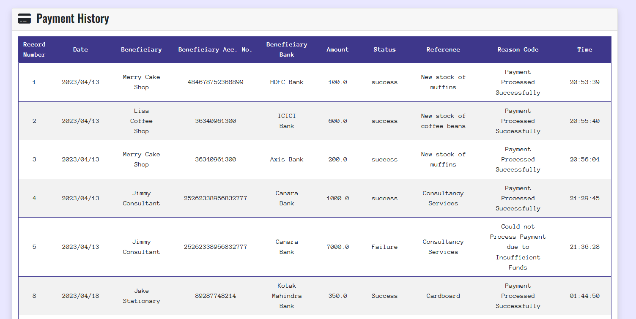

**Payment History Downloaded PDF**

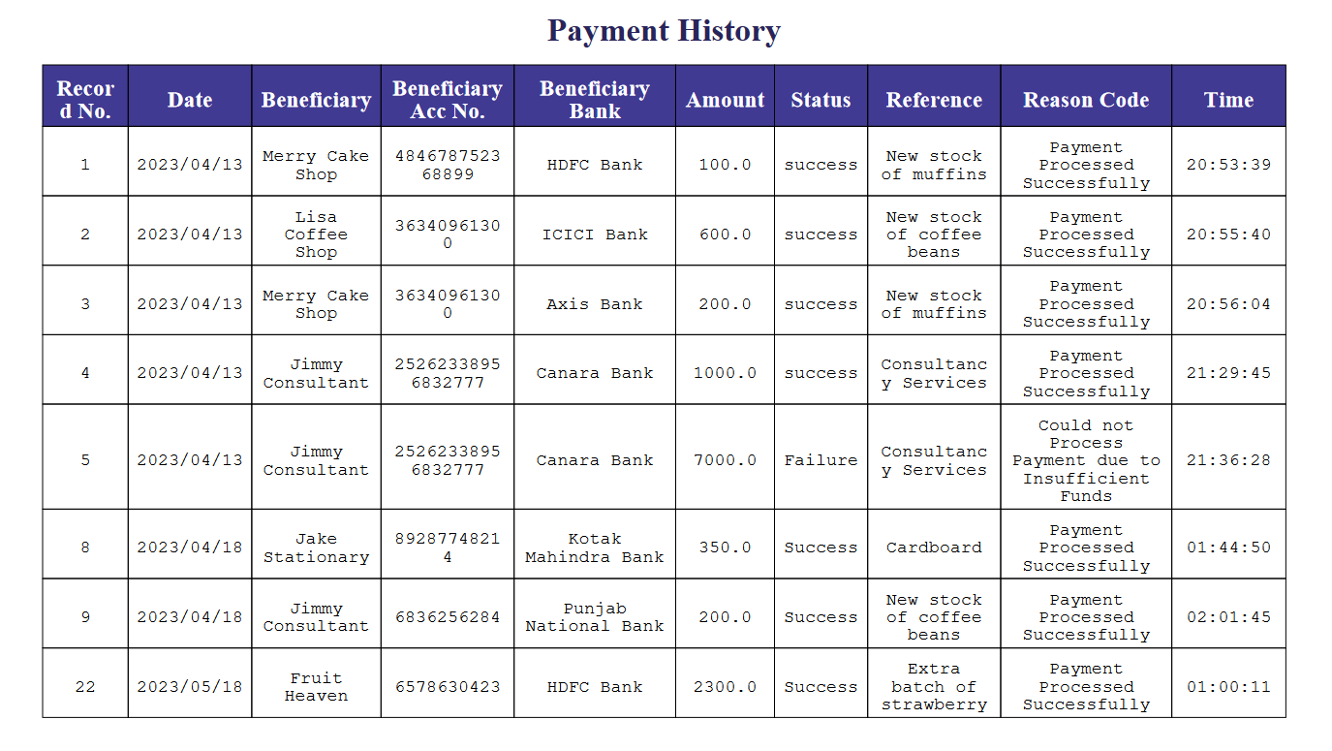

**Transaction History Panel Page**

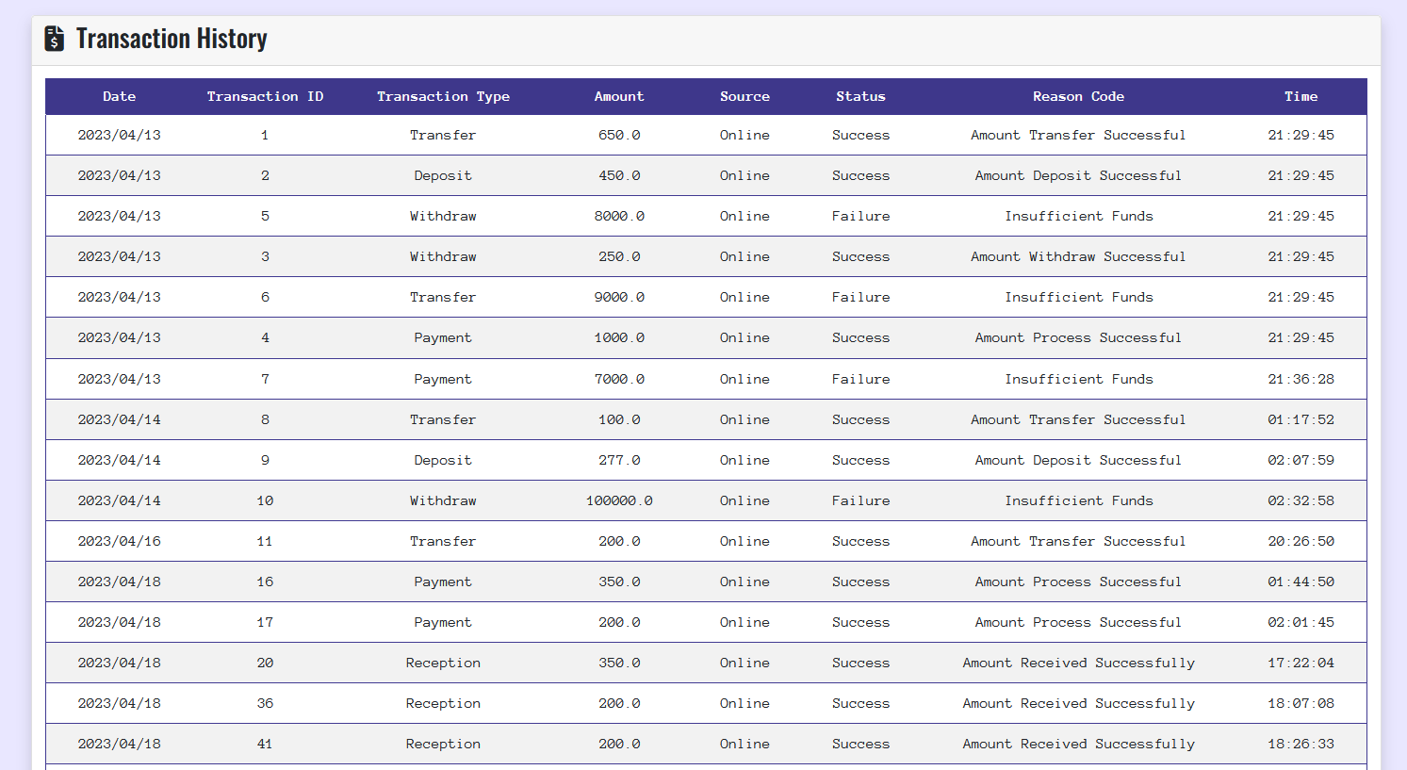

**Transaction History Downloaded PDF**

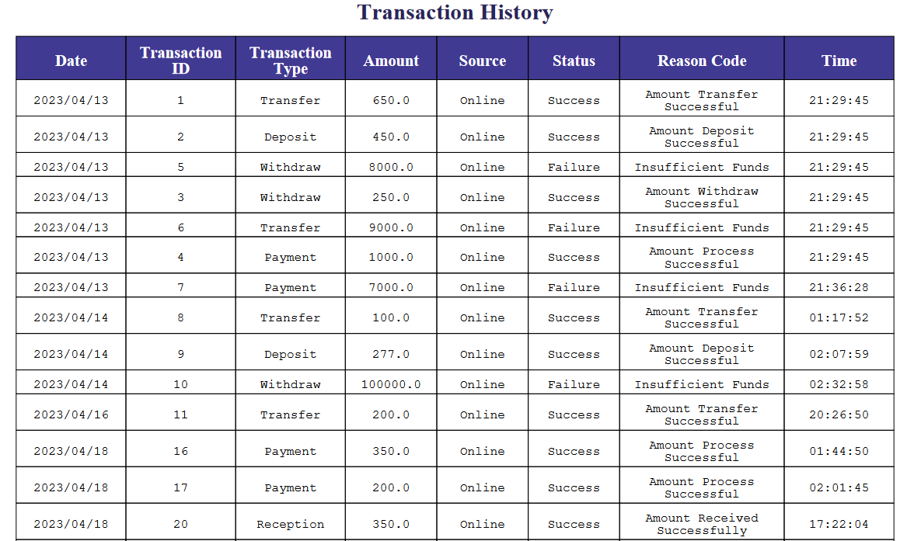

**Loan Panel Page**

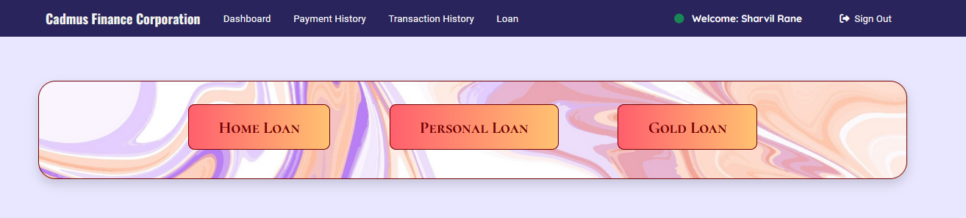

**Home Loan Section**

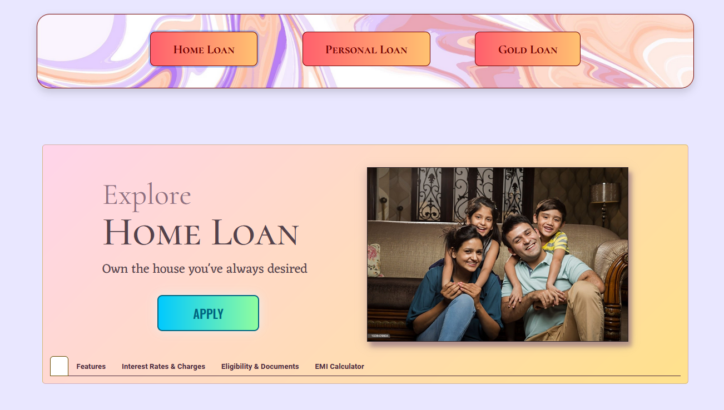

**Home Loan - Features Section**

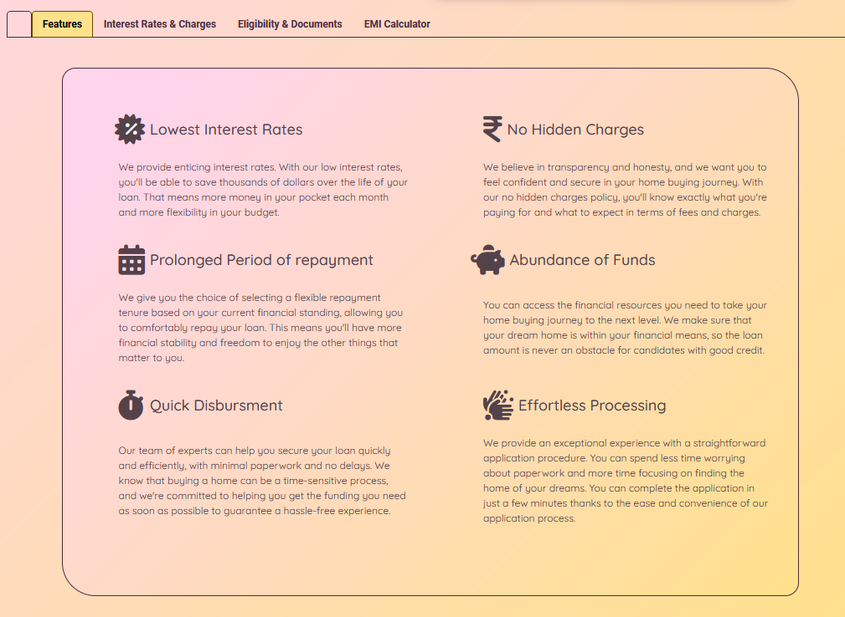

**Home Loan (Interest Rate & Charges) Section**

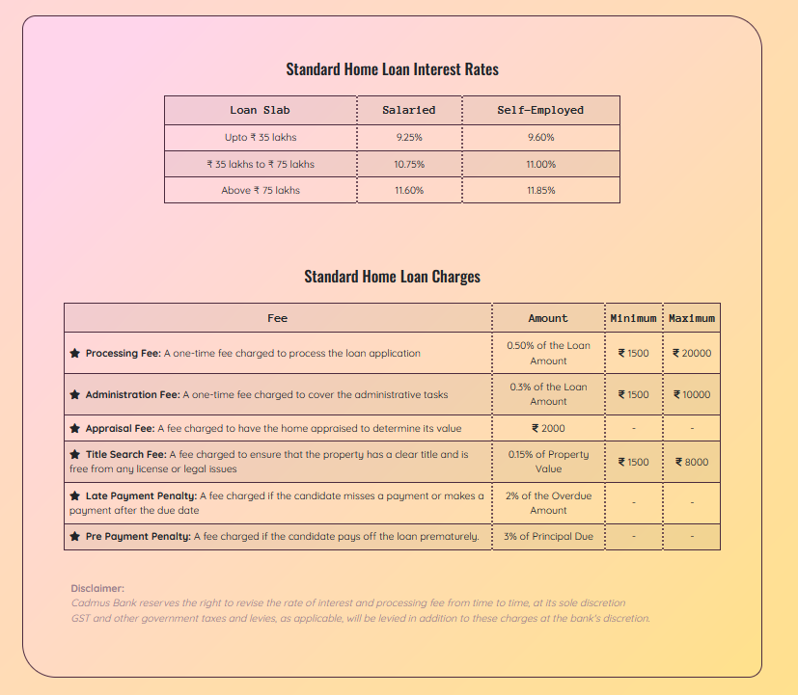

**Home Loan (Eligibility & Documents) Section**

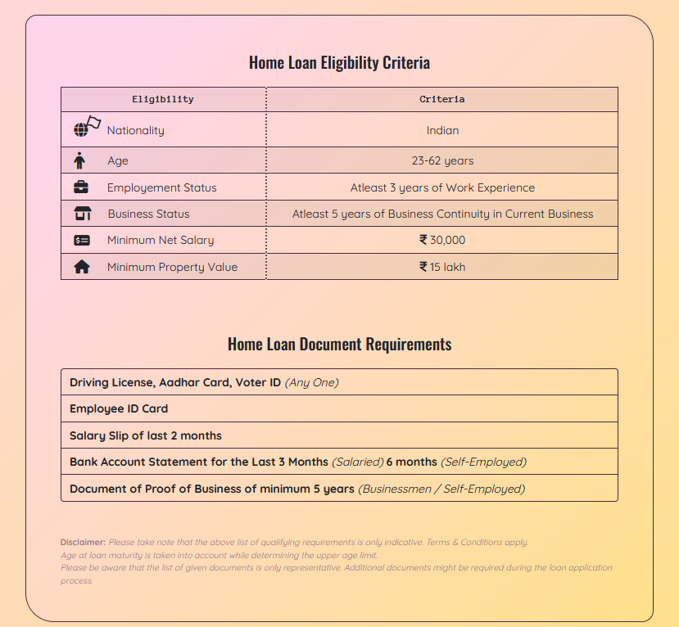

**Home Loan (EMI Calculator) Section**

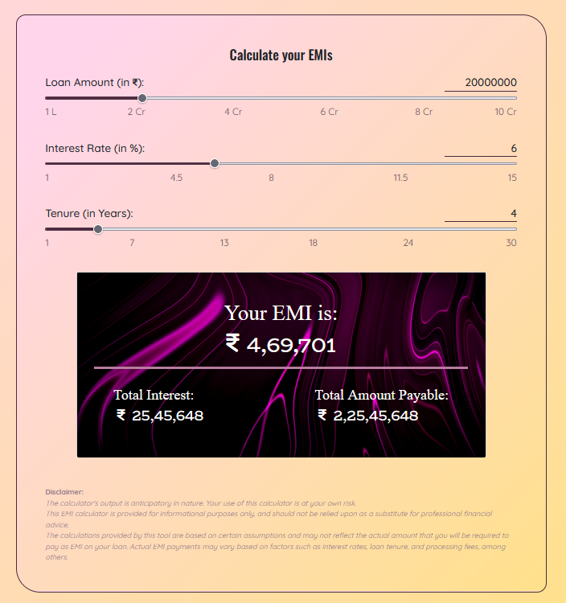

**Home Loan Application Offcanvas**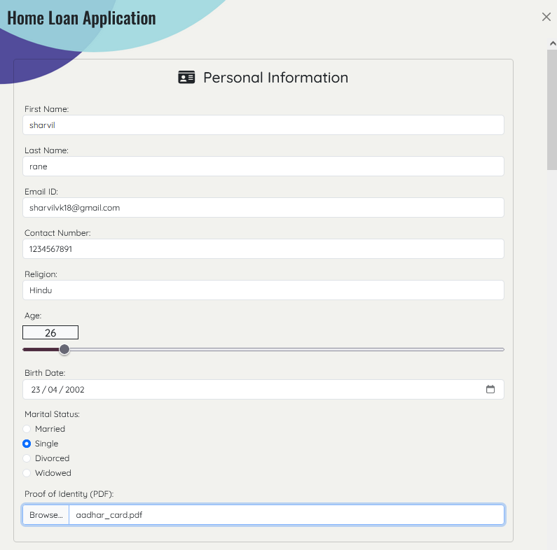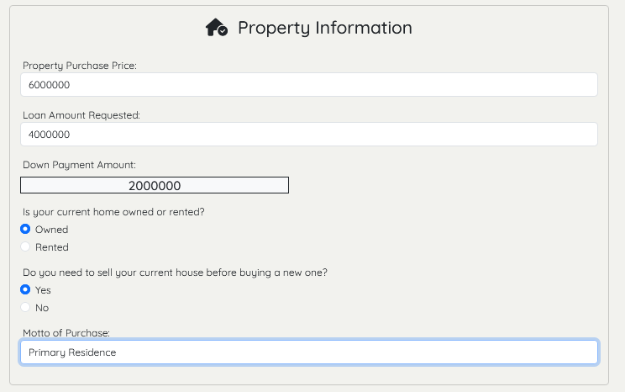

**Home Loan Application Successful Page**

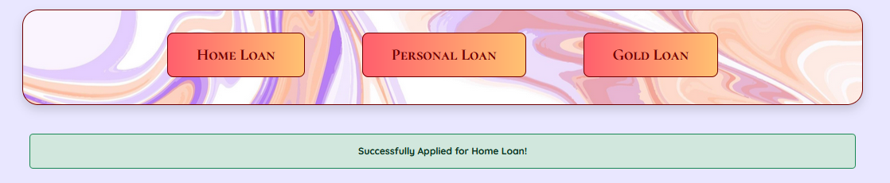

**Personal Loan Section**

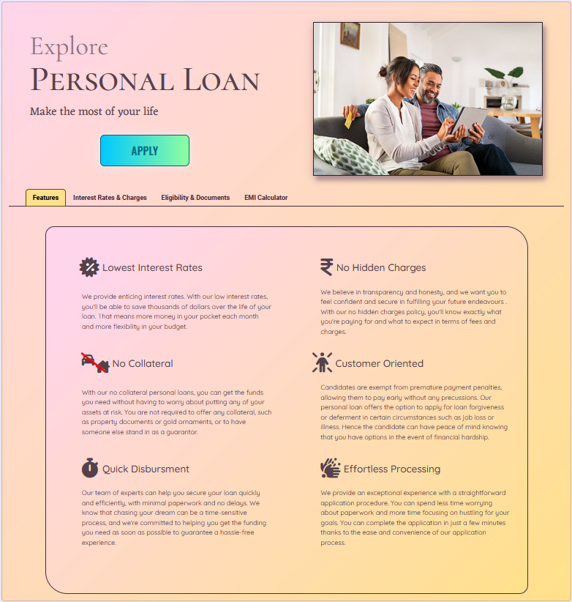

**Gold Loan Section**

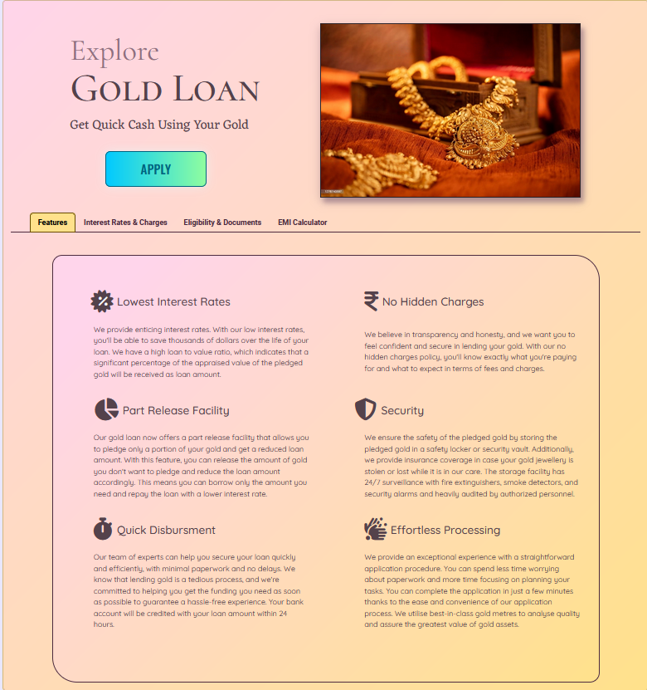

**Admin Dashboard Page**

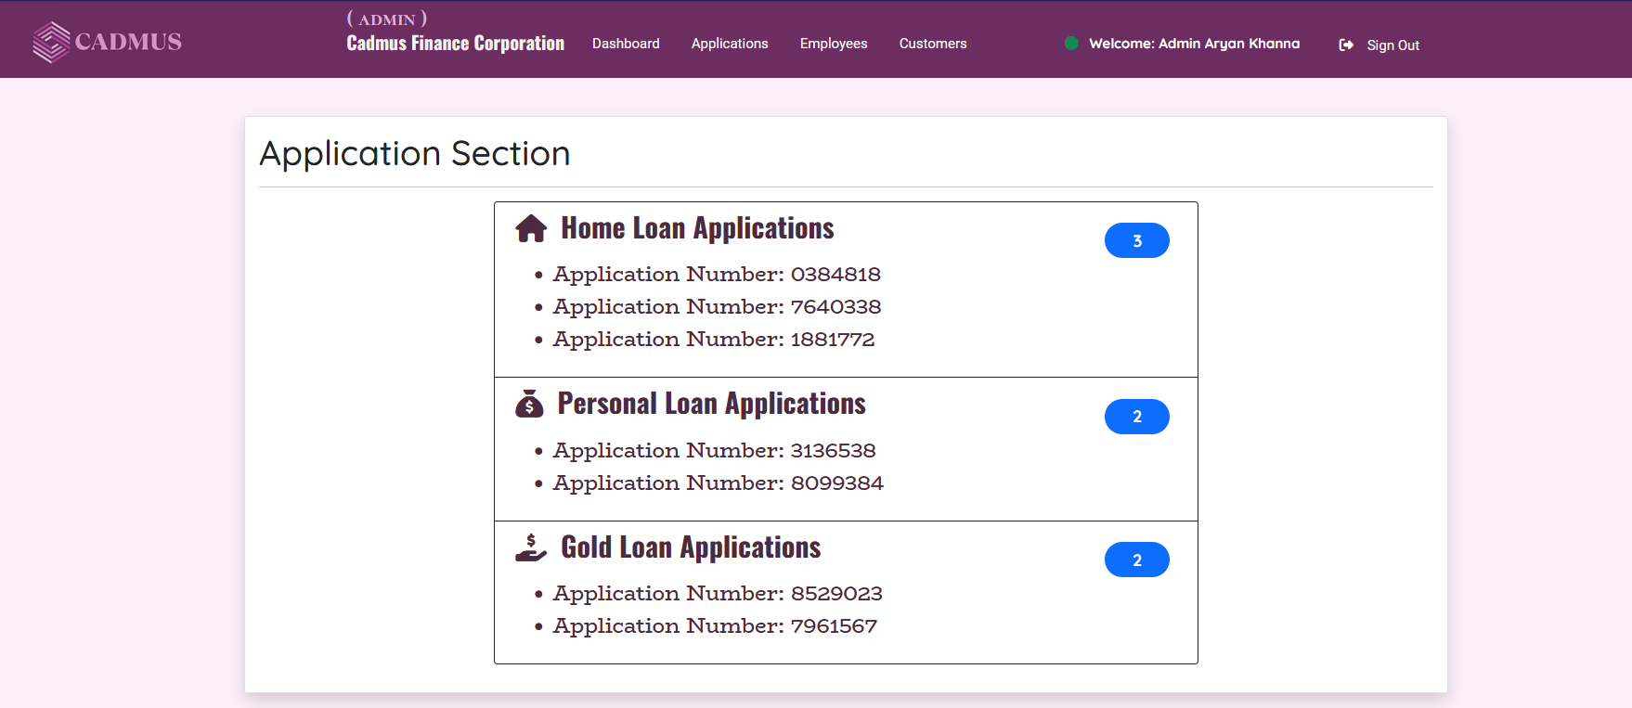

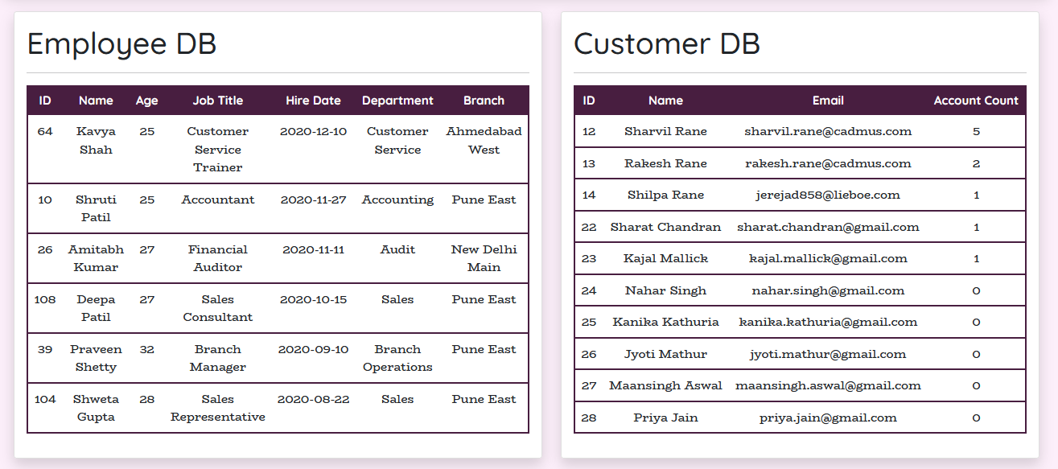

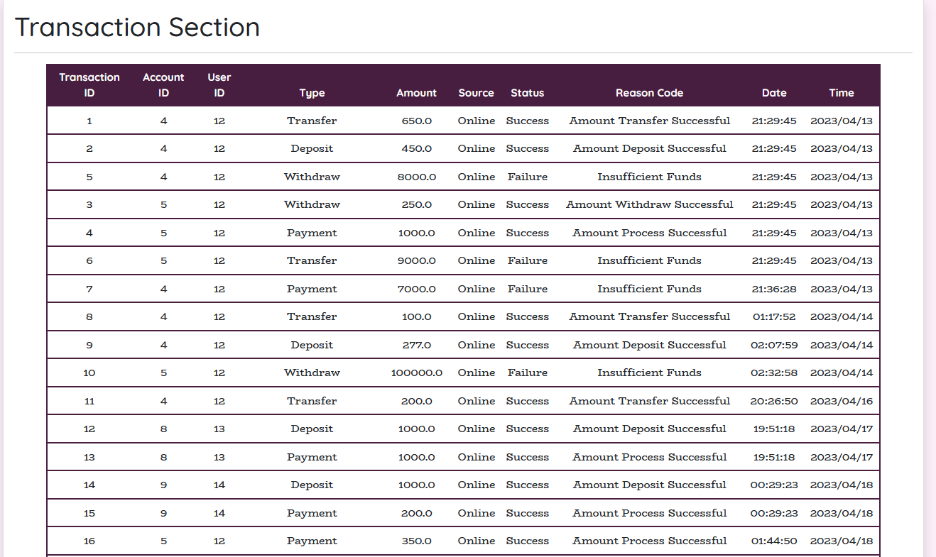

**Admin Dashboard Application Panel**

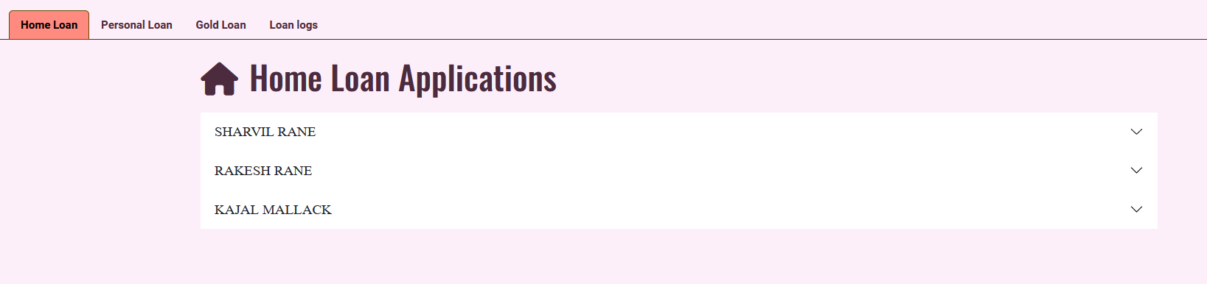

**Applied Home Loan Information**

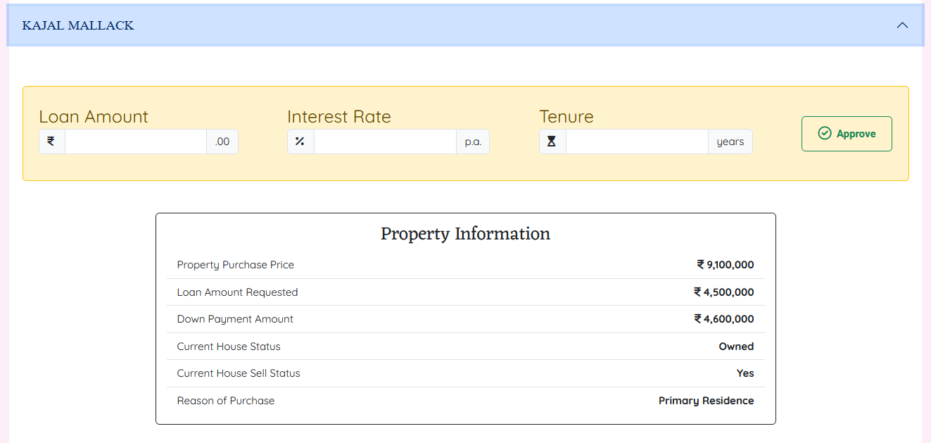

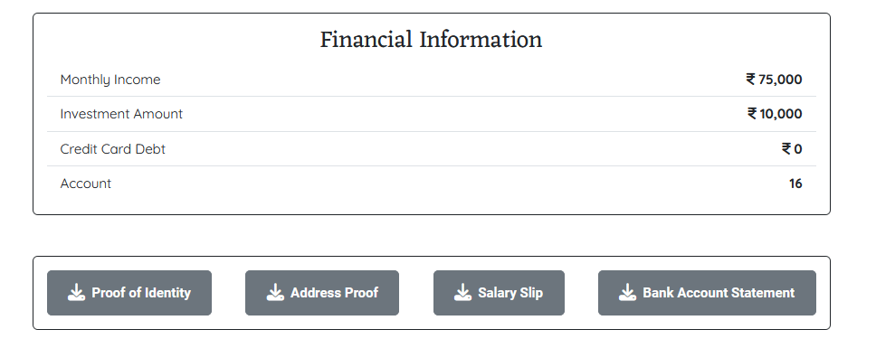

**Approve Loan Section**

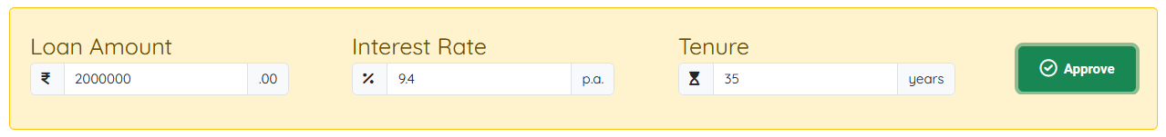

**Approval Email in Mail Application**



**Approval Email Content**

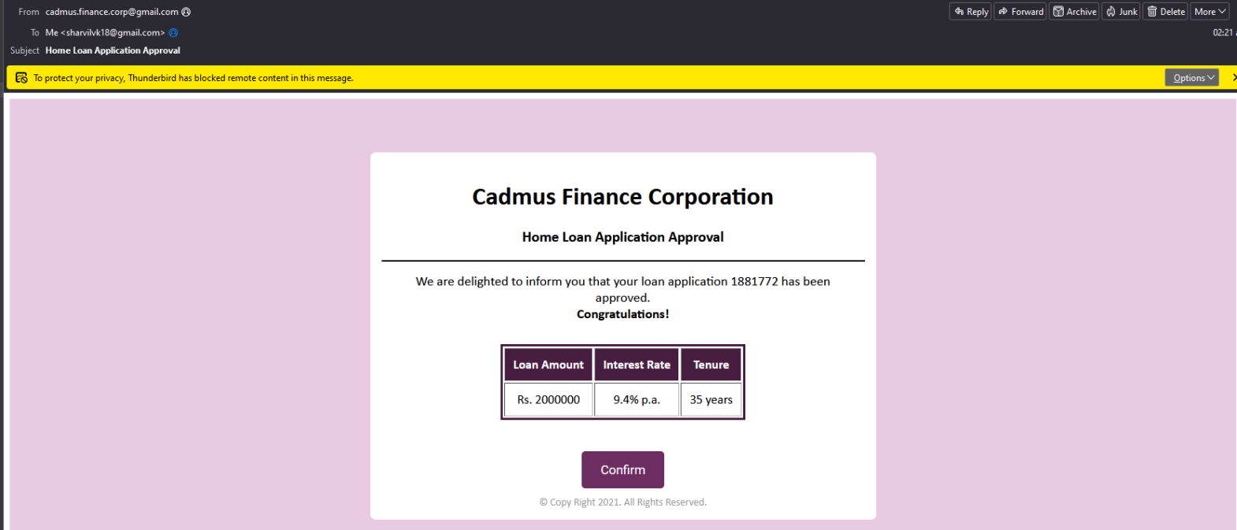

**Insufficient Amount in Account Email**

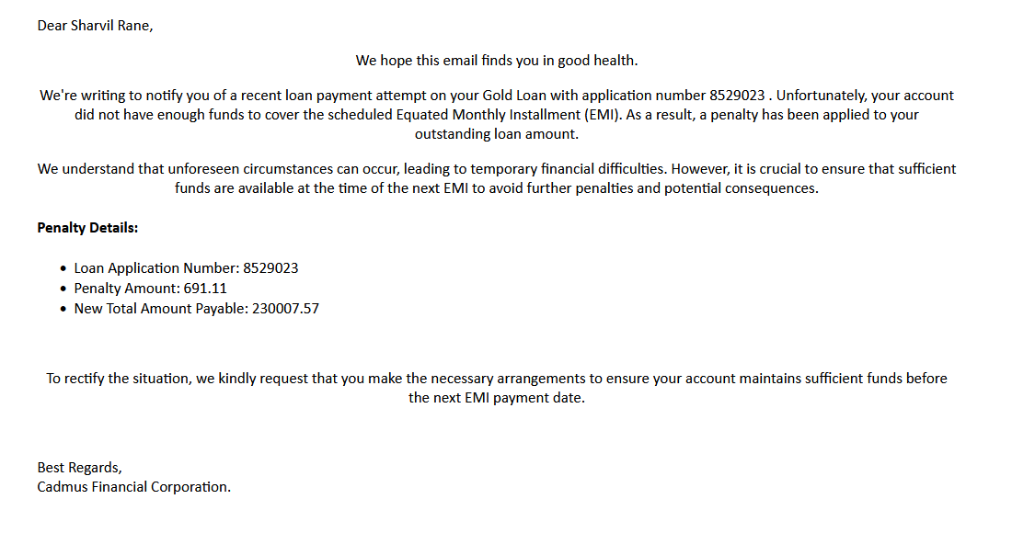

**Applied Home Loan after Approval**

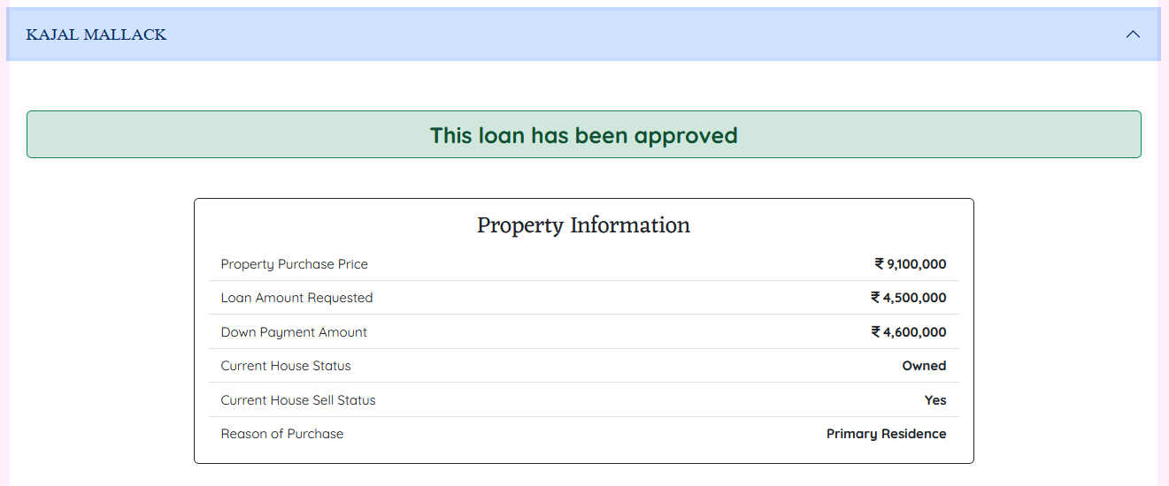

**Personal Loan Section**

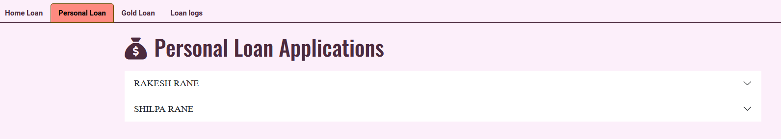

**Gold Loan Section**

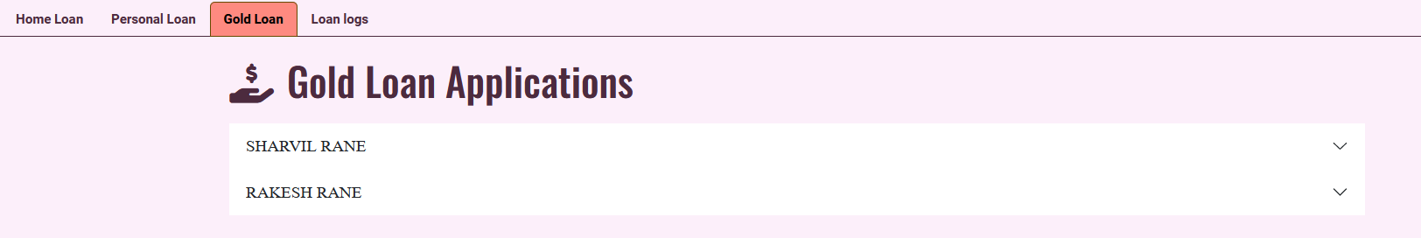

**Loan Log Section**

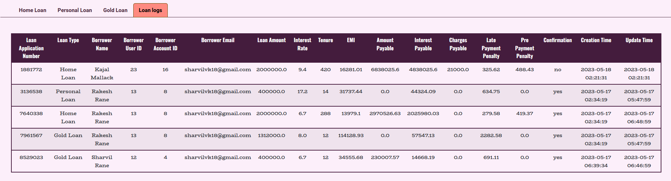

**Employee Panel**

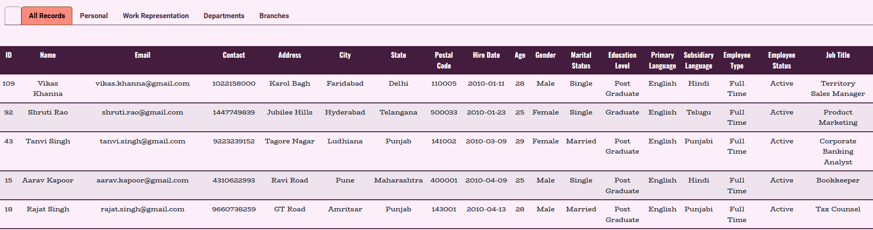

**Employee Personal Information Section**

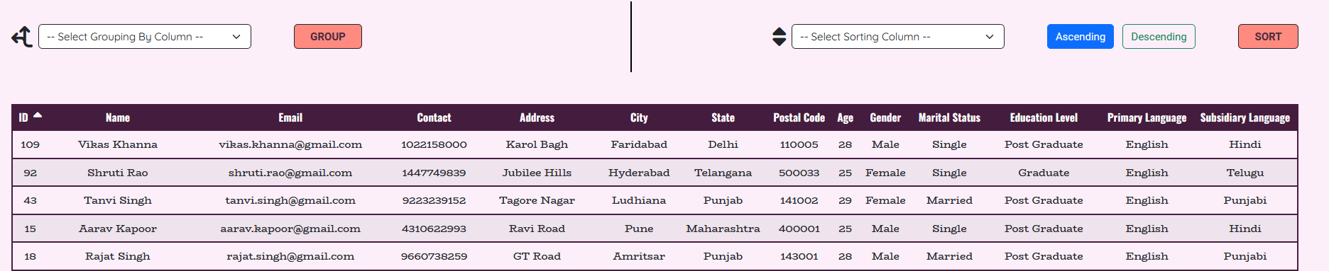

**Personal Information Group by City**

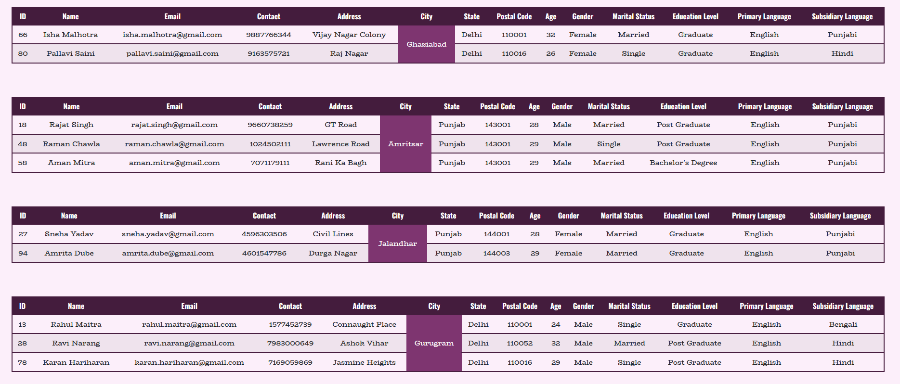

**Employee Work Representation with Searched Employee**

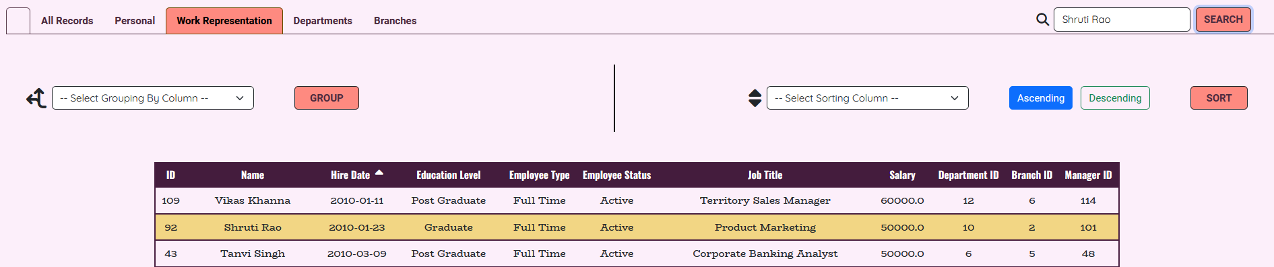

**Employee Department Section**

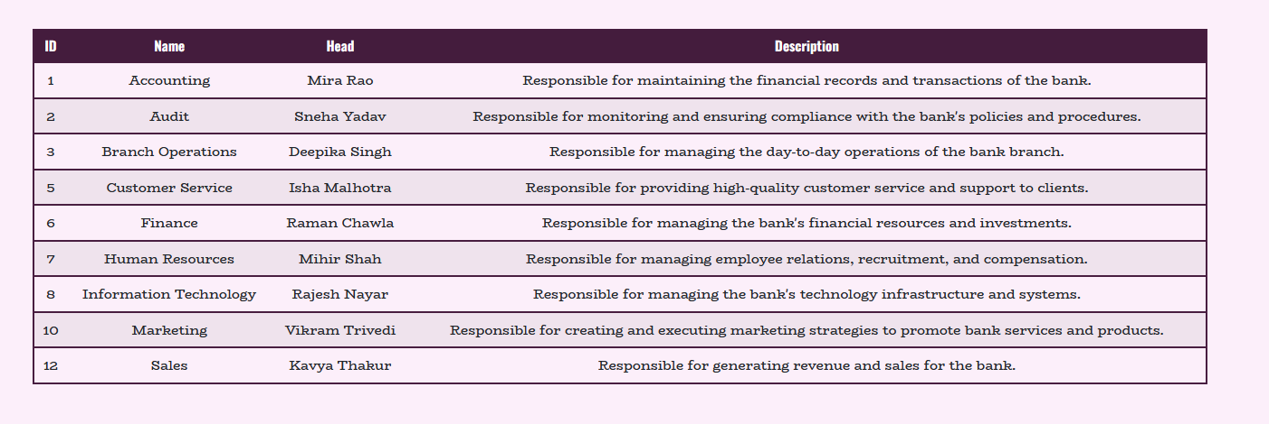

**Employee Branch Section**

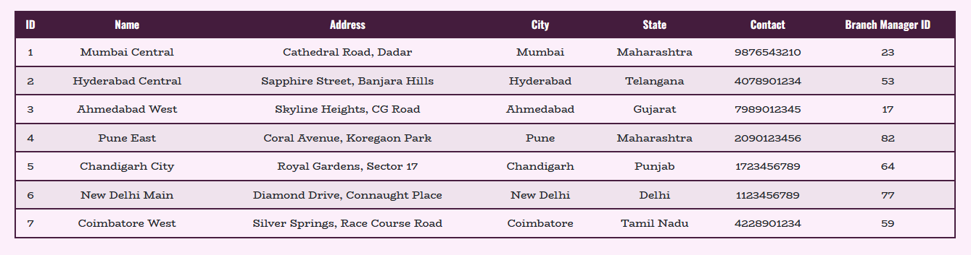

**Customer Panel Sort by Name Descending**

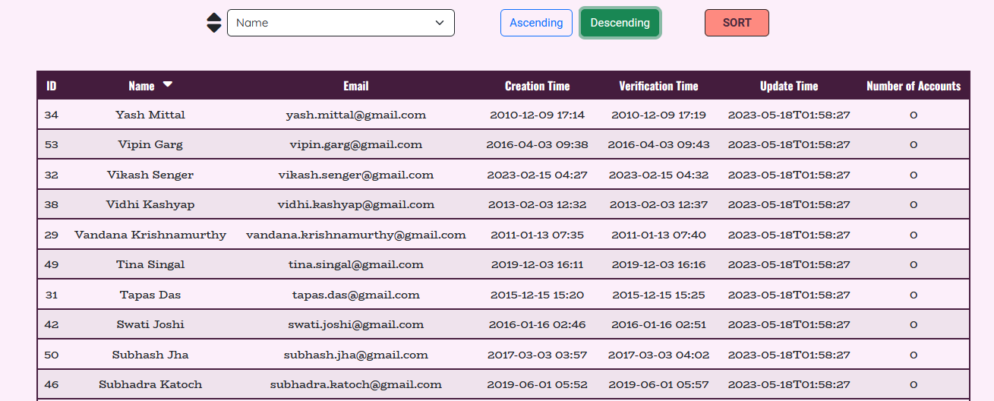

**Payments Section Group by Beneficiary Bank**

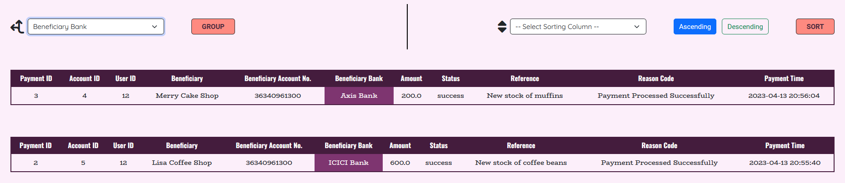

**Accounts Section with Searched Account Name**

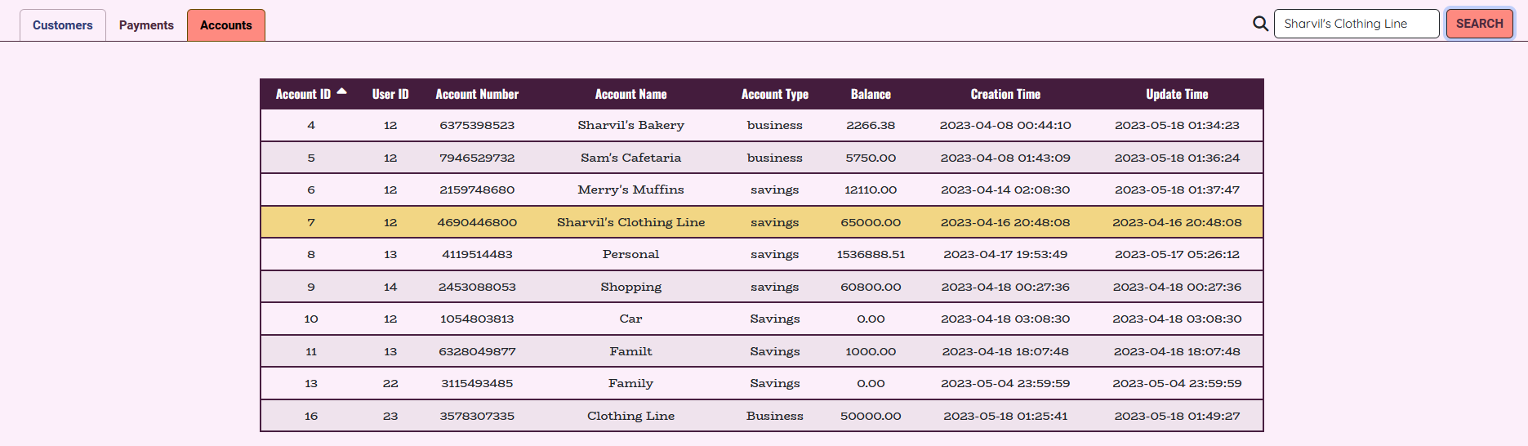

# 6.0 Coding

The coding section refers to the phase of software development where programmers write instructions or code to create computer programs or applications. Coding involves translating the logic and requirements of a software project into a programming language that a computer can understand and execute. The following section contains the code written to construct the Banking Management System.

**NOTE: Please visit the GitHub Repository for a well detailed and structured coding section:** <https://github.com/Sharvil18/Cadmus_Financial_Corporation.git>

## 6.1 Setup Files

**application.properties -**

spring.jpa.hibernate.ddl-auto=update

spring.datasource.url=jdbc:mysql://localhost:3306/bank

spring.datasource.username=root

spring.datasource.password=

spring.datasource.driver-class-name=com.mysql.jdbc.Driver

spring.servlet.multipart.max-file-size=100MB

spring.servlet.multipart.max-request-size=100MB

# Server Attributes / Config:

server.address=127.0.0.1

server.port=8070

# Disable Default Error Page:

server.error.whitelabel.enabled=false

**pom.xml -**

<?xml version="1.0" encoding="UTF-8"?>

<project xmlns="http://maven.apache.org/POM/4.0.0" xmlns:xsi="http://www.w3.org/2001/XMLSchema-instance"

xsi:schemaLocation="http://maven.apache.org/POM/4.0.0 https://maven.apache.org/xsd/maven-4.0.0.xsd">

<modelVersion>4.0.0</modelVersion>

<parent>

<groupId>org.springframework.boot</groupId>

<artifactId>spring-boot-starter-parent</artifactId>

<version>3.0.5</version>

<relativePath/> <!-- lookup parent from repository -->

</parent>

<groupId>com.bank</groupId>

<artifactId>demoBank</artifactId>

<version>0.0.1-SNAPSHOT</version>

<name>demoBank</name>

<description>Banking Management System</description>

<properties>

<java.version>17</java.version>

</properties>

<dependencies>

<dependency>

<groupId>org.springframework.boot</groupId>

<artifactId>spring-boot-starter-data-jpa</artifactId>

</dependency>

<dependency>

<groupId>org.springframework.boot</groupId>

<artifactId>spring-boot-starter-mail</artifactId>

</dependency>

<dependency>

<groupId>org.springframework.boot</groupId>

<artifactId>spring-boot-starter-web</artifactId>

</dependency>

<dependency>

<groupId>com.mysql</groupId>

<artifactId>mysql-connector-j</artifactId>

<scope>runtime</scope>

</dependency>

<dependency>

<groupId>org.springframework.boot</groupId>

<artifactId>spring-boot-starter-test</artifactId>

<scope>test</scope>

</dependency>

<dependency>

<groupId>org.springframework</groupId>

<artifactId>spring-jdbc</artifactId>

<version>5.3.2</version>

</dependency>

<dependency>

<groupId>org.springframework.boot</groupId>

<artifactId>spring-boot-starter-tomcat</artifactId>

<scope>provided</scope>

</dependency>

<dependency>

<groupId>org.apache.tomcat.embed</groupId>

<artifactId>tomcat-embed-jasper</artifactId>

<scope>provided</scope>

</dependency>

<dependency>

<groupId>org.springframework.boot</groupId>

<artifactId>spring-boot-starter-validation</artifactId>

<version>2.4.1</version>

</dependency>

<dependency>

<groupId>jakarta.servlet.jsp.jstl</groupId>

<artifactId>jakarta.servlet.jsp.jstl-api</artifactId>

<version>2.0.0</version>

</dependency>

<dependency>

<groupId>org.glassfish.web</groupId>

<artifactId>jakarta.servlet.jsp.jstl</artifactId>

<version>2.0.0</version>

</dependency>

<dependency>

<groupId>org.springframework.security</groupId>

<artifactId>spring-security-crypto</artifactId>

<version>5.4.2</version>

</dependency>

<dependency>

<groupId>com.github.librepdf</groupId>

<artifactId>openpdf</artifactId>

<version>1.3.8</version>

</dependency>

<dependency>

<groupId>org.springframework.boot</groupId>

<artifactId>spring-boot-devtools</artifactId>

<optional>true</optional>

</dependency>

</dependencies>

<build>

<plugins>

<plugin>

<groupId>org.springframework.boot</groupId>

<artifactId>spring-boot-maven-plugin</artifactId>

</plugin>

</plugins>

</build>

</project>

**database_script.sql -**

--GO TO my.ini CONFIGURATION FILE OF DATABASE AND MAKE THE FOLLOWING CHANGE:

--max_allowed_packet = 128*1024*1024

DROP DATABASE IF EXISTS bank;

CREATE DATABASE bank;

USE bank;

-- user table structure

CREATE TABLE users(

user_id INT NOT NULL AUTO_INCREMENT PRIMARY KEY,

first_name VARCHAR(50) NOT NULL,

last_name VARCHAR(50) NOT NULL,

email VARCHAR(200) NOT NULL UNIQUE,

password VARCHAR(200) NOT NULL,

token VARCHAR(200) NULL,

code INT NULL,

verified INT DEFAULT 0,

verified_at DATETIME,

created_at TIMESTAMP,

updated_at TIMESTAMP DEFAULT NOW()

);

-- bank accounts table structure

CREATE TABLE accounts(

account_id INT NOT NULL AUTO_INCREMENT PRIMARY KEY,

user_id INT,

account_number VARCHAR(100) NOT NULL,

account_name VARCHAR(50) NOT NULL,

account_type VARCHAR(50) NOT NULL,

balance DECIMAL(18, 2) DEFAULT 0.00,

created_at TIMESTAMP,

updated_at TIMESTAMP DEFAULT NOW(),

FOREIGN KEY(user_id) REFERENCES users(user_id) ON DELETE CASCADE

);

-- transaction history table

CREATE TABLE transaction_history(

transaction_id INT NOT NULL AUTO_INCREMENT PRIMARY KEY,

account_id INT,

transaction_type VARCHAR(50) NOT NULL,

amount DECIMAL(18, 2),

source VARCHAR(50) NULL,

status VARCHAR(50) NULL,

reason_code VARCHAR(100) NULL,

created_at TIMESTAMP,

FOREIGN KEY(account_id) REFERENCES accounts(account_id) ON DELETE CASCADE

);

-- payment table structure

CREATE TABLE payments(

payment_id INT NOT NULL AUTO_INCREMENT PRIMARY KEY,

account_id INT,

beneficiary VARCHAR(50) NULL,

beneficiary_acc_no VARCHAR(200) NULL,

amount DECIMAL(18, 2) NULL,

reference_no VARCHAR(100) NULL,

status VARCHAR(50) NULL,

reason_code VARCHAR(100) NULL,

created_at TIMESTAMP,

FOREIGN KEY(account_id) REFERENCES accounts(account_id) ON DELETE CASCADE

);

-- transaction history view

CREATE VIEW v_transaction_history

AS

SELECT t.transaction_id, a.account_id, u.user_id, t.transaction_type, t.amount, t.source, t.status, t.reason_code, t.created_at

FROM transaction_history AS t

INNER JOIN accounts AS a

ON t.account_id = a.account_id

INNER JOIN users as u

ON a.user_Id = u.user_id;

-- payment history view

CREATE VIEW v_payments

AS

SELECT p.payment_id, a.account_id, u.user_id, p.beneficiary, p.beneficiary_acc_no, p.amount, p.status, p.reference_no, p.reason_code, p.created_at

FROM payments AS p

INNER JOIN accounts as a

ON p.account_id = a.account_id

INNER JOIN users as u

ON u.user_id = a.user_id;

select * from v_transaction_history;

select * from v_payments;

-- ADMIN TABLE CREATION

-- department table

CREATE TABLE department (

department_id INT PRIMARY KEY,

department_name INT NOT NULL,

department_head VARCHAR(255) NOT NULL,

department_description VARCHAR(255));

--branch table

CREATE TABLE branch (

branch_id INT PRIMARY KEY,

name VARCHAR(255) NOT NULL,

address VARCHAR(255) NOT NULL,

city VARCHAR(255) NOT NULL,

state VARCHAR(255) NOT NULL,

contact VARCHAR(255) NOT NULL,

manager_id VARCHAR(255) NOT NULL);

--employee table

CREATE TABLE employee (

employee_id INT PRIMARY KEY,

first_name VARCHAR(100) NOT NULL,

last_name VARCHAR(100) NOT NULL,

email VARCHAR(100) NOT NULL,

contact VARCHAR(20) NOT NULL,

address VARCHAR(255) NOT NULL,

city VARCHAR(100) NOT NULL,

state VARCHAR(100) NOT NULL,

postal_code VARCHAR(20) NOT NULL,

hire_date DATE NOT NULL,

age INT NOT NULL,

gender VARCHAR(50) NOT NULL,

marital_status VARCHAR(100) NOT NULL,

education_level VARCHAR(100) NOT NULL,

primary_language VARCHAR(100) NOT NULL,

subsidiary_language VARCHAR(255) NOT NULL,

employee_type VARCHAR(100) NOT NULL,

employee_status VARCHAR(100) NOT NULL,

job_title VARCHAR(100) NOT NULL,

salary DECIMAL(10, 2) NOT NULL,

department_id INT NOT NULL,

branch_id INT NOT NULL

manager_id INT,

FOREIGN_KEY(manager_id) REFERENCES employee(employee_id),

FOREIGN_KEY(department_id) REFERENCES department(department_id),

FOREIGN_KEY(branch_id) REFERENCES branch(branch_id));

**admin_side_script.sql -**

CREATE TABLE employee (

employee_id INT NOT NULL PRIMARY KEY AUTO_INCREMENT,

first_name VARCHAR(100) NOT NULL,

last_name VARCHAR(100) NOT NULL,

email VARCHAR(100) NOT NULL,

contact VARCHAR(20) NOT NULL,

address VARCHAR(255) NOT NULL,

city VARCHAR(100) NOT NULL,

state VARCHAR(100) NOT NULL,

postal_code VARCHAR(20) NOT NULL,

hire_date DATE NOT NULL,

age INT NOT NULL,

gender VARCHAR(50) NOT NULL,

marital_status VARCHAR(100) NOT NULL,

education_level VARCHAR(100) NOT NULL,

primary_language VARCHAR(100) NOT NULL,

subsidiary_language VARCHAR(255) NOT NULL,

employee_type VARCHAR(100) NOT NULL,

employee_status VARCHAR(100) NOT NULL,

job_title VARCHAR(100) NOT NULL,

salary DECIMAL(10, 2) NOT NULL,

department_id INT NOT NULL,

branch_id INT NOT NULL,

manager_id INT,

FOREIGN KEY(manager_id) REFERENCES department(manager_id),

FOREIGN KEY(department_id) REFERENCES department(department_id) ON DELETE CASCADE,

FOREIGN KEY(branch_id) REFERENCES branch(branch_id) ON DELETE CASCADE);

CREATE TABLE department (

department_id INT NOT NULL PRIMARY KEY AUTO_INCREMENT,

department_name VARCHAR(255) NOT NULL,

department_head VARCHAR(255) NOT NULL,

department_description VARCHAR(255));

CREATE TABLE branch (

branch_id INT NOT NULL PRIMARY KEY AUTO_INCREMENT,

name VARCHAR(255) NOT NULL,

address VARCHAR(255) NOT NULL,

city VARCHAR(255) NOT NULL,

state VARCHAR(255) NOT NULL,

contact VARCHAR(255) NOT NULL,

manager_id INT NOT NULL,

FOREIGN KEY(manager_id) REFERENCES employee(employee_id));

INSERT INTO department (department_name, department_head, department_description) VALUES

('Accounting', 'Deepak Kumar', 'Responsible for maintaining the financial records and transactions of the bank.'),

('Audit', 'Rajat Sharma', 'Responsible for monitoring and ensuring compliance with the bank\'s policies and procedures.'),

('Branch Operations', 'Neeraj Verma', 'Responsible for managing the day-to-day operations of the bank branch.'),

('Customer Service', 'Priya Sharma', 'Responsible for providing high-quality customer service and support to clients.'),

('Finance', 'Amit Patel', 'Responsible for managing the bank\'s financial resources and investments.'),

('Human Resources', 'Sonia Gupta', 'Responsible for managing employee relations, recruitment, and compensation.'),

('Information Technology', 'Vikram Singh', 'Responsible for managing the bank\'s technology infrastructure and systems.'),

('Marketing', 'Amita Singh', 'Responsible for creating and executing marketing strategies to promote bank services and products.'),

('Sales', 'Sudhir Gupta', 'Responsible for generating revenue and sales for the bank.');

INSERT INTO branch (name, address, city, state, contact, manager_id) VALUES

('Mumbai Central', 'Cathedral Road, Dadar', 'Mumbai', 'Maharashtra', '9876543210', 23),

('Hyderabad Central', 'Sapphire Street, Banjara Hills', 'Hyderabad', 'Telangana', '4078901234', 53),

('Ahmedabad West', 'Skyline Heights, CG Road', 'Ahmedabad', 'Gujarat', '7989012345', 17),

('Pune East', 'Coral Avenue, Koregaon Park', 'Pune', 'Maharashtra', '2090123456', 82),

('Chandigarh City', 'Royal Gardens, Sector 17', 'Chandigarh', 'Punjab', '1723456789', 64),

('New Delhi Main', 'Diamond Drive, Connaught Place', 'New Delhi', 'Delhi', '1123456789', 77),

('Coimbatore West', 'Silver Springs, Race Course Road', 'Coimbatore', 'Tamil Nadu', '4228901234', 59);

-- insert employees for accountant department

INSERT INTO employee (first_name, last_name, email, contact, address, city, state, postal_code, hire_date, age, gender, marital_status, education_level, primary_language, subsidiary_language, employee_type, employee_status, job_title, salary, department_id, branch_id) VALUES

('Akash', 'Gupta', 'akash.gupta@gmail.com', '9876543210', '10, MG Road', 'Bangalore', 'Karnataka', '560001', '2022-05-01', 27, 'Male', 'Married', 'Post Graduate', 'Hindi', 'English', 'Full Time', 'Active', 'Financial Analyst', 75000, 1, 8),

('Amit', 'Shah', 'amit.shah@gmail.com', '9876543211', '11, Nehru Road', 'Mumbai', 'Maharashtra', '400001', '2022-05-01', 29, 'Male', 'Married', 'Post Graduate', 'Hindi', 'English', 'Full Time', 'Active', 'Accountant', 45000, 1, 1),

('Shruti', 'Patil', 'shruti.patil@gmail.com', '9876543212', '12, Karve Road', 'Pune', 'Maharashtra', '411001', '2022-05-01', 25, 'Female', 'Single', 'Graduate', 'Marathi', 'English', 'Full Time', 'Active', 'Accountant', 40000, 1, 1),

-- insert employees for operation department

INSERT INTO employee (first_name, last_name, email, contact, address, city, state, postal_code, hire_date, age, gender, marital_status, education_level, primary_language, subsidiary_language, employee_type, employee_status, job_title, salary, department_id, branch_id) VALUES

('Ravi', 'Narang', 'ravi.narang@gmail.com', '9876543224', '24, Ashok Vihar', 'Delhi', 'Delhi', '110052', '2022-05-03', 32, 'Male', 'Married', 'Post Graduate', 'Hindi', 'English', 'Full Time', 'Active', 'Teller', 40000, 3, 1),

('Sneha', 'Mehta', 'sneha.mehta@gmail.com', '9876543225', '25, Kandivali', 'Mumbai', 'Maharashtra', '400101', '2022-05-03', 29, 'Female', 'Single', 'Post Graduate', 'Marathi', 'English', 'Full Time', 'Active', 'Teller', 40000, 3, 1),

('Aditya', 'Joshi', 'aditya.joshi@gmail.com', '9876543226', '26, Maninagar', 'Ahmedabad', 'Gujarat', '380008', '2022-05-03', 27, 'Male', 'Single', 'Graduate', 'Gujarati', 'English', 'Full Time', 'Active', 'Teller', 40000, 3, 3),

-- insert employees for finance department

INSERT INTO employee (first_name, last_name, email, contact, address, city, state, postal_code, hire_date, age, gender, marital_status, education_level, primary_language, subsidiary_language, employee_type, employee_status, job_title, salary, department_id, branch_id) VALUES

('Pallavi', 'Ahuja', 'pallavi.ahuja@gmail.com', '9876543201', '1, Green Park', 'Delhi', 'Delhi', '110016', '2022-05-02', 26, 'Female', 'Single', 'Graduate', 'Hindi', 'English', 'Part Time', 'Active', 'Investment Banking Analyst', 70000, 6, 11),

('Rajat', 'Verma', 'rajat.verma@gmail.com', '9876543202', '2, Shankar Nagar', 'Nagpur', 'Maharashtra', '440010', '2022-05-02', 30, 'Male', 'Married', 'Post Graduate', 'Marathi', 'English', 'Full Time', 'Active', 'Investment Banking Associate', 85000, 6, 10),

('Arjun', 'Kapoor', 'arjun.kapoor@gmail.com', '9876543203', '3, Ellis Road', 'Chennai', 'Tamil Nadu', '600002', '2022-05-02', 28, 'Male', 'Single', 'Post Graduate', 'Tamil', 'English', 'Full Time', 'Active', 'Asset Management', 75000, 6, 12),

## 6.2 Configuration Files

**AppConfig.java -**

package com.bank.config;

import com.bank.interceptors.AppInterceptor;

import org.springframework.context.annotation.Bean;

import org.springframework.context.annotation.ComponentScan;

import org.springframework.context.annotation.Configuration;

import org.springframework.web.servlet.config.annotation.InterceptorRegistry;

import org.springframework.web.servlet.config.annotation.ResourceHandlerRegistry;

import org.springframework.web.servlet.config.annotation.WebMvcConfigurationSupport;

import org.springframework.web.servlet.view.InternalResourceViewResolver;

import org.springframework.web.servlet.view.JstlView;

@Configuration

@ComponentScan(basePackages = {"com.bank"})

public class AppConfig extends WebMvcConfigurationSupport {

@Override

protected void addResourceHandlers(ResourceHandlerRegistry registry) {

registry.addResourceHandler("css/**","images/**", "js/**",

"/app/css/**" , "/app/images/**", "/app/js/**",

"/app/dashboard/css/**" , "/app/dashboard/images/**", "/app/dashboard/js/**",

"/account/css/**" , "/account/images/**", "/account/js/**",

"/login/css/**" , "/login/images/**", "/login/js/**",

"/transact/css/**" , "/transact/images/**", "/transact/js/**",

"/apply/css/**" , "/apply/images/**", "/apply/js/**",

"/app/admin/css/**" , "/app/admin/images/**", "/app/admin/js/**"

)

.addResourceLocations("classpath:/static/css/", "classpath:/static/images/", "classpath:/static/js/");

}

// End Of Resource Handler.

@Bean

public InternalResourceViewResolver viewResolver(){

InternalResourceViewResolver jspViewResolver = new InternalResourceViewResolver();

jspViewResolver.setPrefix("/WEB-INF/jsp/");

jspViewResolver.setSuffix(".jsp");

jspViewResolver.setViewClass(JstlView.class);

return jspViewResolver;

}

@Override

protected void addInterceptors(InterceptorRegistry registry) {

registry.addInterceptor(new AppInterceptor()).addPathPatterns("/app/*");

}

}

**MailConfig.java -**

package com.bank.config;

import jakarta.mail.Authenticator;

import jakarta.mail.Session;

import org.springframework.context.annotation.Bean;

import org.springframework.mail.javamail.JavaMailSenderImpl;

import java.util.Properties;

public class MailConfig {

@Bean

public static JavaMailSenderImpl getMailConfig() {

JavaMailSenderImpl emailConfig = new JavaMailSenderImpl();

Properties props = emailConfig.getJavaMailProperties();

props.setProperty("mail.smtp.host", "smtp.gmail.com");

props.setProperty("mail.smtp.port", "465");

props.setProperty("mail.smtp.auth", "true");

props.setProperty("mail.smtp.ssl.enable", "true");

emailConfig.setUsername("cadmus.finance.corp@gmail.com");

emailConfig.setPassword("cghm ssum irce npjf");

return emailConfig;

}

}

## 6.3 Miscellaneous Files

**AdvisorController.java -**

package com.bank.controller_advisor;

import com.bank.models.Admin;

import com.bank.models.User;

import org.springframework.web.bind.annotation.ControllerAdvice;

import org.springframework.web.bind.annotation.ModelAttribute;

@ControllerAdvice

public class AdvisorController {

@ModelAttribute("registerUser")

public User getUserDefaults() {

return new User();

}

}

**MailMessenger.java -**

package com.bank.mailMessenger;

import com.bank.config.MailConfig;

import com.oracle.wls.shaded.org.apache.bcel.generic.NEW;

import jakarta.mail.MessagingException;

import jakarta.mail.internet.MimeMessage;

import org.springframework.core.io.ByteArrayResource;

import org.springframework.core.io.InputStreamResource;

import org.springframework.mail.javamail.JavaMailSender;

import org.springframework.mail.javamail.MimeMessageHelper;

import org.xml.sax.InputSource;

import java.io.ByteArrayInputStream;

public class MailMessenger {

public static void htmlEmailMessenger(String from, String toMail, String subject, String body, byte[] pdfBytes) {

//Get email config:

JavaMailSender sender = MailConfig.getMailConfig();

//Set mime message

MimeMessage message = sender.createMimeMessage();

try {

//Set mime message helper

MimeMessageHelper htmlMessage = new MimeMessageHelper(message, true);

//Set mail attributes/properties

htmlMessage.setTo(toMail);

htmlMessage.setFrom(from);

htmlMessage.setSubject(subject);

htmlMessage.setText(body, true);

if(pdfBytes!= null)

htmlMessage.addAttachment("details.pdf", new ByteArrayResource(pdfBytes));

} catch (MessagingException e) {

throw new RuntimeException(e);

}

//Send message

sender.send(message);

}

}

**DemoBankApplication.java -**

package com.bank;

import org.springframework.boot.SpringApplication;

import org.springframework.boot.autoconfigure.SpringBootApplication;

import org.springframework.scheduling.annotation.EnableScheduling;

import org.springframework.security.crypto.bcrypt.BCrypt;

import java.util.ArrayList;

import java.util.List;

@SpringBootApplication

@EnableScheduling

public class DemoBankApplication {

public static void main(String[] args) {

SpringApplication.run(DemoBankApplication.class, args);

}

}

## 6.4 Models

**Account.java -**

@Entity

@Table(name = "accounts")

public class Account {

@Id

private int account_id;

private int user_id;

private String account_number;

private String account_name;

private String account_type;

private BigDecimal balance;

private LocalDateTime created_at;

private LocalDateTime updated_at;

public int getAccount_id() {

return account_id;

}

public void setAccount_id(int account_id) {

this.account_id = account_id;

}

public int getUser_id() {

return user_id;

}

public void setUser_id(int user_id) {

this.user_id = user_id;

}

public String getAccount_number() {

return account_number;

}

public void setAccount_number(String account_number) {

this.account_number = account_number;

}

public String getAccount_name() {

return account_name;

}

public void setAccount_name(String account_name) {

this.account_name = account_name;

}

public String getAccount_type() {

return account_type;

}

public void setAccount_type(String account_type) {

this.account_type = account_type;

}

public BigDecimal getBalance() {

return balance;

}

public void setBalance(BigDecimal balance) {

this.balance = balance;

}

public LocalDateTime getCreated_at() {

return created_at;

}

public void setCreated_at(LocalDateTime created_at) {

this.created_at = created_at;

}

public LocalDateTime getUpdated_at() {

return updated_at;

}

public void setUpdated_at(LocalDateTime updated_at) {

this.updated_at = updated_at;

}

}

**Admin.java -**

@Entity

public class Admin {

@Id

private String admin_id;

private String admin_email;

private String admin_first_name;

private String admin_last_name;

private String admin_password;

private LocalDateTime admin_last_login;

public String getAdmin_id() {

return admin_id;

}

public void setAdmin_id(String admin_id) {

this.admin_id = admin_id;

}

public String getAdmin_email() {

return admin_email;

}

public void setAdmin_email(String admin_email) {

this.admin_email = admin_email;

}

public String getAdmin_first_name() {

return admin_first_name;

}

public void setAdmin_first_name(String admin_first_name) {

this.admin_first_name = admin_first_name;

}

public String getAdmin_last_name() {

return admin_last_name;

}

public void setAdmin_last_name(String admin_last_name) {

this.admin_last_name = admin_last_name;

}

public String getAdmin_password() {

return admin_password;

}

public void setAdmin_password(String admin_password) {

this.admin_password = admin_password;

}

public LocalDateTime getAdmin_last_login() {

return admin_last_login;

}

public void setAdmin_last_login(LocalDateTime admin_last_login) {

this.admin_last_login = admin_last_login;

}

}

**Branch.java -**

public class Branch {

@Id

private int branch_id;

private String name;

private String address;

private String city;

private String state;

private String contact;

private int manager_id;

public int getBranch_id() {

return branch_id;

}

public void setBranch_id(int branch_id) {

this.branch_id = branch_id;

}

public String getName() {

return name;

}

public void setName(String name) {

this.name = name;

}

public String getAddress() {

return address;

}

public void setAddress(String address) {

this.address = address;

}

public String getCity() {

return city;

}

public void setCity(String city) {

this.city = city;

}

public String getState() {

return state;

}

public void setState(String state) {

this.state = state;

}

public String getContact() {

return contact;

}

public void setContact(String contact) {

this.contact = contact;

}

public int getManager_id() {

return manager_id;

}

public void setManager_id(int manager_id) {

this.manager_id = manager_id;

}

}

**Customer.java -**

@Entity

@Table(name = "v_customer")

public class Customer {

@Id

private int user_id;

private String name;

private String email;

private LocalDateTime created_at;

private LocalDateTime updated_at;

private LocalDateTime verified_at;

private int account_count;

public int getUser_id() {

return user_id;

}

public void setUser_id(int user_id) {

this.user_id = user_id;

}

public String getName() {

return name;

}

public void setName(String name) {

this.name = name;

}

public String getEmail() {

return email;

}

public void setEmail(String email) {

this.email = email;

}

public LocalDateTime getCreated_at() {

return created_at;

}

public void setCreated_at(LocalDateTime created_at) {

this.created_at = created_at;

}

public LocalDateTime getUpdated_at() {

return updated_at;

}

public void setUpdated_at(LocalDateTime updated_at) {

this.updated_at = updated_at;

}

public LocalDateTime getVerified_at() {

return verified_at;

}

public void setVerified_at(LocalDateTime verified_at) {

this.verified_at = verified_at;

}

public int getAccount_count() {

return account_count;

}

public void setAccount_count(int account_count) {

this.account_count = account_count;

}

}

**Department.java -**

@Entity

public class Department {

@Id

private int department_id;

private String department_name;

private String department_head;

private String department_description;

private int department_head_id;

public int getDepartment_id() {

return department_id;

}

public void setDepartment_id(int department_id) {

this.department_id = department_id;

}

public String getDepartment_name() {

return department_name;

}

public void setDepartment_name(String department_name) {

this.department_name = department_name;

}

public String getDepartment_head() {

return department_head;

}

public void setDepartment_head(String department_head) {

this.department_head = department_head;

}

public String getDepartment_description() {

return department_description;

}

public void setDepartment_description(String department_description) {

this.department_description = department_description;

}

public int getDepartment_head_id() {

return department_head_id;

}

public void setDepartment_head_id(int department_head_id) {

this.department_head_id = department_head_id;

}

}

**Employee.java -**

@Entity

public class Employee {

@Id

private int employee_id;

private String first_name;

private String last_name;

private String email;

private String contact;

private String address;

private String city;

private String state;

private String postal_code;

private LocalDate hire_date;

private int age;

private String gender;

private String marital_status;

private String education_level;

private String primary_language;

private String subsidiary_language;

private String employee_type;

private String employee_status;

private String job_title;

private double salary;

private int department_id;

private int branch_id;

private Integer manager_id;

public int getEmployee_id() {

return employee_id;

}

public void setEmployee_id(int employee_id) {

this.employee_id = employee_id;

}

public String getFirst_name() {

return first_name;

}

public void setFirst_name(String first_name) {

this.first_name = first_name;

}

public String getLast_name() {

return last_name;

}

public void setLast_name(String last_name) {

this.last_name = last_name;

}

public String getEmail() {

return email;

}

public void setEmail(String email) {

this.email = email;

}

public String getContact() {

return contact;

}

public void setContact(String contact) {

this.contact = contact;

}

public String getAddress() {

return address;

}

public void setAddress(String address) {

this.address = address;

}

public String getCity() {

return city;

}

public void setCity(String city) {

this.city = city;

}

public String getState() {

return state;

}

}

**EmployeeView.java -**

@Entity

@Table(name = "v_employee")

public class EmployeeView {

@Id

private int employee_id;

private String Name;

private int age;

private String job_title;

private LocalDate hire_date;

private String department_name;

private String branch_name;

public int getEmployee_id() {

return employee_id;

}

public void setEmployee_id(int employee_id) {

this.employee_id = employee_id;

}

public String getName() {

return Name;

}

public void setName(String name) {

Name = name;

}

public int getAge() {

return age;

}

public void setAge(int age) {

this.age = age;

}

public String getJob_title() {

return job_title;

}

public LocalDate getHire_date() {

return hire_date;

}

public void setHire_date(LocalDate hire_date) {

this.hire_date = hire_date;

}

public void setJob_title(String job_title) {

this.job_title = job_title;

}

public String getDepartment_name() {

return department_name;

}

public void setDepartment_name(String department_name) {

this.department_name = department_name;

}

public String getBranch_name() {

return branch_name;

}

public void setBranch_name(String branch_name) {

this.branch_name = branch_name;

}

}

**LoanLog.java -**

@Entity

@Table(name = "loan_log")

public class LoanLog {

@Id

private String loan_application_number;

private String loan_type;

private String borrower_name;

private int borrower_user_id;

private String borrower_email;

private double final_loan_amount;

private double final_interest_rate;

private int final_tenure;

private double final_emi;

private double total_amount_payable;

private double total_interest_payable;

private double charges_payable;

private double late_payment_penalty;

private double pre_payment_penalty;

private LocalDateTime created_at;

private LocalDateTime updated_at;

private int borrower_account_id;

private double total_penalty_payable;

private String is_confirmed;

public String getLoan_application_number() {

return loan_application_number;

}

public void setLoan_application_number(String loan_application_number) {

this.loan_application_number = loan_application_number;

}

public String getLoan_type() {

return loan_type;

}

public void setLoan_type(String loan_type) {

this.loan_type = loan_type;

}

public String getBorrower_name() {

return borrower_name;

}

public void setBorrower_name(String borrower_name) {

this.borrower_name = borrower_name;

}

public int getBorrower_user_id() {

return borrower_user_id;

}

public void setBorrower_user_id(int borrower_user_id) {

this.borrower_user_id = borrower_user_id;

}

public String getBorrower_email() {

return borrower_email;

}

public void setBorrower_email(String borrower_email) {

this.borrower_email = borrower_email;

}

public double getFinal_loan_amount() {

return final_loan_amount;

}

public void setFinal_loan_amount(double final_loan_amount) {

this.final_loan_amount = final_loan_amount;

}

}

**Payment.java -**

@Entity

@Table(name = "payments")

public class Payment {

@Id

private int payment_id;

private int account_id;

private String beneficiary;

private String beneficiary_acc_no;

private String beneficiary_bank;

private double amount;

private String reference_no;

private String status;

private String reason_code;

private LocalDateTime created_at;

public int getPayment_id() {

return payment_id;

}

public void setPayment_id(int payment_id) {

this.payment_id = payment_id;

}

public int getAccount_id() {

return account_id;

}

public void setAccount_id(int account_id) {

this.account_id = account_id;

}

public String getBeneficiary() {

return beneficiary;

}

public void setBeneficiary(String beneficiary) {

this.beneficiary = beneficiary;

}

public String getBeneficiary_acc_no() {

return beneficiary_acc_no;

public void setBeneficiary_acc_no(String beneficiary_acc_no) {

this.beneficiary_acc_no = beneficiary_acc_no;

}

}

**PaymentHistory.java -**

@Entity

@Table(name = "v_payments")

public class PaymentHistory {

@Id

private int payment_id;

private int account_id;

private int user_id;

private String beneficiary;

private String beneficiary_acc_no;

private String beneficiary_bank;

private double amount;

private String status;

private String reference_no;

private String reason_code;

private LocalDateTime created_at;

public int getPayment_id() {

return payment_id;

}

public void setPayment_id(int payment_id) {

this.payment_id = payment_id;

}

public int getAccount_id() {

return account_id;

}

public void setAccount_id(int account_id) {

this.account_id = account_id;

}

public int getUser_id() {

return user_id;

}

public void setUser_id(int user_id) {

this.user_id = user_id;

}

public String getBeneficiary() {

return beneficiary;

}

public void setBeneficiary(String beneficiary) {

this.beneficiary = beneficiary;

}

public String getBeneficiary_acc_no() {

return beneficiary_acc_no;

}

public void setBeneficiary_acc_no(String beneficiary_acc_no) {

this.beneficiary_acc_no = beneficiary_acc_no;

}

}

**Transact.java -**

@Entity

@Table(name = "transaction_history")

public class Transact {

@Id

private int transaction_id;

private int account_id;

private String transaction_type;

private double amount;

private String source;

private String status;

private String reason_code;

private String created_at;

public int getTransaction_id() {

return transaction_id;

}

public void setTransaction_id(int transaction_id) {

this.transaction_id = transaction_id;

}

public int getAccount_id() {

return account_id;

}

public void setAccount_id(int account_id) {

this.account_id = account_id;

}

public String getTransaction_type() {

return transaction_type;

}

public void setTransaction_type(String transaction_type) {

this.transaction_type = transaction_type;

}

public double getAmount() {

return amount;

}

public void setAmount(double amount) {

this.amount = amount;

}

public String getSource() {

return source;

}

public void setSource(String source) {

this.source = source;

}

public String getStatus() {

return status;

}

public void setStatus(String status) {

this.status = status;

}

public String getReason_code() {

return reason_code;

}

public void setReason_code(String reason_code) {

this.reason_code = reason_code;

}

public String getCreated_at() {

return created_at;

}

public void setCreated_at(String created_at) {

this.created_at = created_at;

}

}

**TransactionHistory.java -**

@Entity

@Table(name = "v_transaction_history")

public class TransactionHistory {

@Id

private int transaction_id;

private int account_id;

private int user_id;

private String transaction_type;

private double amount;

private String source;

private String status;

private String reason_code;

private LocalDateTime created_at;

public int getTransaction_id() {

return transaction_id;

}

public void setTransaction_id(int transaction_id) {

this.transaction_id = transaction_id;

}

public int getAccount_id() {

return account_id;

}

public void setAccount_id(int account_id) {

this.account_id = account_id;

}

public int getUser_id() {

return user_id;

}

public void setUser_id(int user_id) {

this.user_id = user_id;

}

public String getTransaction_type() {

return transaction_type;

}

public void setTransaction_type(String transaction_type) {

this.transaction_type = transaction_type;

}

public double getAmount() {

return amount;

}

public void setAmount(double amount) {

this.amount = amount;

}

}

**User.java -**

@Entity

@Table(name = "users")

public class User {

@Id

private int user_id;

@NotEmpty(message = "First name cannot be empty")

@Size(min=3, message = "First name must be greater than 3 characters")

private String first_name;

@NotEmpty(message = "Last name cannot be empty")

@Size(min=3, message = "Last name must be greater than 3 characters")

private String last_name;

@Email

@NotEmpty(message="Email cannot be empty")

@Pattern(regexp = "([a-zA-Z0-9]+(?:[._+-][a-zA-Z0-9]+)*)@([a-zA-Z0-9]+(?:[.-][a-zA-Z0-9]+)*[.][a-zA-Z]{2,})", message = "Please enter a valid email")

private String email;

@NotEmpty(message="Password cannot empty")

@NotNull

private String password;

private String token;

private String code;

private int verified;

private LocalDate verified_at;

private LocalDateTime created_at;

private LocalDateTime updated_at;

public int getUser_id() {

return user_id;

}

public void setUser_id(int user_id) {

this.user_id = user_id;

}

public String getFirst_name() {

return first_name;

}

public void setFirst_name(String first_name) {

this.first_name = first_name;

}

public String getLast_name() {

return last_name;

}

public void setLast_name(String last_name) {

this.last_name = last_name;

}

public String getEmail() {

return email;

}

public void setEmail(String email) {

this.email = email;

}

}

**UserView.java -**

@Entity

@Table(name = "v_users")

public class UserView {

@Id

private int user_id;

private String name;

private String email;

private int account_count;

public int getUser_id() {

return user_id;

}

public void setUser_id(int user_id) {

this.user_id = user_id;

}

public String getName() {

return name;

}

public void setName(String name) {

this.name = name;

}

public String getEmail() {

return email;

}

public void setEmail(String email) {

this.email = email;

}

public int getAccount_count() {

return account_count;

}

public void setAccount_count(int account_count) {

this.account_count = account_count;

}

}

## 6.5 Repositories

**AccountRepository.java -**

package com.bank.repository;

@Repository

public interface AccountRepository extends CrudRepository<Account, Integer> {

@Query(value = "SELECT * FROM accounts WHERE user_id = :user_id", nativeQuery = true)

List<Account> getUserAccountsById(@Param("user_id")int user_id);

@Query(value = "SELECT * FROM accounts", nativeQuery = true)

List<Account> getAllAccounts();

@Query(value = "SELECT sum(balance) FROM accounts WHERE user_id = :user_id", nativeQuery = true)

BigDecimal getTotalBalance(@Param("user_id") int user_id);

@Query(value = "SELECT balance FROM accounts WHERE user_id = :user_id AND account_id = :account_id", nativeQuery = true)

Double getAccountBalance(@Param("user_id") int user_id, @Param("account_id") int account_id);

@Query(value = "SELECT balance FROM accounts WHERE account_number = :account_number", nativeQuery = true)

Double getBalanceByAccountNumber(@Param("account_number") String account_number);

@Query(value = "SELECT account_id FROM accounts WHERE account_number = :account_number", nativeQuery = true)

int getAccountIdByAccountNumber(@Param("account_number") String account_number);

@Query(value = "SELECT account_number FROM accounts", nativeQuery = true)

List<String> getAllAccountNumber();

@Query(value = "SELECT account_number FROM accounts WHERE user_id = :user_id", nativeQuery = true)

List<String> getAccountNumberById(@Param("user_id") int user_id);

@Modifying

@Transactional

@Query(value = "UPDATE accounts set balance = :new_balance WHERE account_id = :account_id", nativeQuery = true)

void changeAccountBalanceById(@Param("new_balance") double new_balance, @Param("account_id") int account_id);

@Modifying

@Transactional

@Query(value = "UPDATE accounts set balance = :new_balance WHERE account_number = :account_number", nativeQuery = true)

void changeAccountBalanceByAccountNumber(@Param("new_balance") double new_balance, @Param("account_number") String account_number);

@Modifying

@Transactional

@Query(value = "UPDATE accounts set updated_at = NOW() WHERE account_id = :account_id", nativeQuery = true)

void setUpdatedAt(@Param("account_id") int account_id);

@Modifying

@Query(value = "INSERT INTO accounts(user_id, account_number, account_name, account_type, created_at) VALUES" +

"(:user_id, :account_number, :account_name, :account_type, NOW())", nativeQuery = true)

@Transactional

void createBankAccount(@Param("user_id") int user_id,

@Param("account_number") String account_number,

@Param("account_name") String account_name,

@Param("account_type") String account_type);

}

**AdminRepository.java -**

package com.bank.repository;

@Repository

public interface AdminRepository extends CrudRepository<Admin, String> {

@Query(value = "SELECT admin_id FROM admin", nativeQuery = true)

List<String> getAllAdminID();

@Query(value = "SELECT admin_email FROM admin WHERE admin_id = :admin_id", nativeQuery = true)

String getAdminEmail(@Param("admin_id") String admin_email);

@Query(value = "SELECT admin_password FROM admin WHERE admin_id = :admin_id", nativeQuery = true)

String getAdminPassword(@Param("admin_id") String admin_id);

@Query(value = "SELECT * FROM admin WHERE admin_id = :admin_id", nativeQuery = true)

Admin getAdminDetails(@Param("admin_id") String admin_id);

@Modifying @Transactional

@Query(value = "UPDATE admin SET admin_last_login = :admin_last_login WHERE admin_id = :admin_id", nativeQuery = true)

void updateAdminLastLogin(@Param("admin_last_login") LocalDateTime admin_last_login, @Param("admin_id") String admin_id);

}

**BranchRepository.java -**

package com.bank.repository;

@Repository

public interface BranchRepository extends CrudRepository<Branch, Integer> {

@Query(value = "SELECT name FROM branch WHERE branch_id=:branch_id", nativeQuery = true)

String getBranchNameById(@Param("branch_id") String branch_id);

@Query(value = "SELECT * FROM branch", nativeQuery = true)

List<Branch> getAllBranch();

}

**CustomerRepository.java** -

package com.bank.repository;

@Repository

public interface CustomerRepository extends CrudRepository<Customer, Integer> {

@Query(value = "SELECT * FROM v_customer", nativeQuery = true)

List<Customer> getAllCustomers();

@Query(value = "SELECT * FROM v_customer ORDER BY user_id", nativeQuery = true)

List<Customer> getCustomersOrderByID();

@Query(value = "SELECT * FROM v_customer ORDER BY user_id DESC", nativeQuery = true)

List<Customer> getCustomersOrderByIDDesc();

}

**DepartmentRepository.java -**

package com.bank.repository;

@Repository

public interface DepartmentRepository extends CrudRepository<Department, Integer> {

@Query(value = "SELECT * FROM department", nativeQuery = true)

List<Department> getAllDepartment();

@Query(value = "SELECT department_name FROM department WHERE department_id=:department_id", nativeQuery = true)

String getDepartmentNameById(@Param("department_id") String department_id);

}

**EmployeeRepository.java -**

package com.bank.repository;

@Repository

public interface EmployeeRepository extends CrudRepository<Employee, Integer> {

@Query(value = "SELECT * FROM employee ORDER BY hire_date", nativeQuery = true)

List<Employee> getAllEmployee();

@Query(value = "SELECT * FROM employee ORDER BY employee_id", nativeQuery = true)

List<Employee> getAllEmployeeSortByID();

@Query(value = "SELECT * FROM employee ORDER BY employee_id DESC", nativeQuery = true)

List<Employee> getAllEmployeeSortByIDDesc();

@Query(value = "SELECT * FROM employee ORDER BY email", nativeQuery = true)

@Query(value="SELECT DISTINCT(city) FROM employee", nativeQuery = true)

List<String> getDistinctCity();

@Query(value = "SELECT * FROM employee where city=:city", nativeQuery = true)

List<Employee> getSpecificCity(@Param("city") String city);

}

**EmployeeViewRepository.java -**

package com.bank.repository;

@Repository

public interface EmployeeViewRepository extends CrudRepository<EmployeeView, Integer> {

@Query(value = "SELECT * FROM v_employee", nativeQuery = true)

List<EmployeeView> getEmployeeView();

}

**HomeLoanApplicationRepository.java -**

package com.bank.repository;

@Repository

public interface HomeApplicationRepository extends CrudRepository<HomeLoanApplication, Integer> {

@Query(value = "SELECT user_id FROM home_loan_application", nativeQuery = true)

List<Integer> getAllUsersAppliedHomeLoan();

@Query(value = "SELECT * FROM home_loan_application", nativeQuery = true)

List<HomeLoanApplication> getAllHomeLoanApplications();

@Query(value = "SELECT email FROM home_loan_application WHERE application_number=:application_number", nativeQuery = true)

String getEmailHomeLoanApplicationByApplicationNumber(@Param("application_number") String application_number);

@Query(value = "SELECT address_proof FROM home_loan_application WHERE application_number=:application_number", nativeQuery = true)

byte[] getAddressProofHomeLoanApplicationByApplicationNumber(@Param("application_number") String application_number);

@Query(value = "SELECT proof_of_identity FROM home_loan_application WHERE application_number=:application_number", nativeQuery = true)

byte[] getIdentityProofHomeLoanApplicationByApplicationNumber(@Param("application_number") String application_number);

@Query(value = "SELECT salary_slip FROM home_loan_application WHERE application_number=:application_number", nativeQuery = true)

byte[] getSalarySlipHomeLoanApplicationByApplicationNumber(@Param("application_number") String application_number);

@Query(value = "SELECT bank_account_statement FROM home_loan_application WHERE application_number=:application_number", nativeQuery = true)

byte[] getAccountStatementHomeLoanApplicationByApplicationNumber(@Param("application_number") String application_number);

@Query(value = "SELECT COUNT(*) FROM home_loan_application", nativeQuery = true)

int getHomeLoanApplicationCount();

@Query(value = "SELECT * FROM home_loan_application WHERE application_number=:application_number", nativeQuery = true)

HomeLoanApplication getHomeLoanApplicationByApplicationNumber(@Param("application_number") String application_number);

@Modifying

@Transactional

@Query(value = "UPDATE home_loan_application SET approved='yes' WHERE application_number=:application_number", nativeQuery = true)

void setApprovedToYesHomeLoanApplication(@Param("application_number") String application_number);

@Modifying

@Transactional

@Query(value = "UPDATE home_loan_application SET confirm='yes' WHERE application_number=:application_number", nativeQuery = true)

void setConfirmToYesHomeLoanApplication(@Param("application_number") String application_number);

@Modifying

@Transactional

@Query(value = "UPDATE home_loan_application SET final_loan_amount=:final_loan_amount, final_interest_rate=:final_interest_rate, final_tenure=:final_tenure, final_emi=:final_emi, total_amount_payable=:total_amount_payable, " +

"total_interest_payable=:total_interest_payable, charges_payable=:charges_payable, late_payment_penalty=:late_payment_penalty, pre_payment_penalty=:pre_payment_penalty", nativeQuery = true)

void calculateEMI(@Param("final_loan_amount") double final_loan_amount,

@Param("final_interest_rate") double final_interest_rate,

@Param("final_tenure") int final_tenure,

@Param("final_emi") double final_emi,

@Param("total_amount_payable") double total_amount_payable,

@Param("total_interest_payable") double total_interest_payable,

@Param("charges_payable") double charges_payable,

@Param("late_payment_penalty") double late_payment_penalty,

@Param("pre_payment_penalty") double pre_payment_penalty);

@Modifying

@Transactional

@Query(value = "INSERT INTO home_loan_application(user_id, application_number, first_name, last_name, email, contact, religion, age, birth_date, marital_status, proof_of_identity, address_house, address_complex, address_street_line1, address_street_line2, " +

"address_city, address_state, address_postal_code, address_proof, company_name, job_title, employment_status, employment_period, work_mode, department, salary, industry, salary_slip, income, investment, credit_card_debt, account, " +

"bank_account_statement, purchase_price, loan_amount_requested, down_payment_amount, current_home, sell_current, motto_purchase) VALUES " +

"(:user_id, :application_number, :first_name, :last_name, :email, :contact, :religion, :age, :birth_date, :marital_status, :proof_of_identity, :address_house, :address_complex, :address_street_line1, :address_street_line2, :address_city, " +

":address_state, :address_postal_code, :address_proof, :company_name, :job_title, :employment_status, :employment_period, :work_mode, :department, :salary, :industry, :salary_slip, :income, :investment, :credit_card_debt, " +

":account, :bank_account_statement, :purchase_price, :loan_amount_requested, :down_payment_amount, :current_home, :sell_current, :motto_purchase)", nativeQuery = true)

void applyHomeLoan(@Param("user_id") int user_id,

@Param("application_number") String application_number,

@Param("first_name") String first_name,

@Param("last_name") String last_name,

@Param("email") String email,

@Param("contact") String contact,

@Param("religion") String religion,

@Param("age") int age,

@Param("birth_date") LocalDate birth_date,

@Param("marital_status") String marital_status,

@Param("proof_of_identity") byte[] proof_of_identity,

@Param("address_house") String address_house,

@Param("address_complex") String address_complex,

@Param("address_street_line1") String address_street_line1,

@Param("address_street_line2") String address_street_line2,

@Param("address_city") String address_city,

@Param("address_state") String address_state,

@Param("address_postal_code") String address_postal_code,

@Param("address_proof") byte[] address_proof,

@Param("company_name") String company_name,

@Param("job_title") String job_title,

@Param("employment_status") String employment_status,

@Param("employment_period") int employment_period,

@Param("work_mode") String work_mode,

@Param("department") String department,

@Param("salary") double salary,

@Param("industry") String industry,

@Param("salary_slip") byte[] salary_slip,

@Param("income") double income,

@Param("investment") double investment,

@Param("credit_card_debt") double credit_card_debt,

@Param("account") int account,

@Param("bank_account_statement") byte[] bank_account_statement,

@Param("purchase_price") double purchase_price,

@Param("loan_amount_requested") double loan_amount_requested,

@Param("down_payment_amount") double down_payment_amount,

@Param("current_home") String current_home,

@Param("sell_current") String sell_current,

@Param("motto_purchase") String motto_purchase);

}

**LoanLogRepository.java -**

package com.bank.repository;

@Repository

public interface LoanLogRepository extends CrudRepository<LoanLog, String> {

@Query(value = "SELECT * FROM loan_log", nativeQuery = true)

List<LoanLog> getAllLoanLogs();

@Query(value = "SELECT * FROM loan_log WHERE loan_application_number=:loan_application_number", nativeQuery = true)

LoanLog getLoanLogsByApplicationNumber(@Param("loan_application_number") String loan_application_number);

@Modifying

@Transactional

@Query(value = "UPDATE loan_log SET total_amount_payable=:total_amount_payable WHERE loan_application_number=:loan_application_number", nativeQuery = true)

void updateAmountPayableByApplicationNumber(@Param("total_amount_payable") double total_amount_payable, @Param("loan_application_number") String loan_application_number);

@Modifying

@Transactional

@Query(value = "UPDATE loan_log SET charges_payable=0 WHERE loan_application_number=:loan_application_number", nativeQuery = true)

void updateChargesPayableByApplicationNumber(@Param("loan_application_number") String loan_application_number);

@Modifying

@Transactional

@Query(value = "UPDATE loan_log SET total_penalty_payable=:total_penalty_payable WHERE loan_application_number=:loan_application_number", nativeQuery = true)

void setPenaltyPayableByApplicationNumber(@Param("total_penalty_payable") double total_penalty_payable, @Param("loan_application_number") String loan_application_number);

@Modifying

@Transactional

@Query(value = "UPDATE loan_log SET updated_at=:updated_at WHERE loan_application_number=:loan_application_number", nativeQuery = true)

void logUpdateTimeByApplicationNumber(@Param("updated_at") LocalDateTime updated_at, @Param("loan_application_number") String loan_application_number);

@Modifying

@Transactional

@Query(value = "UPDATE loan_log SET is_confirmed='yes' WHERE loan_application_number=:loan_application_number", nativeQuery = true)

void setConfirmedToYesByApplicationNumber(@Param("loan_application_number") String loan_application_number);

@Modifying

@Transactional

@Query(value = "INSERT INTO loan_log(loan_application_number, loan_type, borrower_name, borrower_user_id, borrower_email, final_loan_amount, final_interest_rate, final_tenure, final_emi, total_amount_payable, total_interest_payable, " +

"charges_payable, late_payment_penalty, pre_payment_penalty, created_at, updated_at, borrower_account_id, is_confirmed) " +

"VALUES(:loan_application_number, :loan_type, :borrower_name, :borrower_user_id, :borrower_email, :final_loan_amount, :final_interest_rate, :final_tenure, :final_emi, :total_amount_payable, :total_interest_payable, " +

":charges_payable, :late_payment_penalty, :pre_payment_penalty, NOW(), NOW(), :borrower_account_id, :is_confirmed)", nativeQuery = true)

void logLoan(@Param("loan_application_number") String loan_application_number,

@Param("loan_type") String loan_type,

@Param("borrower_name") String borrower_name,

@Param("borrower_user_id") int borrower_user_id,

@Param("borrower_email") String borrower_email,

@Param("final_loan_amount") double final_loan_amount,

@Param("final_interest_rate") double final_interest_rate,

@Param("final_tenure") int final_tenure,

@Param("final_emi") double final_emi,

@Param("total_amount_payable") double total_amount_payable,

@Param("total_interest_payable") double total_interest_payable,

@Param("charges_payable") double charges_payable,

@Param("late_payment_penalty") double late_payment_penalty,

@Param("pre_payment_penalty") double pre_payment_penalty,

@Param("borrower_account_id") int borrower_account_id,

@Param("is_confirmed") String is_confirmed);

}

**PaymentHistoryRepository.java -**

package com.bank.repository;

@Repository

public interface PaymentHistoryRepository extends CrudRepository<PaymentHistory, Integer> {

@Query(value = "SELECT * FROM v_payments where user_id = :user_id ORDER BY created_at", nativeQuery = true)

List<PaymentHistory> getPaymentRecordsById(@Param("user_id") int user_id);

@Query(value = "SELECT * FROM v_payments", nativeQuery = true)

List<PaymentHistory> getAllPayments();

@Query(value = "SELECT * FROM v_payments ORDER BY payment_id", nativeQuery = true)

List<PaymentHistory> getCustomersOrderByPaymentId();

@Query(value = "SELECT * FROM v_payments ORDER BY payment_id DESC", nativeQuery = true)

List<PaymentHistory> getCustomersOrderByPaymentIdDesc();

List<PaymentHistory> getCustomersOrderByPaymentTimeDesc();

@Query(value="SELECT DISTINCT(account_id) FROM v_payments", nativeQuery = true)

List<String> getDistinctAccountId();

@Query(value = "SELECT * FROM v_payments where account_id=:account_id", nativeQuery = true)

List<PaymentHistory> getSpecificAccountId(@Param("account_id") String account_id);

}

**PaymentRepository.java -**

package com.bank.repository;

@Repository

public interface PaymentRepository extends CrudRepository<Payment, Integer> {

@Modifying

@Query(value = "INSERT INTO payments(account_id, beneficiary, beneficiary_acc_no, beneficiary_bank, amount, reference_no, status, reason_code, created_at) " +

"VALUES(:account_id, :beneficiary, :beneficiary_acc_no, :beneficiary_bank, :amount, :reference_no, :status, :reason_code, :created_at)", nativeQuery = true)

@Transactional

void makePayment(@Param("account_id") int account_id,

@Param("beneficiary") String beneficiary,

@Param("beneficiary_acc_no") String beneficiary_acc_no,

@Param("beneficiary_bank") String beneficiary_bank,

@Param("amount") double amount,

@Param("reference_no") String reference_no,

@Param("status") String status,

@Param("reason_code") String reason_code,

@Param("created_at") LocalDateTime created_at);

}

**TransactHistoryRepository.java -**

package com.bank.repository;

@Repository

public interface TransactHistoryRepository extends CrudRepository<TransactionHistory, Integer> {

@Query(value = "SELECT * FROM v_transaction_history WHERE user_id = :user_id ORDER BY created_at", nativeQuery = true)

List<TransactionHistory> getTransactionRecordsById(@Param("user_id")int user_id);

@Query(value = "SELECT * FROM v_transaction_history ORDER BY created_at", nativeQuery = true)

List<TransactionHistory> getAllTransactionRecords();

}

**TransactRepository.java -**

package com.bank.repository;

@Repository

public interface TransactRepository extends CrudRepository<Transact, Integer> {

@Modifying

@Transactional

@Query(value = "INSERT INTO transaction_history(account_id, transaction_type, amount, source, status, reason_code, created_at) " +

"VALUES(:account_id, :transaction_type, :amount, :source, :status, :reason_code, :created_at)", nativeQuery = true)

void logTransaction(@Param("account_id") int account_id,

@Param("transaction_type") String transaction_type,

@Param("amount") double amount,

@Param("source") String source,

@Param("status") String status,

@Param("reason_code") String reason_code,

@Param("created_at") LocalDateTime created_at);

}

**UserRepository.java -**

package com.bank.repository;

@Repository

public interface UserRepository extends CrudRepository<User, Integer> {

@Query(value = "SELECT email FROM users WHERE email = :email", nativeQuery = true)

String getUserEmail(@Param("email") String email);

@Query(value = "SELECT password FROM users WHERE email = :email", nativeQuery = true)

String getUserPassword(@Param("email") String email);

@Query(value = "SELECT * FROM users WHERE email = :email", nativeQuery = true)

User getUserDetails(@Param("email") String email);

@Query(value = "SELECT verified FROM users WHERE email = :email", nativeQuery = true)

int isVerified(@Param("email") String email);

@Query(value = "SELECT email FROM users", nativeQuery = true)

List<String> getAllEmails();

@Modifying

@Query(value = "INSERT INTO users (first_name, last_name, email, password, token, code, created_at) VALUES" +

"(:first_name, :last_name, :email, :password, :token, :code, :created_at)", nativeQuery = true)

@Transactional

void registerUser(@Param("first_name") String first_name,

@Param("last_name") String last_name,

@Param("email") String email,

@Param("password") String password,

@Param("token") String token,

@Param("code") int code,

@Param("created_at")LocalDateTime created_at);

@Modifying

@Query(value = "UPDATE users set token=null, code=null, verified=1, verified_at=NOW(), updated_at=NOW() where " +

"token=:token AND code=:code", nativeQuery = true)

@Transactional

void verifyAccount(@Param("token") String token,

@Param("code") String code);

@Query(value = "SELECT token FROM users WHERE token = :token", nativeQuery = true)

String checkToken(@Param("token") String token);

@Query(value = "SELECT * FROM users", nativeQuery = true)

List<User> getAllUsers();

}

**UserViewRepository.java -**

package com.bank.repository;

@Repository

public interface UserViewRepository extends CrudRepository<UserView, Integer> {

@Query(value = "SELECT * FROM v_users", nativeQuery = true)

List<UserView> getUserView();

}

## 6.6. Helpers

**DateFormatter.java -**

package com.bank.helpers;

import java.time.LocalDateTime;

import java.time.format.DateTimeFormatter;

import java.time.format.FormatStyle;

public class DateFormatter {

public static String formatLocalDateTime(LocalDateTime localDateTime, String pattern) {

DateTimeFormatter dateTimeFormatter = DateTimeFormatter.ofLocalizedDate(FormatStyle.FULL);

String formattedDateTime = localDateTime.format(dateTimeFormatter);

return formattedDateTime;

}

public static String getFormattedDate(LocalDateTime localDateTime) {

String pattern = "yyyy/MM/dd";

DateTimeFormatter dateFormatter = DateTimeFormatter.ofPattern(pattern);

String dateFormat = localDateTime.format(dateFormatter);

return dateFormat;

}

public static String getFormattedTime(LocalDateTime localDateTime) {

String pattern = "HH:mm:ss";

DateTimeFormatter timeFormatter = DateTimeFormatter.ofPattern(pattern);

String timeFormat = localDateTime.format(timeFormatter);

return timeFormat;

}

}

**LoanPaymentScheduler.java -**

package com.bank.helpers;

import com.bank.mailMessenger.MailMessenger;

import com.bank.models.LoanLog;

import com.bank.repository.AccountRepository;

import com.bank.repository.LoanLogRepository;

import com.bank.repository.TransactRepository;

import com.bank.repository.UserRepository;

import org.springframework.beans.factory.annotation.Autowired;

import org.springframework.scheduling.annotation.Scheduled;

import org.springframework.stereotype.Service;

import java.time.LocalDateTime;

import java.util.Date;

import java.util.HashMap;

@Service

public class LoanPaymentScheduler {

@Autowired

UserRepository userRepository;

@Autowired

AccountRepository accountRepository;

@Autowired

LoanLogRepository loanLogRepository;

@Autowired

TransactRepository transactRepository;

@Scheduled(cron = "0 0 0 1 * *")

public void LoanPayment() {

HashMap<String, Integer> months = new HashMap<>();

for(LoanLog log : loanLogRepository.getAllLoanLogs()) {

System.out.println("Inside scheduler");

if(log.getTotal_amount_payable() > 0 && (log.getIs_confirmed().equals("yes"))) {

System.out.println("Time: " + new Date().toString() + "\n" + log.getLoan_type() + " -- " + log.getLoan_application_number());

LoanLog loanLog = loanLogRepository.getLoanLogsByApplicationNumber(log.getLoan_application_number());

int borrowerAccountID = loanLog.getBorrower_account_id();

int borrowerUserID = loanLog.getBorrower_user_id();

double emi = loanLog.getFinal_emi();

double charges = loanLog.getCharges_payable();

double penalty = loanLog.getTotal_penalty_payable();

double final_amount = emi + charges + penalty;

double accountBalance = accountRepository.getAccountBalance(borrowerUserID, borrowerAccountID);

if (accountBalance < final_amount) {

System.out.println("Insufficient Balance");

String email = loanLog.getBorrower_email();

String emailBody = HTML.insufficientBalance(loanLog.getBorrower_name(), loanLog.getLoan_type(), loanLog.getLoan_application_number(), loanLog.getLate_payment_penalty(),

loanLog.getTotal_amount_payable());

MailMessenger.htmlEmailMessenger("cadmus.finance.corp@gmail.com", email, loanLog.getLoan_type() + " Insufficient Balance Notice", emailBody, null);

//Log unsuccessful transaction

transactRepository.logTransaction(borrowerAccountID, loanLog.getLoan_type() + " Payment", final_amount, "Online", "Failure", "Insufficient Balance", LocalDateTime.now());

loanLogRepository.setPenaltyPayableByApplicationNumber(loanLog.getTotal_penalty_payable() + loanLog.getLate_payment_penalty(), loanLog.getLoan_application_number());

}

else {

double newAccountBalance = accountBalance - final_amount;

accountRepository.changeAccountBalanceById(newAccountBalance, borrowerAccountID);

loanLogRepository.updateAmountPayableByApplicationNumber(loanLog.getTotal_amount_payable() - final_amount, loanLog.getLoan_application_number());

loanLogRepository.updateChargesPayableByApplicationNumber(loanLog.getLoan_application_number());

loanLogRepository.setPenaltyPayableByApplicationNumber(0, loanLog.getLoan_application_number());

loanLogRepository.logUpdateTimeByApplicationNumber(LocalDateTime.now(), loanLog.getLoan_application_number());

transactRepository.logTransaction(borrowerAccountID, loanLog.getLoan_type() + " Payment", final_amount, "Online", "Success", "Loan Payment Successful", LocalDateTime.now());

System.out.println("Successful loan payment");

}

}

}

}

}

**Token.java -**

package com.bank.helpers;

import java.util.UUID;

public class Token {

public static String generateToken() {

String token = UUID.randomUUID().toString();

return token;

}

}

## 6.7 Controllers

**AccountController.java -**

@Controller

@RequestMapping("/account")

public class AccountController {

@Autowired

private AccountRepository accountRepository;

@PostMapping("/create_account")

public String createAccount(@RequestParam("account_name") String accountName,

@RequestParam("account_type") String accountType,

RedirectAttributes redirectAttributes,

HttpSession session) {

//Check for empty strings

if(accountName.isEmpty() || accountType.isEmpty()) {

redirectAttributes.addFlashAttribute("error", "Account Name or Account Type Cannot be Empty!");

return "redirect:/app/dashboard";

}

//Get logged in user

User user = (User) session.getAttribute("user");

//Generate account number

String bankAccountNumber = GenerateAccountNumber.generateAccountNumber();

//Creating account

accountRepository.createBankAccount(user.getUser_id(), bankAccountNumber, accountName, accountType);

//Set success message

redirectAttributes.addFlashAttribute("success", "Account Created Successfully!");

return "redirect:/app/dashboard";

}

}

**AppController.java**

package com.bank.controllers;

import com.bank.helpers.*;

import com.bank.mailMessenger.MailMessenger;

import com.bank.models.*;

import com.bank.repository.*;

import com.lowagie.*;

import org.springframework.*;

import java.io.*;

import java.lang.reflect.InvocationTargetException;

import java.lang.reflect.Method;

import java.util.*;

@Controller

@RequestMapping("/app")

public class AppController {

@Autowired

private AccountRepository accountRepository;

@Autowired

private UserRepository userRepository;

@Autowired

private PaymentHistoryRepository paymentHistoryRepository;

@Autowired

private TransactHistoryRepository transactHistoryRepository;

@Autowired

private EmployeeViewRepository employeeViewRepository;

@Autowired

private UserViewRepository userViewRepository;

@Autowired

private EmployeeRepository employeeRepository;

@Autowired

private DepartmentRepository departmentRepository;

@Autowired

private BranchRepository branchRepository;

@Autowired

private HomeApplicationRepository homeApplicationRepository;

@Autowired

private PersonalLoanApplicationRepository personalLoanApplicationRepository;

@Autowired

private GoldLoanApplicationRepository goldLoanApplicationRepository;

@Autowired

private CustomerRepository customerRepository;

@Autowired

private LoanLogRepository loanLogRepository;

User user;

@GetMapping("/dashboard")

public ModelAndView getDashboard(HttpSession session, RedirectAttributes redirectAttributes) {

//Set view

ModelAndView getDashboardPage = new ModelAndView("dashboard");

//Get the details of the logged in user

user = (User) session.getAttribute("user");

//Get the accounts of the logged in user

List<Account> getUserAccounts = accountRepository.getUserAccountsById(user.getUser_id());

//Get balance

BigDecimal totalAccountBalance = accountRepository.getTotalBalance(user.getUser_id());

userRepository.updatedAtNow();

//Set objects

getDashboardPage.addObject("userAccounts", getUserAccounts);

getDashboardPage.addObject("totalBalance", totalAccountBalance);

return getDashboardPage;

}

@GetMapping("/payment_history")

public ModelAndView getPaymentHistory(HttpSession session, HttpServletResponse response) throws DocumentException, IOException {

//Set view

ModelAndView getPaymentHistoryPage = new ModelAndView("paymentHistory");

//Get logged in user

user = (User) session.getAttribute("user");

//Get payment record

List<PaymentHistory> userPaymentHistory = paymentHistoryRepository.getPaymentRecordsById(user.getUser_id());

//Get the accounts of the logged in user

List<Account> getUserAccounts = accountRepository.getUserAccountsById(user.getUser_id());

//Set objects

getPaymentHistoryPage.addObject("payment_history", userPaymentHistory);

getPaymentHistoryPage.addObject("userAccounts", getUserAccounts);

return getPaymentHistoryPage;

}

@GetMapping("/transact_history")

public ModelAndView getTransactHistory(HttpSession session) {

// Set View:

ModelAndView getTransactHistoryPage = new ModelAndView("transactHistory");

// Get Logged In User:\

user = (User) session.getAttribute("user");

// Get Transaction History / Records:

List<TransactionHistory> userTransactHistory = transactHistoryRepository.getTransactionRecordsById(user.getUser_id());

//Get the accounts of the logged in user

List<Account> getUserAccounts = accountRepository.getUserAccountsById(user.getUser_id());

getTransactHistoryPage.addObject("transact_history", userTransactHistory);

getTransactHistoryPage.addObject("userAccounts", getUserAccounts);

return getTransactHistoryPage;

}

@GetMapping("/payment_history_export_pdf")

public void exportPaymentHistoryToPDF(HttpServletResponse response, HttpSession session) throws DocumentException, IOException {

//Prepare for exporting PDF

response.setContentType("application/pdf");

DateFormat dateFormatter = new SimpleDateFormat("yyyy-MM-dd");

String currentDateTime = dateFormatter.format(new Date());

//Get logged in user

user = (User) session.getAttribute("user");

//Set header

String headerKey = "Content-Disposition";

String headerValue = "attachment; filename=" + user.getFirst_name() + " " + user.getLast_name() + "_payment_history_" + currentDateTime + ".pdf";

response.setHeader(headerKey, headerValue);

//Get payment record

List<PaymentHistory> userPaymentHistoryList = paymentHistoryRepository.getPaymentRecordsById(user.getUser_id());

//Export Payment history to PDF

PaymentHistoryPDFExporter paymentHistoryPDFExporter = new PaymentHistoryPDFExporter(userPaymentHistoryList);

paymentHistoryPDFExporter.export(response);

}

@GetMapping("/loan")

public ModelAndView getLoan(HttpSession session, RedirectAttributes redirectAttributes) {

//Set view

ModelAndView getLoanPage = new ModelAndView("loan");

//Get the details of the logged in user

user = (User) session.getAttribute("user");

//Get the accounts of the logged in user

List<Account> getUserAccounts = accountRepository.getUserAccountsById(user.getUser_id());

//Get total balance

BigDecimal totalAccountBalance = accountRepository.getTotalBalance(user.getUser_id());

int accBalance;

if(totalAccountBalance == null)

accBalance = 0;

else

accBalance = totalAccountBalance.intValue();

getLoanPage.addObject("userAccounts", getUserAccounts);

getLoanPage.addObject("totalAccountBalance", accBalance);

return getLoanPage;

}

@GetMapping("/admin_dashboard")

public ModelAndView getAdminDashboard(HttpSession session, RedirectAttributes redirectAttributes) {

//Set view

ModelAndView getDashboardPage = new ModelAndView("admindashboard");

//Get the details of the logged in admin

Admin admin = (Admin) session.getAttribute("admin");

getDashboardPage.addObject("admin", admin);

//Get employee view

List<EmployeeView> employeeViews = employeeViewRepository.getEmployeeView();

getDashboardPage.addObject("employeeViews", employeeViews);

//Get user view

List<UserView> userViews = userViewRepository.getUserView();

getDashboardPage.addObject("userViews", userViews);

//Get Home loan count

int homeLoanCount = homeApplicationRepository.getHomeLoanApplicationCount();

getDashboardPage.addObject("homeLoanCount", homeLoanCount);

//Get Personal loan count

int personalLoanCount = personalLoanApplicationRepository.getPersonalLoanApplicationCount();

getDashboardPage.addObject("personalLoanCount", personalLoanCount);

//Get Gold loan count

int goldLoanCount = goldLoanApplicationRepository.getGoldLoanApplicationCount();

getDashboardPage.addObject("goldLoanCount", goldLoanCount);

//Get all user applied for home loan

List<HomeLoanApplication> allUsersAppliedHomeLoan = homeApplicationRepository.getAllHomeLoanApplications();

getDashboardPage.addObject("allUsersAppliedHomeLoan", allUsersAppliedHomeLoan);

//Get all user applied for personal loan

List<PersonalLoanApplication> allUsersAppliedPersonalLoan = personalLoanApplicationRepository.getAllPersonalLoanApplications();

getDashboardPage.addObject("allUsersAppliedPersonalLoan", allUsersAppliedPersonalLoan);

//Get all user applied for personal loan

List<GoldLoanApplication> allUsersAppliedGoldLoan = goldLoanApplicationRepository.getAllGoldLoanApplications();

getDashboardPage.addObject("allUsersAppliedGoldLoan", allUsersAppliedGoldLoan);

//Get all transactions

List<TransactionHistory> allTransactionRecords = transactHistoryRepository.getAllTransactionRecords();

getDashboardPage.addObject("allTransactionRecords", allTransactionRecords);

return getDashboardPage;

}

@GetMapping("/employee_panel")

public ModelAndView getEmployeePanel(HttpSession session, RedirectAttributes redirectAttributes) {

System.out.println("In employee panel controller");

//Set view

ModelAndView getEmployeePage = new ModelAndView("employeePanel");

//Get all employees

List<Employee> allEmployees = employeeRepository.getAllEmployee();

getEmployeePage.addObject("allEmployees", allEmployees);

//Get Departments

List<Department> allDepartments = departmentRepository.getAllDepartment();

getEmployeePage.addObject("allDepartments", allDepartments);

//Get Branches

List<Branch> allBranches = branchRepository.getAllBranch();

getEmployeePage.addObject("allBranches", allBranches);

return getEmployeePage;

}

@GetMapping("/application_panel")

public ModelAndView getApplicationPanel(HttpSession session, RedirectAttributes redirectAttributes) {

System.out.println("In application panel controller");

//Set view

ModelAndView getEmployeePage = new ModelAndView("applicationPanel");

//Get all home loan applications

List<HomeLoanApplication> allHomeLoanApplications = homeApplicationRepository.getAllHomeLoanApplications();

getEmployeePage.addObject("allHomeLoanApplications", allHomeLoanApplications);

//Get all personal loan applications

List<PersonalLoanApplication> allPersonalLoanApplications = personalLoanApplicationRepository.getAllPersonalLoanApplications();

getEmployeePage.addObject("allPersonalLoanApplications", allPersonalLoanApplications);

//Get all gold loan applications

List<GoldLoanApplication> allGoldLoanApplications = goldLoanApplicationRepository.getAllGoldLoanApplications();

getEmployeePage.addObject("allGoldLoanApplications", allGoldLoanApplications);

//Get loan logs

List<LoanLog> allLoanLogs = loanLogRepository.getAllLoanLogs();

getEmployeePage.addObject("allLoanLogs", allLoanLogs);

return getEmployeePage;

}

@GetMapping("/application_panel/home_loan/export_address_proof")

public ResponseEntity<byte[]> exportAddressProofPDFHomeLoan(@RequestParam("application_number") String applicationNumber) throws SQLException, IOException {

System.out.println("Inside exporting home loan address proof pdf controller");

byte[] pdfBytes = homeApplicationRepository.getAddressProofHomeLoanApplicationByApplicationNumber(applicationNumber);

HttpHeaders httpHeaders = new HttpHeaders();

httpHeaders.setContentType(MediaType.APPLICATION_PDF);

httpHeaders.setContentDisposition(ContentDisposition.builder("attachment").filename("Home Loan Address Proof Application Number - " + applicationNumber).build());

ResponseEntity<byte[]> response = new ResponseEntity<>(pdfBytes, httpHeaders, HttpStatus.OK);

return response;

}

@PostMapping("/application_panel/approve/home_loan")

public String approveHomeLoan(@RequestParam("loan_amount") String loanAmount,

@RequestParam("interest_rate") String interestRate,

@RequestParam("tenure") String tenure,

@RequestParam("application_number") String applicationNumber,

HttpSession session,

RedirectAttributes redirectAttributes) throws IOException {

System.out.println("In approve home loan panel");

//Check for empty strings

if(loanAmount.isEmpty() || interestRate.isEmpty() || tenure.isEmpty()) {

redirectAttributes.addFlashAttribute("error", "Loan Amount OR Interest Rate OR Tenure cannot be empty");

return "redirect:/app/application_panel?application_number=" + applicationNumber;

}

//Set approved to yes

homeApplicationRepository.setApprovedToYesHomeLoanApplication(applicationNumber);

//Get email

String email = homeApplicationRepository.getEmailHomeLoanApplicationByApplicationNumber(applicationNumber);

//Convert Variables

long principal = Long.parseLong(loanAmount);

float rate = Float.parseFloat(interestRate);

int period = Integer.parseInt(tenure);

//EMI calculation

rate = rate / (12 * 100);

period = period * 12;

double emi = (principal * rate * Math.pow((1 + rate), period)) / (Math.pow((1 + rate), period) - 1);

double totalAmountPayable = emi * period;

double totalInterestPayable = totalAmountPayable - principal;

//Charges calculation

double processingFee = principal * 0.5 / 100;

if(processingFee < 1500)

processingFee = 1500;

else if(processingFee > 20000)

processingFee = 20000;

double administrationFee = principal * 0.3 / 100;

if(administrationFee < 1500)

administrationFee = 1500;

else if(administrationFee > 10000)

administrationFee = 20000;

double titleSearchFee = principal * 0.15 / 100;

if(titleSearchFee < 1500)

titleSearchFee = 1500;

else if(titleSearchFee > 8000)

titleSearchFee = 8000;

double appraisalFee = 2000;

double latePaymentPenalty = emi * 2 / 100;

double prePaymentPenalty = emi * 3 / 100;

double chargesPayable = processingFee + administrationFee + appraisalFee + titleSearchFee;

//Get home loan application

HomeLoanApplication homeLoanApplication = homeApplicationRepository.getHomeLoanApplicationByApplicationNumber(applicationNumber);

loanLogRepository.logLoan(applicationNumber, "Home Loan", homeLoanApplication.getFirst_name() + " " + homeLoanApplication.getLast_name(), homeLoanApplication.getUser_id(), email, principal, Float.parseFloat(interestRate),

period, emi, totalAmountPayable, totalInterestPayable, chargesPayable, latePaymentPenalty, prePaymentPenalty, homeLoanApplication.getAccount(), homeLoanApplication.getConfirm());

//Get email HTML body

String emailBody = HTML.htmlHomeLoanApprovalTemplate("Home", applicationNumber, loanAmount, interestRate, tenure);

//Get details pdf

HomeLoanLogPDFExporter homeLoanLogPDFExporter = new HomeLoanLogPDFExporter(homeLoanApplication, loanLogRepository.getLoanLogsByApplicationNumber(applicationNumber));

byte[] pdfBytes = homeLoanLogPDFExporter.export();

//Send email notification

MailMessenger.htmlEmailMessenger("cadmus.finance.corp@gmail.com", email, "Home Loan Application Approval", emailBody, pdfBytes);

return "redirect:/app/application_panel";

}

@GetMapping("/customer_panel")

public ModelAndView getCustomerPanel(HttpSession session, RedirectAttributes redirectAttributes) {

System.out.println("In customer panel controller");

//Set view

ModelAndView getCustomerPage = new ModelAndView("customerPanel");

//Get customers

List<Customer> allCustomers = customerRepository.getAllCustomers();

getCustomerPage.addObject("allCustomers", allCustomers);

//Get payments

List<PaymentHistory> allPayments = paymentHistoryRepository.getAllPayments();

getCustomerPage.addObject("allPayments", allPayments);

//Get Accounts

List<Account> allAccounts = accountRepository.getAllAccounts();

getCustomerPage.addObject("allAccounts", allAccounts);

//Set active tab

getCustomerPage.addObject("activeTab", "customer");

return getCustomerPage;

}

@PostMapping("/customer_panel")

public ModelAndView getCustomerPanel(@RequestParam("sort-option") String sortOption,

@RequestParam("sorting-technique") String sortingTechnique,

@RequestParam("sorting-panel") String sortingPanel,

HttpSession session,

RedirectAttributes redirectAttributes) {

System.out.println("In customer panel POST controller");

//Set view

ModelAndView getCustomerPage = new ModelAndView("customerPanel");

if(sortingPanel.equals("customer")) {

//Get payments

List<PaymentHistory> allPayments = paymentHistoryRepository.getAllPayments();

getCustomerPage.addObject("allPayments", allPayments);

//Get Accounts

List<Account> allAccounts = accountRepository.getAllAccounts();

getCustomerPage.addObject("allAccounts", allAccounts);

//Get customers

List<Customer> allCustomers = customerRepository.getAllCustomers();

//Set active tab

getCustomerPage.addObject("activeTab", sortingPanel);

//Check for empty field

if(sortOption.equals("")) {

getCustomerPage.addObject("errorCustomer", "Please select Sorting Column");

getCustomerPage.addObject("allCustomers", allCustomers);

return getCustomerPage;

}

List<Customer> customerSorted;

if(sortOption.equals("ID") && sortingTechnique.equals("ascending")) {

customerSorted = customerRepository.getCustomersOrderByID();

getCustomerPage.addObject("customerSorted", customerSorted);

getCustomerPage.addObject("customerSortingColumn_technique", "ID_asc");

}

if(sortOption.equals("ID") && sortingTechnique.equals("descending")) {

customerSorted = customerRepository.getCustomersOrderByIDDesc();

getCustomerPage.addObject("customerSorted", customerSorted);

getCustomerPage.addObject("customerSortingColumn_technique", "ID_desc");

}

if(sortOption.equals("name") && sortingTechnique.equals("ascending")) {

customerSorted = customerRepository.getCustomersOrderByName();

getCustomerPage.addObject("customerSorted", customerSorted);

getCustomerPage.addObject("customerSortingColumn_technique", "name_asc");

}

if(sortOption.equals("name") && sortingTechnique.equals("descending")) {

customerSorted = customerRepository.getCustomersOrderByNameDesc();

getCustomerPage.addObject("customerSorted", customerSorted);

getCustomerPage.addObject("customerSortingColumn_technique", "name_desc");

}

List<PaymentHistory> paymentSorted;

String[] groupPaymentByCols = {"account_id", "user_id", "beneficiary_bank", "status", "reason_code"};

List<String> distinctValues = new ArrayList<>();

Map<String, List<PaymentHistory>> PaymentsGroupedByCol;

Map<String,Map<String, List<PaymentHistory>>> paymentObj = new HashMap<>();

for (String col : groupPaymentByCols) {

if (sortOption.equals(col)) {

try {

String colFormatted = "";

for(String s : col.split("_"))

colFormatted += s.substring(0, 1).toUpperCase() + s.substring(1);

Method getDistinctValuesMethod = PaymentHistoryRepository.class.getDeclaredMethod("getDistinct" + colFormatted);

distinctValues = (List<String>) getDistinctValuesMethod.invoke(paymentHistoryRepository);

Method getSpecificValuesMethod = PaymentHistoryRepository.class.getDeclaredMethod("getSpecific" + colFormatted, String.class);

PaymentsGroupedByCol = new HashMap<>();

for (String value : distinctValues) {

List<PaymentHistory> payments = (List<PaymentHistory>) getSpecificValuesMethod.invoke(paymentHistoryRepository, value);

PaymentsGroupedByCol.put(value, payments);

}

paymentObj.put(col, PaymentsGroupedByCol);

} catch (NoSuchMethodException | IllegalAccessException | InvocationTargetException e) {

e.printStackTrace();

}

}

}

getCustomerPage.addObject("groupedPaymentObj", paymentObj);

}

return getCustomerPage;

}

}

**AuthController.java -**

@Controller

public class AuthController {

@Autowired

private UserRepository userRepository;

@Autowired

private AdminRepository adminRepository;

@GetMapping("/login")

public ModelAndView getLogin() {

System.out.println("In login controller");

ModelAndView getLoginPage = new ModelAndView(("login"));

//Set token string

String token = Token.generateToken();

//Set token to view

getLoginPage.addObject("token", token);

getLoginPage.addObject("PageTitle", "Login");

return getLoginPage;

}

@PostMapping("/login")

public String login(@RequestParam("email") String email,

@RequestParam("password") String password,

@RequestParam("_token") String token,

Model model,

HttpSession session) {

//Validate input fields / form data

if(email.isEmpty() || email == null || password.isEmpty() || password == null) {

model.addAttribute("error", "Username or Password cannot be empty");

return "login";

}

//Check for valid email

String regex = "([a-zA-Z0-9]+(?:[._+-][a-zA-Z0-9]+)*)@([a-zA-Z0-9]+(?:[.-][a-zA-Z0-9]+)*[.][a-zA-Z]{2,})";

Pattern pattern = Pattern.compile(regex);

Matcher matcher = pattern.matcher(email);

if(!matcher.matches()) {

model.addAttribute("error", "Please enter a Valid Email Address");

return "login";

}

//Check if email exists

List<String> allEmails = userRepository.getAllEmails();

if(!allEmails.contains(email)) {

model.addAttribute("error", "Your Account does not exist. Please Sign Up!");

return "login";

}

//Get email from database

String getEmailInDB = userRepository.getUserEmail(email);

//Check password

if(getEmailInDB != null) {

//Get password from database

String getPasswordInDB = userRepository.getUserPassword(getEmailInDB);

//Validate password

if(!BCrypt.checkpw(password, getPasswordInDB)) {

model.addAttribute("error", "Incorrect Username or Password");

return "login";

}

}

else {

model.addAttribute("error", "Something went wrong. Please contact support");

return "error";

}

//Get verified from database

int verified = userRepository.isVerified(getEmailInDB);

//Check if user account is verified

if(verified != 1) {

model.addAttribute("error", "This Account is not yet Verified. Please check email in order to verify account.");

return "login";

}

//Proceed to log the user in

User user = userRepository.getUserDetails(getEmailInDB);

//Set session attribute

session.setAttribute("user", user);

session.setAttribute("token", token);

session.setAttribute("authenticated", true);

return "redirect:/app/dashboard";

}

@GetMapping("/logout")

public String logout(HttpSession session, RedirectAttributes redirectAttributes) {

session.invalidate();

redirectAttributes.addFlashAttribute("logged_out", "Logged Out successfully");

return "redirect:/login";

}

@GetMapping("/adminlogin")

public ModelAndView getAdminLogin() {

System.out.println("In admin login controller");

ModelAndView getAdminLoginPage = new ModelAndView("adminlogin");

return getAdminLoginPage;

}

@PostMapping("/adminlogin")

public String loginAdmin(@RequestParam("admin_email") String adminEmail,

@RequestParam("admin_password") String adminPassword,

@RequestParam("admin_id") String adminID,

HttpSession session,

Model model) {

if(adminEmail.isEmpty() || adminPassword.isEmpty() || adminID.isEmpty()) {

model.addAttribute("error", "Email OR Password OR ID cannot be Empty");

return "adminlogin";

}

//Check if admin ID exists

List<String> allAdminID = adminRepository.getAllAdminID();

if(!allAdminID.contains(adminID)) {

model.addAttribute("error", "Admin with this ID does not exist");

return "adminlogin";

}

//Check for valid email

String regex = "([a-zA-Z0-9]+(?:[._+-][a-zA-Z0-9]+)*)@([a-zA-Z0-9]+(?:[.-][a-zA-Z0-9]+)*[.][a-zA-Z]{2,})";

Pattern pattern = Pattern.compile(regex);

Matcher matcher = pattern.matcher(adminEmail);

if(!matcher.matches()) {

model.addAttribute("error", "Please enter a Valid Email Address");

return "adminlogin";

}

//Check if email matches

String adminEmailInDB = adminRepository.getAdminEmail(adminID);

if(!adminEmail.equals(adminEmailInDB)) {

model.addAttribute("error", "Incorrect Email Address OR Password");

return "adminlogin";

}

//Check if password matches

String adminPasswordInDB = adminRepository.getAdminPassword(adminID);

if(!BCrypt.checkpw(adminPassword, adminPasswordInDB)) {

model.addAttribute("error", "Incorrect Email Address or Password");

return "adminlogin";

}

//Get admin details

Admin admin = adminRepository.getAdminDetails(adminID);

LocalDateTime currentTimeStamp = LocalDateTime.now();

adminRepository.updateAdminLastLogin(currentTimeStamp, admin.getAdmin_id());

//Set session attribute

session.setAttribute("admin", admin);

return "redirect:/app/admin_dashboard";

}

@GetMapping("/adminlogout")

public String AdminLogout(HttpSession session, RedirectAttributes redirectAttributes) {

session.invalidate();

redirectAttributes.addFlashAttribute("logged_out", "Logged Out successfully");

return "redirect:/adminlogin";

}

}

**IndexController.java -**

package com.bank.controllers;

@Controller

public class IndexController {

@Autowired

private UserRepository userRepository;

@Autowired

private HomeApplicationRepository homeApplicationRepository;

@Autowired

private PersonalLoanApplicationRepository personalLoanApplicationRepository;

@Autowired

private GoldLoanApplicationRepository goldLoanApplicationRepository;

@Autowired

private LoanLogRepository loanLogRepository;

@GetMapping("/")

public ModelAndView getIndex() {

ModelAndView getIndexPage = new ModelAndView("index");

getIndexPage.addObject("PageTitle", "Home");

System.out.println("In index controller");

return getIndexPage;

}

@GetMapping("/perk")

public ModelAndView getPerk() {

ModelAndView getPerkPage = new ModelAndView(("perk"));

System.out.println("In perk controller");

getPerkPage.addObject("PageTitle", "Perk");

return getPerkPage;

}

@GetMapping("/aboutus")

public ModelAndView getAboutus() {

ModelAndView getAboutusPage = new ModelAndView(("aboutus"));

System.out.println("In Aboutus controller");

getAboutusPage.addObject("PageTitle", "Aboutus");

return getAboutusPage;

}

@GetMapping("/error")

public ModelAndView getError() {

ModelAndView getErrorPage = new ModelAndView(("error"));

System.out.println("In Error controller");

getErrorPage.addObject("PageTitle", "Error");

return getErrorPage;

}

@GetMapping("/verify")

public ModelAndView getVerify(@RequestParam("token") String token,

@RequestParam("code") String code) {

//Set View

ModelAndView getVerifyPage;

//Get token in database

String dbToken = userRepository.checkToken(token);

//check if token is valid

if(dbToken == null) {

getVerifyPage = new ModelAndView("error");

getVerifyPage.addObject("error", "This Session Has Expired");

return getVerifyPage;

}

//Update verified_at

userRepository.verifiedAtNow();

//Update and verify account

userRepository.verifyAccount(token, code);

getVerifyPage = new ModelAndView("login");

System.out.println("In Verify controller");

getVerifyPage.addObject("success", "Account Verified Successfully, Please proceed to log in!");

return getVerifyPage;

}

@GetMapping("/confirm")

public ModelAndView confirmLoan(@RequestParam("loan_type") String loanType,

@RequestParam("application_number") String applicationNumber) {

System.out.println("In Loan Confirmation Controller");

ModelAndView getLoginPage = new ModelAndView("login");

if(loanType.equals("Home")) {

homeApplicationRepository.setConfirmToYesHomeLoanApplication(applicationNumber);

loanLogRepository.setConfirmedToYesByApplicationNumber(applicationNumber);

}

else if(loanType.equals("Personal")) {

personalLoanApplicationRepository.setConfirmToYesPersonalLoanApplication(applicationNumber);

loanLogRepository.setConfirmedToYesByApplicationNumber(applicationNumber);

}

else if(loanType.equals("Gold")) {

goldLoanApplicationRepository.setConfirmToYesGoldLoanApplication(applicationNumber);

loanLogRepository.setConfirmedToYesByApplicationNumber(applicationNumber);

}

return getLoginPage;

}

}

**LoanController.java -**

package com.bank.controllers;

@Controller

@RequestMapping("/apply")

public class LoanController {

@Autowired

private HomeApplicationRepository homeApplicationRepository;

@Autowired

private PersonalLoanApplicationRepository personalLoanApplicationRepository;

@Autowired

private GoldLoanApplicationRepository goldLoanApplicationRepository;

User user;

@PostMapping("/home_loan")

public String applyHomeLoan(@RequestParam("HL_UserFirstName") String userFirstName,

@RequestParam("HL_UserLastName") String userLastName,

@RequestParam("HL_UserEmail") String userEmail,

@RequestParam("HL_UserContact") String userContact,

@RequestParam("HL_UserReligion") String userReligion,

@RequestParam("HL_UserAge") String userAge,

@RequestParam("HL_UserBirthDate") String userBirthDate,

@RequestParam("HL_UserMaritalStatus") String userMaritalStatus,

@RequestParam("HL_UserProofIdentity") MultipartFile userProofIdentity,

@RequestParam("HL_UserAddressHouse") String userAddressHouse,

@RequestParam("HL_UserAddressComplex") String userAddressComplex,

@RequestParam("HL_UserAddressStreetLine1") String userAddressStreetLine1,

@RequestParam("HL_UserAddressStreetLine2") String userAddressStreetLine2,

@RequestParam("HL_UserAddressCity") String userAddressCity,

@RequestParam("HL_userAddressState") String userAddressState,

@RequestParam("HL_UserAddressPostalCode") String userAddressPostalCode,

@RequestParam("HL_UserAddressProof") MultipartFile userAddressProof,

@RequestParam("HL_UserCompanyName") String userCompanyName,

@RequestParam("HL_UserJobTitle") String userJobTitle,

@RequestParam("HL_UserEmploymentStatus") String userEmploymentStatus,

@RequestParam("HLEmploymentPeriod") String userEmploymentPeriod,

@RequestParam("HL_UserWorkMode") String userWorkMode,

@RequestParam("HL_UserDepartment") String userDepartment,

@RequestParam("HL_UserSalary") String userSalary,

@RequestParam("HL_UserIndustry") String userIndustry,

@RequestParam("HL_UserSalarySlip") MultipartFile userSalarySlip,

@RequestParam("HL_UserIncome") String userIncome,

@RequestParam("HL_UserInvestment") String userInvestment,

@RequestParam("HL_UserCreditCardDebt") String userCreditCardDebt,

@RequestParam("HL_UserAccount") String userAccount,

@RequestParam("HL_UserBankAccountStatement") MultipartFile userBankAccountStatement,

@RequestParam("HL_UserPurchasePrice") String userPurchasePrice,

@RequestParam("HL_UserLoanAmountRequested") String userLoanAmountRequested,

@RequestParam("HL_UserDownPaymentAmount_hidden") String userDownPaymentAmount,

@RequestParam("HL_UserCurrentHome") String userCurrentHome,

@RequestParam("HL_UserSellCurrent") String userSellCurrent,

@RequestParam("HL_UserMottoPurchase") String userMottoPurchase,

HttpSession session,

RedirectAttributes redirectAttributes) throws IOException {

//Get logged in user

user = (User) session.getAttribute("user");

int userId = user.getUser_id();

List<Integer> usersApplied = homeApplicationRepository.getAllUsersAppliedHomeLoan();

if(usersApplied.contains(userId)) {

redirectAttributes.addFlashAttribute("error", "You have already applied for Home Loan");

return "redirect:/app/loan";

}

//Converting variables

int userAgeInt = Integer.parseInt(userAge);

LocalDate userBirthDateLocalDate = LocalDate.parse(userBirthDate);

int userEmploymentPeriodInt = Integer.parseInt(userEmploymentPeriod);

double userSalaryDouble = Double.parseDouble(userSalary);

double userIncomeDouble = Double.parseDouble(userIncome);

double userInvestmentDouble = Double.parseDouble(userInvestment);

double userCreditCardDebtDouble = Double.parseDouble(userCreditCardDebt);

int userAccountInt = Integer.parseInt(userAccount);

double userPurchasePriceBigDecimal = Double.parseDouble(userPurchasePrice);

double userLoanAmountRequestedBigDecimal = Double.parseDouble(userLoanAmountRequested);

double userDownPaymentAmountBigDecimal = Double.parseDouble(userDownPaymentAmount);

//Generate application number

String applicationNumber = GenerateAccountNumber.generateApplicationNumber();

//Converting PDF files into byte arrays

byte[] userProofIdentityByteArray = userProofIdentity.getBytes();

byte[] userAddressProofByteArray = userAddressProof.getBytes();

byte[] userSalarySlipByteArray = userSalarySlip.getBytes();

byte[] userBankAccountStatementByteArray = userBankAccountStatement.getBytes();

homeApplicationRepository.applyHomeLoan(userId, applicationNumber, userFirstName, userLastName, userEmail, userContact, userReligion, userAgeInt, userBirthDateLocalDate, userMaritalStatus, userProofIdentityByteArray,

userAddressHouse, userAddressComplex, userAddressStreetLine1, userAddressStreetLine2, userAddressCity, userAddressState, userAddressPostalCode, userAddressProofByteArray,

userCompanyName, userJobTitle, userEmploymentStatus, userEmploymentPeriodInt, userWorkMode, userDepartment, userSalaryDouble, userIndustry, userSalarySlipByteArray,

userIncomeDouble, userInvestmentDouble, userCreditCardDebtDouble, userAccountInt, userBankAccountStatementByteArray,

userPurchasePriceBigDecimal, userLoanAmountRequestedBigDecimal, userDownPaymentAmountBigDecimal, userCurrentHome, userSellCurrent, userMottoPurchase);

redirectAttributes.addFlashAttribute("success", "Successfully Applied for Home Loan!");

return "redirect:/app/loan";

}

}

**RegisterController.java -**

package com.bank.controllers;

@Controller

public class RegisterController {

@Autowired

private UserRepository userRepository;

@GetMapping("/register")

public ModelAndView getRegister() {

ModelAndView getRegisterPage = new ModelAndView(("register"));

System.out.println("In register controller");

getRegisterPage.addObject("PageTitle", "Register");

return getRegisterPage;

}

@PostMapping("/register")

public ModelAndView register(@Valid @ModelAttribute("registerUser") User user,

BindingResult result,

@RequestParam("first_name") String first_name,

@RequestParam("last_name") String last_name,

@RequestParam("email") String email,

@RequestParam("password") String password,

@RequestParam("confirm_password") String confirm_password,

@RequestParam("password-strength") String passwordStrength) throws MessagingException {

ModelAndView registrationPage = new ModelAndView("register");

//Check for Errors

if(result.hasErrors() && confirm_password.isEmpty()) {

registrationPage.addObject("confirm_pass", "Please confirm your password");

return registrationPage;

}

if(!passwordStrength.equals("Strong")) {

registrationPage.addObject("pass", "Password Strength must be Strong");

return registrationPage;

}

//Check for password match

if(!password.equals(confirm_password)) {

registrationPage.addObject("passwordMisMatch", "Passwords do not match");

return registrationPage;

}

List<String> allEmails = userRepository.getAllEmails();

if(allEmails.contains(email)) {

registrationPage.addObject("EmailExists", "Email Address is already registered. Please head to the log in section.");

return registrationPage;

}

//Get token string

String token = Token.generateToken();

//Generate random code

Random rand = new Random();

int bound = 123;

int code = bound * rand.nextInt(bound);

//Get email HTML body

String emailBody = HTML.htmlEmailTemplate(token, code);

//Hash password

String hashed_password = BCrypt.hashpw(password, BCrypt.gensalt());

//Get current date

LocalDateTime localDateTime = LocalDateTime.now();

//Register user

userRepository.registerUser(first_name, last_name, email, hashed_password, token, code, localDateTime);

//Send email notification

MailMessenger.htmlEmailMessenger("cadmus.finance.corp@gmail.com", email, "Account Verification for Cadmus Financial Corporation", emailBody, null);

//Return to register page

String successMessage = "Account Registered Successfully. Please check your email and verify your account!";

registrationPage.addObject("success", successMessage);

return registrationPage;

}

}

**TransactController.java -**

package com.bank.controllers;

@Controller

@RequestMapping("/transact")

public class TransactController {

@Autowired

private AccountRepository accountRepository;

@Autowired

private PaymentRepository paymentRepository;

@Autowired

private TransactRepository transactRepository;

User user;

double accountBalance;

double newBalance;

LocalDateTime currentDateTime = LocalDateTime.now();

//Deposit Method

@PostMapping("/deposit")

public String deposit(@RequestParam("deposit_amount") String depositAmount,

@RequestParam("account_id") String accountID,

HttpSession session,

RedirectAttributes redirectAttributes) {

//Check for empty strings

if(depositAmount.isEmpty() || accountID.isEmpty()) {

redirectAttributes.addFlashAttribute("error", "Deposit Amount OR Depositing Account cannot be Empty");

return "redirect:/app/dashboard";

}

//Get logged in user

user = (User) session.getAttribute("user");

//Get current account balance

int account_id = Integer.parseInt(accountID);

accountBalance = accountRepository.getAccountBalance(user.getUser_id(), account_id);

//Check if deposit amount is 0

double depositAmountValue = Double.parseDouble(depositAmount);

if (depositAmountValue == 0) {

redirectAttributes.addFlashAttribute("error", "Deposit Amount cannot be Zero (0)");

return "redirect:/app/dashboard";

}

//Update balance

newBalance = accountBalance + depositAmountValue;

accountRepository.changeAccountBalanceById(newBalance, account_id);

accountRepository.setUpdatedAt(account_id);

//Log successful transaction

transactRepository.logTransaction(account_id, "Deposit", depositAmountValue, "Online", "Success", "Amount Deposit Successful", currentDateTime);

redirectAttributes.addFlashAttribute("success", "Amount Deposited Successfully!");

return "redirect:/app/dashboard";

}

//Transfer Method

@PostMapping("/transfer")

public String transfer(@RequestParam("transfer_from") String transfer_from,

@RequestParam("transfer_to") String transfer_to,

@RequestParam("transfer_amount") String transfer_amount,

HttpSession session,

RedirectAttributes redirectAttributes) {

//Check for empty strings

if(transfer_from.isEmpty() || transfer_to.isEmpty() || transfer_amount.isEmpty()) {

redirectAttributes.addFlashAttribute("error", "Transferring Account OR Transferred Account OR Transfer Amount cannot be Empty");

return "redirect:/app/dashboard";

}

//Get logged in user

user = (User) session.getAttribute("user");

//Converting variables

int transferFromId = Integer.parseInt(transfer_from);

int transferToId = Integer.parseInt(transfer_to);

double transferAmount = Double.parseDouble(transfer_amount);

//Check if user transferring into the same account

if(transferFromId == transferToId) {

redirectAttributes.addFlashAttribute("error", "Cannot Transfer into the Same Account. Please Select an Appropriate Account for Transferring");

return "redirect:/app/dashboard";

}

//Check if transfer amount is zero

if (transferAmount == 0) {

redirectAttributes.addFlashAttribute("error", "Transfer Amount cannot be Zero (0)");

return "redirect:/app/dashboard";

}

//Get current account balance

double accountBalanceOfAccountTransferringFrom = accountRepository.getAccountBalance(user.getUser_id(), transferFromId);

//Check if transfer amount is more than current balance

if(accountBalanceOfAccountTransferringFrom < transferAmount) {

redirectAttributes.addFlashAttribute("error", "Insufficient Funds to Perform this Transfer");

//Log failed transaction

transactRepository.logTransaction(transferFromId, "Transfer", transferAmount, "Online", "Failure", "Insufficient Funds", currentDateTime);

return "redirect:/app/dashboard";

}

double accountBalanceOfAccountTransferringTo = accountRepository.getAccountBalance(user.getUser_id(), transferToId);

//Set new balance

double newBalanceOfAccountTransferringFrom = accountBalanceOfAccountTransferringFrom - transferAmount;

double newBalanceOfAccountTransferringTo = accountBalanceOfAccountTransferringTo + transferAmount;

//Change balance of account transferring from

accountRepository.changeAccountBalanceById(newBalanceOfAccountTransferringFrom, transferFromId);

//Change balance of account transferring to

accountRepository.changeAccountBalanceById(newBalanceOfAccountTransferringTo, transferToId);

//Update time

accountRepository.setUpdatedAt(transferFromId);

//Log successful transaction

transactRepository.logTransaction(transferFromId, "Transfer", transferAmount, "Online", "Success", "Amount Transfer Successful", currentDateTime);

redirectAttributes.addFlashAttribute("success", "Amount Transferred Successfully!");

return "redirect:/app/dashboard";

}

//Withdraw Method

@PostMapping("/withdraw")

public String withdraw(@RequestParam("account_id") String accountID,

@RequestParam("withdrawal_amount") String withdrawalAmount,

HttpSession session,

RedirectAttributes redirectAttributes) {

//Check for empty strings

if(withdrawalAmount.isEmpty() || accountID.isEmpty()) {

redirectAttributes.addFlashAttribute("error", "Withdrawal Account OR Withdrawal Amount cannot be Empty");

return "redirect:/app/dashboard";

}

//Convert variables

double withdrawalAmountValue = Double.parseDouble(withdrawalAmount);

int account_id = Integer.parseInt(accountID);

//Check for 0 values

if(withdrawalAmountValue == 0) {

redirectAttributes.addFlashAttribute("error", "Withdrawal Amount cannot be Zero (0)");

return "redirect:/app/dashboard";

}

//Get logged in user

user = (User) session.getAttribute("user");

//Get current account balance

accountBalance = accountRepository.getAccountBalance(user.getUser_id(), account_id);

accountRepository.setUpdatedAt(account_id);

//Check if withdraw amount is more than current balance

if(accountBalance < withdrawalAmountValue) {

redirectAttributes.addFlashAttribute("error", "Insufficient Funds to Perform this Withdrawal");

//Log failed transaction

transactRepository.logTransaction(account_id, "Withdraw", withdrawalAmountValue, "Online", "Failure", "Insufficient Funds", currentDateTime);

return "redirect:/app/dashboard";

}

//Set new balance

newBalance = accountBalance - withdrawalAmountValue;

//Update account balance

accountRepository.changeAccountBalanceById(newBalance, account_id);

//Log successful transaction

transactRepository.logTransaction(account_id, "Withdraw", withdrawalAmountValue, "Online", "Success", "Amount Withdraw Successful", currentDateTime);

redirectAttributes.addFlashAttribute("success", "Amount Withdrawn Successfully!");

return "redirect:/app/dashboard";

}

}

## 6.8 Static Resources

**admin_main.css -**

/* Font styles */

@import url('https://fonts.googleapis.com/css2?family=Anonymous+Pro&family=BioRhyme:wght@400;700&family=Cormorant+SC:wght@300;400;500;600;700&family=Cormorant:ital,wght@0,300;0,400;0,600;0,700;1,400&family=Eczar:wght@400;600&family=Oswald:wght@200;300;500;700&family=Playfair+Display&family=Quicksand:wght@300;400;500;700&family=Roboto:wght@100;300;400;500;700&display=swap');

* {

box-sizing: border-box;

font-family: 'Quicksand', sans-serif;

}

/* Main body */

body {

background-color: #fceffa;

}

/* Main page header */

.main-page-header {

padding: 10px 0px;

background-color: #6c2d60;

}

/* Company Logo */

.company-logo {

position: fixed;

top: 8px;

left: 60px;

z-index: 1;

}

/* Company name */

.company-name {

font-weight: bold;

color: #F2F2EE;

font-family: 'Oswald', sans-serif;

font-size: 20px;

}

.company-name span {

font-family: 'Cormorant SC', serif;

font-size: 23px;

position: relative;

bottom: 27px;

left: 92px;

color: #e1b7d9;

}

/* Navigation */

.navigation li {

display: inline-block;

list-style-type: none;

margin: 5px 15px;

}

.navigation li a {

color: white;

text-decoration: none;

font-family: 'Roboto', sans-serif;

}

**default.css -**

.navbar-selected {

border: solid 2px #00393F;

border-radius: 15px;

background-color: #87BFDA;

}

/* Display Name */

.display-name {

font-weight: bold;

}

/* Buttons */

.btn {

font-family: 'Roboto', sans-serif;

}

/* Main body */

body.home {

background-image: url("../images/home_pg_bg.png");

height: 90vh;

background-repeat: none;

background-size: cover;

}

/* Card Main */

#main-card {

margin: 180px 370px 0px 370px;

font-family: 'Cormorant SC', serif;

font-weight: 700;

font-size: 20px;

}

/* Card heading */

#main-card h1 {

font-family: 'Oswald', sans-serif;

font-size: 66px;

color: #29245b;

}

/* Card title */

#main-card h2 {

font-family: 'Oswald', sans-serif;

color: #5249b6;

}

/* main card paragraph */

#main-card p {

font-family: 'Trirong', serif;

font-size: 22px;

font-weight: 600;

}

/* ADMINLOGIN.HTML STYLING */

#admin-login {

background-image: url("../images/admin_login_pg_bg.png");

height: 100vh;

background-repeat: none;

background-size: cover;

}

#admin-login-card {

margin: 188px auto;

}

.admin-login-btn {

background-color: #a24491;

border: 2px solid #69305c;

box-shadow: 2px 3px 6px #9d4889;

font-family: 'Roboto', sans-serif;

color: white;

margin: 10px 0px;

width: 200px;

}

**main.css -**

.offcanvas .offcanvas-title {

font-family: 'Oswald', sans-serif;

}

/* Payment Card */

.payment-card {

display: none

}

/* Transfer Card */

.transfer-card {

display: none;

}

/* Deposit Card */

.deposit-card {

display: none;

}

/* Withdraw Card */

.withdraw-card {

display: none;

}

.payment-history .card {

width: 1600px;

margin: 0px auto;

}

.payment-history .card .card-header h2 {

font-family: 'Oswald', sans-serif;

}

.payment-history table {

border-left: 2px solid #413A92;

border-right: 2px solid #413A92;

}

.payment-history table th {

position: sticky;

bottom: 70px;

background-color: #413A92;

color: white;

}

.payment-history table td, th {

font-family: 'Anonymous Pro', monospace;

font-size: 18px;

padding: 10px 30px;

vertical-align: middle;

}

.payment-history a {

color: #666666;

text-decoration: none;

}

**main.js -**

//Get Transaction Type

const transactType = document.getElementById('transact-type');

//Get Transaction Forms

const paymentCard = document.getElementsByClassName('payment-card')[0];

const transferCard = document.getElementsByClassName('transfer-card')[0];

const depositCard = document.getElementsByClassName('deposit-card')[0];

const withdrawCard = document.getElementsByClassName('withdraw-card')[0];

//Check for transaction type event listener

transactType.addEventListener('change', () => {

//Check for transaction type and display form

switch(transactType.value) {

case 'payment':

paymentCard.style.display = 'block';

transferCard.style.display = 'none';

depositCard.style.display = 'none';

withdrawCard.style.display = 'none';

break;

case 'transfer':

transferCard.style.display = 'block';

paymentCard.style.display = 'none';

depositCard.style.display = 'none';

withdrawCard.style.display = 'none';

break;

case 'deposit':

depositCard.style.display = 'block';

paymentCard.style.display = 'none';

transferCard.style.display = 'none';

withdrawCard.style.display = 'none';

break;

case 'withdraw':

withdrawCard.style.display = 'block';

paymentCard.style.display = 'none';

depositCard.style.display = 'none';

transferCard.style.display = 'none';

break;

default:

withdrawCard.style.display = 'none';

paymentCard.style.display = 'none';

depositCard.style.display = 'none';

transferCard.style.display = 'none';

break;

}

//End of Check for transaction type and display form

});

//End of Check for transaction type event listener

//Script for buttons returning from payment history / transaction history to dashboard

const UrlString = window.location.search;

const UrlParam = new URLSearchParams(UrlString);

const isPayment = UrlParam.get('payment');

const isTransaction = UrlParam.get('transaction');

const isAddAccount = UrlParam.get('addAccount');

if(isPayment == 'true') {

document.getElementById('transact-btn').click();

const transactType2 = document.getElementById('transact-type');

transactType2.selectedIndex = 1;

paymentCard.style.display = 'block';

transferCard.style.display = 'none';

depositCard.style.display = 'none';

withdrawCard.style.display = 'none';

}

if(isTransaction == 'true') {

document.getElementById('transact-btn').click();

console.log('Inside isTransaction');

}

if(isAddAccount == 'true') {

document.getElementById('add-account-btn').click();

console.log('Inside isAddAccount');

}

## 6.9 Views (JSP)

**admin_header.jsp -**

<!--Main Page Header-->

<div class="main-page-header mb-3" id="header" style="position: fixed; z-index: 1; left: 0px; right: 0px; top: 0px;">

<!--Container-->

<div class="container-fluid d-flex align-items-center justify-content-center mb-2 mt-3">

<!--Company name-->

<div class="company-name">

<span>( admin )</span> Cadmus Finance Corporation

</div>

<!--End of Company name-->

<!--Navigation-->

<div class="navigation ms-3 me-5">

<li><a href="admin_dashboard">Dashboard</a></li>

<li><a href="application_panel">Applications</a></li>

<li><a href="employee_panel">Employees</a></li>

<li><a href="customer_panel">Customers</a></li>

</div>

<!--End of Navigation-->

<!-- Company Logo -->

<a href="/app/admin_dashboard"><img src="images/logos/5.png" height="72px" style="position: fixed;" class="company-logo"></a>

<!--End of Company Logo -->

<!--Display Name-->

<div class="display-name ms-5 text-white">

<i class="fa fa-circle text-success me-2"></i> Welcome: Admin <span>${admin.admin_first_name} ${admin.admin_last_name}</span>

</div>

<!--End of Display Name-->

<!--Signout button-->

<a href="/adminlogout" class="btn btn-md text-white mt-1 ms-3">

<i class="fa-solid fa-right-from-bracket ms-3 me-3"></i>Sign Out

</a>

<!--End of Signout button-->

</div>

<!--End of Container-->

</div>

<!--End of Main Page Header-->

<div style="height:100px"></div>

**footer.jsp -**

<script src="../js/main.js"></script>

</body>

</html>

**header.jsp -**

<!--Main Page Header-->

<div class="main-page-header mb-5" style="position: fixed">

<!--Container-->

<div class="container d-flex align-items-center">

<!--Company name-->

<div class="company-name">

Cadmus Finance Corporation

</div>

<!--End of Company name-->

<!--Navigation-->

<nav class="navigation">

<li><a href="dashboard">Dashboard</a></li>

<li><a href="payment_history">Payment History</a></li>

<li><a href="transact_history">Transaction History</a></li>

<li><a href="loan">Loan</a></li>

</nav>

<!--End of Navigation-->

<!--Display Name-->

<div class="display-name ms-auto text-white">

<i class="fa fa-circle text-success me-2"></i> Welcome: <span>${user.first_name} ${user.last_name}</span>

</div>

<!--End of Display Name-->

<!--Signout button-->

<a href="/logout" class="btn btn-md text-white ms-5">

<i class="fa-solid fa-right-from-bracket me-2"></i>Sign Out

</a>

<!--End of Signout button-->

</div>

<!--End of Container-->

</div>

<!--End of Main Page Header-->

<div style="height: 100px">

</div>

<!-- Company Logo -->

<a href="/app/dashboard"><img src="images/logos/4.png" height="52px" style="position: fixed;" class="company-logo"></a>

**home_loan.jsp -**

<div class="offcanvas offcanvas-top col-5 mx-auto" onload="HLDefaultJob()" tabindex="-1" id="offcanvasHL" aria-labelledby="offcanvasHL" style="height: 87vh;">

<div class="offcanvas-header">

<h2 class="offcanvas-title" id="offcanvasHL">Home Loan Application</h2>

<button type="button" class="btn-close text-reset" data-bs-dismiss="offcanvas" aria-label="Close"></button>

</div>

<div class="offcanvas-body">

<br>

<div class="container pe-5">

<div style="position: fixed;right: 590px;bottom: 140px;">

<a href="#HL-submit-btn"><i class="fa-solid fa-angles-down fa-3x text-dark"></i></a>

</div>

<form action="/apply/home_loan" method="POST" id="HL-form" enctype="multipart/form-data">

<div class="card bg-transparent">

<div class="card-title mt-3 text-center">

<h3><i class="fa-solid fa-id-card me-3"></i>Personal Information</h3>

</div>

<div class="card-body">

<div class="form-group mb-3">

<label class="ms-1" for="">First Name:</label>

<input type="text" name="HL_UserFirstName" class="form-control" placeholder="Enter First Name">

</div>

<div class="form-group mb-3">

<label class="ms-1" for="">Last Name:</label>

<input type="text" name="HL_UserLastName" class="form-control" placeholder="Enter Last Name">

</div>

<div class="form-group mb-3">

<label class="ms-1" for="">Email ID:</label>

<input type="text" name="HL_UserEmail" class="form-control" placeholder="Enter Email Address">

</div>

<div class="form-group mb-3">

<label class="ms-1" for="">Contact Number:</label>

<input type="text" name="HL_UserContact" class="form-control" placeholder="Enter Contact Number">

</div>

<div class="form-group mb-3">

<label class="ms-1" for="">Religion:</label>

<input type="text" name="HL_UserReligion" class="form-control" placeholder="Enter Religion">

</div>

<div class="form-group mb-3">

<label class="ms-1" for="">Age:</label>

<div style="width: 100px;text-align: center;"><h5 class="bg-light border border-dark mt-2" id="HLAge"></h5> </div>

<input type="range" min="23" max="62" value="23" class="slider" name="HL_UserAge" id="HL_UserAge">

</div>

<div class="form-group mb-3">

<label class="ms-1" for="">Birth Date:</label>

<input type="date" name="HL_UserBirthDate" class="form-control" placeholder="Enter Birth Date">

</div>

<div class="form-group mb-3">

<label class="ms-1" for="">Marital Status:</label>

<div class="form-check my-1">

<input type="radio" name="HL_UserMaritalStatus" value="Married" class="form-check-input" id="MaritalStatus_radio1">

<label class="form-check-label" for="MaritalStatus_radio1">Married</label>

</div>

<div class="form-check my-1">

<input type="radio" name="HL_UserMaritalStatus" value="Single" class="form-check-input" id="MaritalStatus_radio2">

<label class="form-check-label" for="MaritalStatus_radio2">Single</label>

</div>

<div class="form-check my-1">

<input type="radio" name="HL_UserMaritalStatus" value="Divorced" class="form-check-input" id="MaritalStatus_radio3">

<label class="form-check-label" for="MaritalStatus_radio3">Divorced</label>

</div>

<div class="form-check my-1">

<input type="radio" name="HL_UserMaritalStatus" value="Widowed" class="form-check-input" id="MaritalStatus_radio4">

<label class="form-check-label" for="MaritalStatus_radio4">Widowed</label>

</div>

</div>

<div class="form-group mb-3">

<label class="ms-1 mb-2" for="">Proof of Identity (PDF):</label>

<input type="file" id=HL_UserProofIdentity name="HL_UserProofIdentity" class="form-control" accept="application/pdf">

</div>

<div class="toast mx-auto mb-5" id="HL_error-toast-personal-info" data-bs-delay="10000" role="alert" aria-live="assertive" aria-atomic="true">

<div class="toast-header">

<h5 class="me-auto text-danger"><i class="fa-solid fa-triangle-exclamation me-3"></i>Error</h5>

<button type="button" class="btn-close" data-bs-dismiss="toast" aria-label="Close"></button>

</div>

<div class="toast-body text-white bg-danger text-center" style="font-size: 17px" id="HL_error-toast-msg-personal-info">

Toast message

</div>

</div>

</div>

</div>

<div class="card bg-transparent mt-4">

<div class="card-title mt-3 text-center">

<h3><i class="fa-solid fa-house-circle-check me-3"></i>Property Information</h3>

</div>

<div class="card-body">

<div class="form-group mb-3">

<label class="ms-1" for="">Property Purchase Price:</label>

<input type="text" id="HL_UserPurchasePrice" name="HL_UserPurchasePrice" class="form-control" placeholder="Enter Purchase Price">

</div>

<div class="form-group mb-3">

<label class="ms-1" for="">Loan Amount Requested:</label>

<input type="text" id="HL_UserLoanAmountRequested" name="HL_UserLoanAmountRequested" class="form-control" placeholder="Enter Loan Amount Requested">

</div>

<div class="form-group mb-3">

<label class="ms-1" for="">Down Payment Amount:</label>

<div style="width: 400px;text-align: center;"><h5 class="bg-light border border-dark mt-2" id="HL_UserDownPaymentAmount"></h5> </div>

<input type="hidden" name="HL_UserDownPaymentAmount_hidden" id="HL_UserDownPaymentAmount_hidden"/>

</div>

<div class="form-group mb-3">

<label class="ms-1" for="">Is your current home owned or rented?</label>

<div class="form-check my-1">

<input type="radio" name="HL_UserCurrentHome" value="Owned" class="form-check-input" id="CurrentHome_radio1">

<label class="form-check-label" for="CurrentHome_radio1">Owned</label>

</div>

<div class="form-check my-1">

<input type="radio" name="HL_UserCurrentHome" value="Rented" class="form-check-input" id="CurrentHome_radio2">

<label class="form-check-label" for="CurrentHome_radio2">Rented</label>

</div>

</div>

<div class="form-group mb-3">

<label class="ms-1" for="">Do you need to sell your current house before buying a new one?</label>

<div class="form-check my-1">

<input type="radio" name="HL_UserSellCurrent" value="Yes" class="form-check-input" id="SellCurrent_radio1">

<label class="form-check-label" for="SellCurrent_radio1">Yes</label>

</div>

<div class="form-check my-1">

<input type="radio" name="HL_UserSellCurrent" value="No" class="form-check-input" id="SellCurrent_radio2">

<label class="form-check-label" for="SellCurrent_radio2">No</label>

</div>

</div>

<div class="form-group mb-3">

<label class="ms-1" for="">Motto of Purchase:</label>

<select id="HL_UserMottoPurchase" name="HL_UserMottoPurchase" class="form-control" id="">

<option value="">-- Select Motto of Purchase --</option>

<option value="Primary Residence">Primary Residence</option>

<option value="Secondary Residence">Secondary Residence</option>

<option value="Investment">Investment</option>

</select>

</div>

<div class="toast mx-auto mb-5" id="HL_error-toast-property-info" data-bs-delay="10000" role="alert" aria-live="assertive" aria-atomic="true">

<div class="toast-header">

<h5 class="me-auto text-danger"><i class="fa-solid fa-triangle-exclamation me-3"></i>Error</h5>

<button type="button" class="btn-close" data-bs-dismiss="toast" aria-label="Close"></button>

</div>

<div class="toast-body text-white bg-danger text-center" style="font-size: 17px" id="HL_error-toast-msg-property-info">

Toast message

</div>

</div>

</div>

</div>

<div class="form-group my-4">

<button class="btn btn-lg loan-submit-btn" id="HL-submit-btn" type="submit">Submit</button>

</div>

</form>

</div>

</div>

</div>

**PaymentHistoryDisplay.jsp -**

<!-- Container -->

<div class="payment-history">

<!-- Payment history card -->

<div class="card shadow">

<!-- Card header -->

<div class="card-header">

<h2><i class="fas fa-credit-card me-2" aria-hidden="true"></i> Payment History</h2>

</div>

<!-- End of Card header -->

<!-- Card body -->

<div class="card-body">

<c:if test="${requestScope.payment_history != null}">

<!-- Payment History Table -->

<table class="table text-center table-striped">

<tr>

<th style="position: sticky; top:51px">Record Number</th>

<th style="position: sticky; top:51px">Date</th>

<th style="position: sticky; top:51px">Beneficiary</th>

<th style="position: sticky; top:51px">Beneficiary Acc. No.</th>

<th style="position: sticky; top:51px">Beneficiary Bank</th>

<th style="position: sticky; top:51px">Amount</th>

<th style="position: sticky; top:51px">Status</th>

<th style="position: sticky; top:51px">Reference</th>

<th style="position: sticky; top:51px">Reason Code</th>

<th style="position: sticky; top:51px">Time</th>

</tr>

<!-- Loop Through Payment History Records -->

<c:forEach items="${requestScope.payment_history}" var="payments">

<tr style="border-bottom: 2px solid #413A92;">

<td>${payments.payment_id}</td>

<td>${f:getFormattedDate(payments.created_at)}</td>

<td>${payments.beneficiary}</td>

<td>${payments.beneficiary_acc_no}</td>

<td>${payments.beneficiary_bank}</td>

<td>${payments.amount}</td>

<td>${payments.status}</td>

<td>${payments.reference_no}</td>

<td>${payments.reason_code}</td>

<td>${f:getFormattedTime(payments.created_at)}</td>

</tr>

</c:forEach>

<!-- End Of Loop Through Payment History Records -->

</table>

<!-- End Of Payment History Table -->

</c:if>

</div>

<!-- End of Card body -->

<!-- Card footer -->

<div class="card-footer">

<h4 class="my-3"><a href="payment_history_export_pdf"><i class="fa-solid fa-download me-3"></i>Download Payment History as PDF</a></h4>

</div>

<!-- End of Card footer -->

</div>

<!-- End of Payment history card -->

</div>

<!-- End of Container -->

**PaymentHistoryNoDisplay.jsp -**

<!-- Container -->

<div class="container">

<div class="no-payment-history">

<!--No payment history card -->

<div class="card shadow">

<!-- Card header -->

<div class="card-header">

<div style="position: relative;right: 70px;">

<i class="fa-solid fa-slash fa-4x my-2" style="position: relative; left: 75px; top: 7px;color: red;"></i>

<i class="fa-solid fa-sack-dollar fa-4x"></i>

<h1 style="display: inline; position: relative; bottom: 7px; left: 15px;">NO Payments carried out</h1>

</div>

</div>

<!--End of Card header -->

<!-- Card body -->

<div class="card-body">

<!-- Card text -->

<div class="card-text">

You have not carried out any payments at the moment. <br>

To initiate a payment, please head to the transaction section or click the link below.

</div>

<!--End of Card text -->

<!-- Payment transaction button -->

<a href="dashboard?payment=true"><button class="btn btn-md my-3 px-4" type="button" style="background-color: #635bbe;border: 2px solid #191637;box-shadow: 2px 3px 6px rgb(0, 0, 145);color: white; font-size:20px"><i class="fa-regular fa-money-bill-1 me-3 fa-xl"></i>Pay</button></a>

<!--End of Payment transaction button -->

</div>

<!--End of Card body -->

</div>

<!--End of No payment history card -->

</div>

<div class="container">

<!--End of Container -->

**deposit_form.jsp -**

<!--Deposit card-->

<div class="card deposit-card bg-transparent">

<!--Card body-->

<div class="card-body">

<!-- Deposit form -->

<form action="/transact/deposit" method="POST" class="deposit-form">

<!--Select account option-->

<!-- <button class="btn dropdown-toggle my-3 mx-0" type="button" id="accountDropdown" data-bs-toggle="dropdown" aria-expanded="false">

Select Account

</button>

<ul class="dropdown-menu" aria-labelledby="accountDropdown">

<li><a class="dropdown-item" value="">-- select account --</a></li>

</ul> -->

<!--Form group-->

<div class="form-group">

<label for="">Select Account</label>

<select name="account_id" class="form-control my-3" id="">

<option value="">-- Select Account --</option>

<c:if test="${userAccounts != null}">

<c:forEach items="${userAccounts}" var="selectAccount">

<option value="${selectAccount.account_id}">${selectAccount.account_name}</option>

</c:forEach>

</c:if>

</select>

</div>

<!-- End of Form group-->

<!--End of Select account option-->

<!--Form group-->

<div class="form-group mb-4">

<label for="">Enter Deposit Amount</label>

<input type="text" name="deposit_amount" class="form-control mt-2" placeholder="Enter Deposit Amount"/>

</div>

<!--End of Form group-->

<!--Form group-->

<div class="form-group mb-4">

<button class="btn btn-md transaction-btn">Deposit</button>

</div>

<!--End of Form group-->

</form>

<!-- End of Deposit form -->

</div>

<!--End of Card body-->

</div>

<!--End of Deposit card-->

**account_display.jsp -**

<div class="container d-flex">

<button data-bs-toggle="offcanvas" data-bs-target="#offcanvasaccount" class="btn btn-lg account-btn" id="add-account-btn" type="button"><i class="fa-regular fa-credit-card fa-xl me-2"></i>Add new Account</button>

<button data-bs-toggle="offcanvas" data-bs-target="#offcanvastransaction" class="btn btn-lg ms-auto transaction-btn" id="transact-btn" type="button"><i class="fa-solid fa-file-invoice-dollar me-2 fa-xl"></i>Transaction</button>

</div>

<div class="container d-flex my-4">

<h2 class="me-auto">Total Accounts Balance:</h2>

<h2 class="ms-auto">

<c:if test="${requestScope.totalBalance != null}">

<c:out value="${totalBalance}" />

</c:if>

</h2>

</div>

<div class="container my-4">

<c:if test="${requestScope.userAccounts != null }">

<c:forEach items="${requestScope.userAccounts}" var="account">

<div class="accordion accordion-flush" id="accordionFlushExample">

<div class="accordion-item">

<h2 class="accordion-header" id="flush-headingOne">

<button class="accordion-button collapsed" type="button" data-bs-toggle="collapse" data-bs-target="#flush-${account.account_id}" aria-expanded="false" aria-controls="flush-collapseOne" style="font-size: 19px;">

${account.account_name}

</button>

</h2>

<div id="flush-${account.account_id}" class="accordion-collapse collapse" aria-labelledby="flush-headingOne" data-bs-parent="#accordionFlushExample">

<div class="accordion-body">

<ul class="list-group list-group-flush">

<li class="list-group-item d-flex">Account Name <span class="ms-auto"><b>${account.account_name}</b></span></li>

<li class="list-group-item d-flex">Account Number <span class="ms-auto"><b>${account.account_number}</b></span></li>

<li class="list-group-item d-flex">Account Type <span class="ms-auto"><b>${account.account_type}</b></span></li>

<li class="list-group-item d-flex">Account Balance <span class="ms-auto"><b>${account.balance}</b></span></li>

<li class="list-group-item d-flex">Created at Date <span class="ms-auto"><b>${f:formatLocalDateTime(account.created_at, 'yyyy/MM/dd')}</b></span></li>

</ul>

</div>

</div>

</div>

</div>

</c:forEach>

</c:if>

</div>

**add_account_offcanvas.jsp -**

<!--Accounts Offcanvas-->

<div class="offcanvas offcanvas-top col-5 mx-auto" tabindex="-1" id="offcanvasaccount" aria-labelledby="offcanvasaccount">

<!--Offcanvas Header-->

<div class="offcanvas-header">

<h2 class="offcanvas-title" id="offcanvasaccount">Create or Add an Account</h2>

<button type="button" class="btn-close text-reset" data-bs-dismiss="offcanvas" aria-label="Close"></button>

</div>

<!--End of Offcanvas Header-->

<!--Offcanvas Body-->

<div class="offcanvas-body">

<br>

<p class="card-text my-2">

Select one of the options below to perform a transaction

</p>

<!--Account form card-->

<div class="card bg-transparent">

<!--Card body-->

<div class="card-body">

<form action="/account/create_account" method="POST" class="add-account-form">

<!--Form group-->

<div class="form-group mb-3">

<label for="">Select Account Type</label>

<select name="account_type" class="form-control" id="">

<option value="">-- Select Account Type --</option>

<option value="Savings">Savings</option>

<option value="Business">Business</option>

</select>

</div>

<!--End of Form group-->

<!--Form group-->

<div class="form-group mb-3">

<label for="">Enter Account Name</label>

<input type="text" name="account_name" class="form-control" placeholder="Enter Account Name">

</div>

<!--End of Form group-->

<!--Form group-->

<div class="form-group mb-4">

<button class="btn btn-md account-btn">Add Account</button>

</div>

<!--End of Form group-->

</form>

</div>

<!--End of Card body-->

</div>

<!--End of Account form card-->

</div>

<!--End of Offcanvas Body-->

<!--Script for blurring effect-->

<script>

const offcanvasAcc =

document.getElementById('offcanvasaccount')

offcanvasAcc.addEventListener('show.bs.offcanvas', () => {

document.getElementById('blur-effect').style.filter = "blur(6px)";

})

offcanvasAcc.addEventListener('hide.bs.offcanvas', () => {

document.getElementById('blur-effect').style.filter = "blur(0px)";

})

</script>

<!--End of Script for blurring effect-->

</div>

<!--End of Accounts Offcanvas-->

**loan_display.jsp -**

<div class="bg-image jumbotron container mt-4 shadow">

<div class="justify-content-center d-flex">

<button class="btn btn-grad mx-5" type="button" data-bs-toggle="collapse" data-bs-target="#home-loan" aria-expanded="false"

aria-controls="home-loan">

Home Loan

</button>

<button class="btn btn-grad mx-5" type="button" data-bs-toggle="collapse" data-bs-target="#personal-loan" aria-expanded="false"

aria-controls="personal-loan">

Personal Loan

</button>

<button class="btn btn-grad mx-5" type="button" data-bs-toggle="collapse" data-bs-target="#gold-loan" aria-expanded="false"

aria-controls="gold-loan">

Gold Loan

</button>

</div>

</div>

<div class="container py-5">

<c:if test="${success != null}">

<div class="alert alert-success text-center border border-success">

<b>${success}</b>

</div>

</c:if>

<c:if test="${error != null}">

<div class="alert alert-danger text-center border border-danger">

<b>${error}</b>

</div>

</c:if>

</div>

<div id="myGroup">

<c:import url="components/loan_panels/homeLoan.jsp"/>

<c:import url="components/loan_panels/personalLoan.jsp"/>

<c:import url="components/loan_panels/goldLoan.jsp"/>

</div>

<c:import url="components/loan_panels/offcanvas/home_loan.jsp"/>

<c:import url="components/loan_panels/offcanvas/personal_loan.jsp"/>

<c:import url="components/loan_panels/offcanvas/gold_loan.jsp"/>

<script src="js/main.js"></script>

**transaction_offcanvas.jsp -**

<!--Transaction Offcanvas-->

<div class="offcanvas offcanvas-top col-5 mx-auto" tabindex="-1" id="offcanvastransaction" aria-labelledby="offcanvastransaction">

<!--Offcanvas Header-->

<div class="offcanvas-header">

<h2 class="offcanvas-title" id="offcanvastransaction">Transaction</h2>

<button type="button" class="btn-close text-reset" data-bs-dismiss="offcanvas" aria-label="Close"></button>

</div>

<!--End of Offcanvas Header-->

<!--Offcanvas Body-->

<div class="offcanvas-body">

<br>

<p class="card-text my-2">

Select one of the options below to perform a transaction

</p>

<!--Transaction type drop down-->

<!-- <button class="btn dropdown-toggle my-3 mx-0" type="button" id="transactDropdown" data-bs-toggle="dropdown" aria-expanded="false">

Select Transaction Type

</button>

<ul class="dropdown-menu " aria-labelledby="transactDropdown" id="transact-type">

<li><a class="dropdown-item" value="payment">Payment</a></li>

<li><a class="dropdown-item" value="transfer">Transfer</a></li>

<li><a class="dropdown-item" value="deposit">Deposit</a></li>

<li><a class="dropdown-item" value="withdraw">Withdraw</a></li>

</ul> -->

<select name="transact-type" class="form-control my-3" id="transact-type">

<option value="">-- Select Transaction Type --</option>

<option value="payment">Payment</option>

<option value="transfer">Transfer</option>

<option value="deposit">Deposit</option>

<option value="withdraw">Withdraw</option>

</select>

<!--End of Transaction type drop down-->

<!-- Payment form card -->

<c:import url="components/transact_forms/payment_form.jsp"/>

<!-- Transfer form card -->

<c:import url="components/transact_forms/transfer_form.jsp"/>

<!-- Deposit form card -->

<c:import url="components/transact_forms/deposit_form.jsp"/>

<!-- Withdraw form card -->

<c:import url="components/transact_forms/withdraw_form.jsp"/>

</div>

<!--End of Offcanvas Body-->

<!--Script for blurring effect-->

<script>

const offcanvasTransac =

document.getElementById('offcanvastransaction')

offcanvasTransac.addEventListener('show.bs.offcanvas', () => {

document.getElementById('blur-effect').style.filter = "blur(6px)";

})

offcanvasTransac.addEventListener('hide.bs.offcanvas', () => {

document.getElementById('blur-effect').style.filter = "blur(0px)";

})

</script>

<!--End of Script for blurring effect-->

</div>

<!--End of Transaction Offcanvas-->

**admindashboard.jsp -**

<html lang="en">

<body>

<c:import url="components/include/admin_header.jsp"/>

<div class="container mt-4">

<div class="card shadow">

<div class="card-body">

<h1 class="card-title">

Application Section

</h1>

<hr>

<div class="card-text">

<ol class="list-group mx-auto my-3" style="width: 60%;">

<li class="list-group-item border-bottom border-dark d-flex justify-content-between align-items-start">

<div class="ms-2 me-auto">

<h2 class="fw-bold" style="font-family: 'Oswald', sans-serif; color: #4C2B3E"><i class="fa-solid fa-house fa-1x me-3 "></i>Home Loan Applications</h2>

<ul type="disc" style="color: #4C2B3E; margin: 20px 10px">

<c:if test="${requestScope.allUsersAppliedHomeLoan != null}">

<c:forEach items="${allUsersAppliedHomeLoan}" var="application">

<h4><li style="font-family: 'BioRhyme', serif;">Application Number: ${application.application_number}</li></h4>

</c:forEach>

</c:if>

</ul>

</div>

<span class="badge bg-primary rounded-pill mt-3 me-3" style="font-size: 18px; padding: 10px 30px">${requestScope.homeLoanCount}</span>

</li>

<li class="list-group-item border-bottom border-dark d-flex justify-content-between align-items-start">

<div class="ms-2 me-auto">

<h2 class="fw-bold" style="font-family: 'Oswald', sans-serif; color: #4C2B3E"><i class="fa-solid fa-sack-dollar fa-1x me-3 "></i>Personal Loan Applications</h2>

<ul type="disc" style="color: #4C2B3E; margin: 20px 10px">

<c:if test="${requestScope.allUsersAppliedPersonalLoan != null}">

<c:forEach items="${allUsersAppliedPersonalLoan}" var="application">

<h4><li style="font-family: 'BioRhyme', serif;">Application Number: ${application.application_number}</li></h4>

</c:forEach>

</c:if>

</ul>

</div>

<span class="badge bg-primary rounded-pill mt-3 me-3" style="font-size: 18px; padding: 10px 30px">${requestScope.personalLoanCount}</span>

</li>

<li class="list-group-item border-bottom border-dark d-flex justify-content-between align-items-start">

<div class="ms-2 me-auto">

<h2 class="fw-bold" style="font-family: 'Oswald', sans-serif; color: #4C2B3E"><i class="fa-solid fa-hand-holding-dollar fa-1x me-3"></i>Gold Loan Applications</h2>

<ul type="disc" style="color: #4C2B3E; margin: 20px 10px">

<c:if test="${requestScope.allUsersAppliedGoldLoan != null}">

<c:forEach items="${allUsersAppliedGoldLoan}" var="application">

<h4><li style="font-family: 'BioRhyme', serif;">Application Number: ${application.application_number}</li></h4>

</c:forEach>

</c:if>

</ul>

</div>

<span class="badge bg-primary rounded-pill mt-3 me-3" style="font-size: 18px; padding: 10px 30px">${requestScope.goldLoanCount}</span>

</li>

</ol>

</div>

</div>

</div>

</div>

<div class="container mt-4 d-flex">

<div class="container">

<div class="card shadow">

<div class="card-body">

<h1 class="card-title">

Employee DB

</h1>

<hr>

<table class="table">

<thead>

<tr>

<th>ID</th>

<th>Name</th>

<th>Age</th>

<th>Job Title</th>

<th>Hire Date</th>

<th>Department</th>

<th>Branch</th>

</tr>

</thead>

<c:forEach items="${requestScope.employeeViews}" var="employee">

<tr style="border-bottom: 2px solid #481e40;">

<td>${employee.employee_id}</td>

<td>${employee.name}</td>

<td>${employee.age}</td>

<td>${employee.job_title}</td>

<td>${employee.hire_date}</td>

<td>${employee.department_name}</td>

<td>${employee.branch_name}</td>

</tr>

</c:forEach>

</table>

</div>

</div>

</div>

<div class="container">

<div class="card shadow">

<div class="card-body">

<h1 class="card-title">

Customer DB

</h1>

<hr>

<table class="table">

<thead>

<tr>

<th>ID</th>

<th>Name</th>

<th>Email</th>

<th>Account Count</th>

</tr>

</thead>

<c:forEach items="${requestScope.userViews}" var="user">

<tr style="border-bottom: 2px solid #481e40;">

<td>${user.user_id}</td>

<td>${user.name}</td>

<td>${user.email}</td>

<td>${user.account_count}</td>

</tr>

</c:forEach>

</table>

</div>

</div>

</div>

</div>

**applicationPanel.jsp -**

<html lang="en">

<body>

<c:import url="components/include/admin_header.jsp"/>

<ul class="nav nav-tabs ms-3"

style="--bs-nav-tabs-border-color: hsl(325, 28%, 23%); --bs-nav-tabs-link-hover-border-color: #4C2B3E; --bs-nav-tabs-link-active-bg: #fe8a80; --bs-nav-tabs-link-active-border-color: #664b00 "

id="myTab" role="tablist">

<li class="nav-item" role="presentation">

<button class="nav-link" id="disabled-tab"

style="--bs-nav-tabs-link-active-bg: white;" data-bs-toggle="tab"

data-bs-target="#disabled-tab-pane" type="button" role="tab"

aria-controls="disabled-tab-pane" aria-selected="false">&nbsp;</button>

</li>

<li class="nav-item" role="presentation">

<button class="nav-link active"

style="--bs-nav-link-color: #4C2B3E; --bs-nav-link-font-weight: 700; font-family: 'Roboto', sans-serif;"

id="home-loan-tab" data-bs-toggle="tab" data-bs-target="#home-loan-tab-pane" type="button"

role="tab" aria-controls="home-loan-tab-pane" aria-selected="true">Home Loan</button>

</li>

<li class="nav-item" role="presentation">

<button class="nav-link"

style="--bs-nav-link-color: #4C2B3E; --bs-nav-link-font-weight: 700; font-family: 'Roboto', sans-serif;"

id="loan-log-tab" data-bs-toggle="tab" data-bs-target="#loan-log-tab-pane" type="button"

role="tab" aria-controls="loan-log-tab-pane" aria-selected="false">Loan logs</button>

</li>

</ul>

<fmt:setLocale value="en_IN" />

<div class="tab-content" id="myTabContent">

<div class="tab-pane fade show active" id="home-loan-tab-pane" role="tabpanel" aria-labelledby="home-loan-tab"

tabindex="0">

<div class="container my-4">

<h2 class="me-auto" style="font-family: 'Oswald', sans-serif;font-size: 45px; color: #4C2B3E"><i class="fa-solid fa-house fa-1x me-3 "></i>Home Loan Applications</h2>

</div>

<div class="container my-4">

<c:if test="${requestScope.allHomeLoanApplications != null }">

<c:forEach items="${requestScope.allHomeLoanApplications}" var="application">

<div class="accordion accordion-flush" id="accordionFlushExample">

<div class="accordion-item">

<h2 class="accordion-header d-flex" id="flush-headingOne">

<button class="accordion-button collapsed" type="button" data-bs-toggle="collapse" data-bs-target="#flush-${application.application_number}" aria-expanded="true" aria-controls="flush-collapseOne" style="font-size: 19px;font-family: 'Trirong', serif;">

${fn:toUpperCase(application.first_name)} ${fn:toUpperCase(application.last_name)}

</button>

</h2>

<div id="flush-${application.application_number}" class="accordion-collapse collapse <c:if test='${application.application_number == param.application_number}'>show</c:if>" aria-labelledby="flush-headingOne" data-bs-parent="#accordionFlushExample">

<div class="accordion-body">

<c:if test="${requestScope.error != null}">

<div class="alert alert-danger text-center border border-danger">

<b>${requestScope.error}</b>

</div>

</c:if>

<c:choose>

<c:when test="${application.approved == 'no'}">

<div class="container my-5 p-4 alert-warning border-warning border rounded" style="font-size:25px;">

<form action="/app/application_panel/approve/home_loan" method="POST" class="d-flex">

<div class="form-group mb-3">

<label for="">Loan Amount</label>

<div class="input-group">

<span class="input-group-text"><i class="fa-solid fa-indian-rupee-sign me-1"></i></span>

<input type="text" class="form-control" name="loan_amount" />

<span class="input-group-text">.00</span>

</div>

</div>

<div class="form-group ms-auto mb-3">

<label for="">Interest Rate</label>

<div class="input-group">

<span class="input-group-text"><i class="fa-solid fa-percent me-1"></i></span>

<input type="text" class="form-control" name="interest_rate" />

<span class="input-group-text">p.a.</span>

</div>

</div>

<div class="form-group ms-auto mb-3">

<label for="">Tenure</label>

<div class="input-group">

<span class="input-group-text"><i class="fa-solid fa-hourglass-start me-1"></i></span>

<input type="text" class="form-control" name="tenure" />

<span class="input-group-text">years</span>

</div>

</div>

<input type="hidden" value="${application.application_number}" name="application_number" />

<button class="btn btn-outline-success ms-auto px-4 my-auto" style="height: 50px;font-weight: bold;" type="submit"><i class="fa-regular fa-circle-check fa-lg me-2"></i>Approve</button>

</form>

</div>

</c:when>

<c:otherwise>

<div class="container text-center my-5 p-2 alert-success border-success border rounded" style="font-size:25px;font-weight: bold">

This loan has been approved

</div>

</c:otherwise>

</c:choose>

<div class="container mt-5 p-3 border border-dark rounded" style="width: 70%">

<div class="tab-content" id="myTabContent">

<div class="tab-pane fade" id="loan-log-tab-pane" role="tabpanel" aria-labelledby="loan-log-tab" tabindex="0">

<div class="mx-auto px-5 my-5" >

<c:if test="${requestScope.allLoanLogs != null}">

<table id='loan-log-table' class="table text-center table-striped">

<tr style="position: sticky; top:80px; background-color: #481e40;color: white;font-family: 'Oswald', sans-serif; text-align: center;">

<th style="font-family: 'Oswald', sans-serif;text-align:center; color: white">Loan Application Number</th>

<th style="font-family: 'Oswald', sans-serif;text-align:center; color: white">Loan Type</th>

<th style="font-family: 'Oswald', sans-serif;text-align:center; color: white">Borrower Name</th>

<th style="font-family: 'Oswald', sans-serif;text-align:center; color: white">Borrower User ID</th>

<th style="font-family: 'Oswald', sans-serif;text-align:center; color: white">Borrower Account ID</th>

<th style="font-family: 'Oswald', sans-serif;text-align:center; color: white">Borrower Email</th>

<th style="font-family: 'Oswald', sans-serif;text-align:center; color: white">Loan Amount</th>

<th style="font-family: 'Oswald', sans-serif;text-align:center; color: white">Interest Rate</th>

<th style="font-family: 'Oswald', sans-serif;text-align:center; color: white">Tenure</th>

<th style="font-family: 'Oswald', sans-serif;text-align:center; color: white">EMI</th>

<th style="font-family: 'Oswald', sans-serif;text-align:center; color: white">Amount Payable</th>

<th style="font-family: 'Oswald', sans-serif;text-align:center; color: white">Interest Payable</th>

<th style="font-family: 'Oswald', sans-serif;text-align:center; color: white">Charges Payable</th>

<th style="font-family: 'Oswald', sans-serif;text-align:center; color: white">Late Payment Penalty</th>

<th style="font-family: 'Oswald', sans-serif;text-align:center; color: white">Pre Payment Penalty</th>

<th style="font-family: 'Oswald', sans-serif;text-align:center; color: white">Confirmation</th>

<th style="font-family: 'Oswald', sans-serif;text-align:center; color: white">Creation Time</th>

<th style="font-family: 'Oswald', sans-serif;text-align:center; color: white">Update Time</th>

</tr>

<c:forEach items="${requestScope.allLoanLogs}" var="loan">

<tr style="border-bottom: 2px solid #481e40">

<td>${loan.loan_application_number}</td>

<td>${loan.loan_type}</td>

<td>${loan.borrower_name}</td>

<td>${loan.borrower_user_id}</td>

<td>${loan.borrower_account_id}</td>

<td>${loan.borrower_email}</td>

<td>${loan.final_loan_amount}</td>

<td>${loan.final_interest_rate}</td>

<td>${loan.final_tenure}</td>

<td>${loan.final_emi}</td>

<td>${loan.total_amount_payable}</td>

<td>${loan.total_interest_payable}</td>

<td>${loan.charges_payable}</td>

<td>${loan.late_payment_penalty}</td>

<td>${loan.pre_payment_penalty}</td>

<td>${loan.is_confirmed}</td>

<td>${fn:replace(loan.created_at, 'T', ' ')}</td>

<td>${fn:replace(loan.updated_at, 'T', ' ')}</td>

</tr>

</c:forEach>

</table>

</c:if>

</div>

</div>

</div>

</body>

</html>

**dashboard.jsp -**

<html lang="en">

<body>

<div id="blur-effect">

<!-- Header -->

<c:import url="components/include/header.jsp"/>

<!-- Container -->

<div class="container">

<!-- Display Message -->

<c:if test="${success != null}">

<div class="alert alert-success text-center border border-success">

<b>${success}</b>

</div>

</c:if>

<!-- End of Display Message -->

<!-- Display Message -->

<c:if test="${error != null}">

<div class="alert alert-danger text-center border border-danger">

<b>${error}</b>

</div>

</c:if>

<!-- End of Display Message -->

</div>

<!-- End of Container -->

<c:choose>

<c:when test="${fn:length(userAccounts) > 0}">

<!-- Display Accounts -->

<c:import url="components/account_display.jsp"/>

</c:when>

<c:otherwise>

<!-- Dont Display Accounts -->

<c:import url="components/no_account_display.jsp"/>

</c:otherwise>

</c:choose>

</div>

<!-- Transaction Offcanvas -->

<c:import url="components/transaction_offcanvas.jsp"/>

<!-- Add Accounts Offcanvas -->

<c:import url="components/add_account_offcanvas.jsp"/>

<!-- Footer -->

<c:import url="components/include/footer.jsp"/>

**error.jsp -**

<html lang="en">

<body class="d-flex align-items-center justify-content-center">

<!--Error card-->

<div class="card col-4 alert alert-danger border-danger text-danger">

<!--Card title-->

<h3 class="card-title">

<i class="fa fa-window-close me-3"></i>Errors:

</h3>

<hr>

<!--End of Card title-->

<!--Card body-->

<div class="card-body">

<!--Card text-->

<p class="card-text">

<!-- Display Message -->

<c:if test="${requestScope.error != null}">

<div class="alert alert-danger text-center border border-danger">

<b>${requestScope.error}</b>

</div>

</c:if>

<!-- End of Display Message -->

</p>

<!--End of Card text-->

</div>

<!--End of Card body-->

<hr>

<!--Card text-->

<div class="card-text">

<!--Back to login page-->

<a href="/login" class="btn btn-md btn-danger">

<i class="fa fa-arrow-alt-circle-left me-3"></i>Back

</a>

<!--End of Back to login page-->

</div>

<!--End of Card text-->

</div>

<!--End of Error card-->

</body>

</html>

**loan.jsp -**

<html lang="en">

<body>

<c:import url="components/include/header.jsp"/>

<c:choose>

<c:when test="${fn:length(userAccounts) == 0}">

<c:import url="components/no_account_display_view.jsp"/>

</c:when>

<c:otherwise>

<c:choose>

<c:when test="${totalAccountBalance >= 50000}">

<c:import url="components/loan_display.jsp"/>

</c:when>

<c:otherwise>

<c:import url="components/no_loan_display.jsp"/>

</c:otherwise>

</c:choose>

</c:otherwise>

</c:choose>

</body>

</html>

# 7.0 Testing

Software testing is a critical element of software quality assurance and represents ultimate review of specification, design and coding. Testing is a well-planned series of steps that result in the successful construction of the software. The following section describes the tests carried out on the Banking Management System.

## 7.1 Unit Testing

Unit testing is a type of software testing that focuses on individual units or components of a software system. The purpose of unit testing is to validate that each unit of the software works as intended and meets the requirements. The primary goal of unit testing is to identify and fix defects in the code early in the development process, which helps improve the overall quality of the software. By testing each unit separately, developers can identify issues quickly and pinpoint the exact location of the problem, making it easier to debug and maintain the codebase.

## 7.2 Integration Testing

Integration testing is used to verify the correct functioning of multiple components or modules when they are integrated together. The purpose of integration testing is to detect any defects or issues that may arise due to the interaction between different units or subsystems within a larger system.

Integration testing focuses on the interfaces and interactions between the integrated components. It ensures that the components work together as intended, exchange data correctly, and maintain the expected behaviour in a unified environment.

## 7.3 System Testing

System testing is a software testing phase that focuses on evaluating the complete and integrated system as a whole. It is performed after integration testing and involves testing the entire system, including all components, subsystems, and their interactions, to ensure that it meets the specified requirements and functions as expected in a real-world environment.

System testing validates the stability and reliability of the system by subjecting it to various scenarios, inputs, and environmental conditions. It helps uncover any issues related to system crashes, data corruption, memory leaks, or other system failures.

## 7.4 Acceptance Testing

Acceptance testing, also known as User Acceptance Testing (UAT) or End-User Testing, is a type of software testing that verifies whether a system meets the requirements and expectations of its intended users or stakeholders. It is conducted to determine if the system is ready for deployment and use in the real-world environment.

Acceptance testing ensures that the system fulfils the specified business requirements and objectives. Acceptance testing assesses the usability and user-friendliness of the system. It evaluates the system's ease of use, user interface, navigation, and overall user experience to ensure that it meets the needs of the end users.

## 7.5 Regression Testing

Regression testing is a software testing technique that is performed to validate that changes or modifications in a software application have not introduced new defects or caused any unintended side effects in previously tested functionalities. It aims to ensure that the existing system functionalities continue to work as expected after changes have been made.

Regression testing assesses the impact of changes made in one part of the software on other interconnected components. It ensures that modifications do not cause unexpected behaviour or errors in other parts of the system. The testing process involves selecting the relevant test cases from the existing test suite that cover the functionalities affected by the changes and then verified that the modified software works correctly.

# 8.0 Future Enhancements

As technology continues to advance at a rapid pace, the world is constantly exploring new ways to enhance its products or services to stay ahead in the competitive landscape. Future enhancements play a crucial role in driving innovation, improving efficiency, and delivering enhanced experiences to customers. With that in mind, the following section lists the future enhancements of the Banking Management System.

## 8.1 Automated KYC

Automated KYC (Know Your Customer) is a future enhancement that can streamline and expedite the customer onboarding process while ensuring compliance with regulatory requirements. By leveraging advanced technologies and data analysis techniques, automated KYC can enhance the efficiency, accuracy, and security of the KYC process.

Automated KYC can employ optical character recognition (OCR) and a recognition machine learning model to extract relevant information from customer documents such as Aadhar Cards, Pan Cards, etc. This automated data capture eliminates manual data entry errors and speeds up the process.

## 8.2 Fraud Detection Model

The rise of online transactions and digital financial systems has unfortunately been accompanied by an increase in fraudulent activities. Detecting and preventing fraud has become a critical concern for businesses and financial institutions.

Machine learning models for fraud detection leverage advanced algorithms and data analytics techniques to automatically identify patterns, anomalies, and suspicious activities within vast amounts of transactional data. These models can learn from historical data and continuously adapt to new fraud patterns, enabling organizations to stay one step ahead of fraudsters.

## 8.3 Integrating Real World Monetary Transactions

At the moment, the Banking Management System deals with fictional currency but incorporating real world finance in the near future holds significant potential to enhance the user experience and expand the scope of financial interactions.

# 9.0 Conclusion

In conclusion, the development and implementation of the banking management system have proven to be a significant milestone in enhancing the efficiency, accuracy, and security of banking operations. The project has successfully addressed the diverse needs of customers, administrators, and the implementation of automated tasks within the banking industry.

The banking management system provides a user-friendly interface that allows customers to conveniently access their accounts, perform transactions, and apply for a range of loans. It offers a seamless and efficient banking experience, reducing manual processes and streamlining operations. Customers can easily monitor their account balances, view transaction history, transfer funds, and initiate various financial activities at their convenience.

The system also equips bank administrators with powerful tools to efficiently manage customer accounts, track transactions, monitor employees, look after branches and carry out other banking operations. The banking management system thus offers a range of features and functionalities that cater to both customers and bank administrators.

The production of the Banking Management System has been a remarkable undertaking that has expanded my understanding and expertise in this rapidly evolving domain. Throughout this project, I have explored various facets of IT, from cutting-edge technologies to emerging trends and their impact on businesses and society as a whole. My research and analysis have provided me with valuable insights into the challenges and opportunities that arise in the IT landscape. The project has allowed me to apply theoretical knowledge to practical scenarios, honing our problem-solving skills and critical thinking abilities.

# 10.0 Bibliography

During the course of making this project, an exhaustive list of resource material was utilized. Following is the list of websites referred and studied at the time of creating the Banking Management System:

<https://bankofindia.co.in/home>

<https://sbi.co.in/web/personal-banking/home>

<https://www.pnbindia.in/downloadprocess.aspx?fid=zvdktQSSd4WoieAHB2eM+Q==>

<https://www.unionbankofindia.co.in/english/home.aspx>

<https://www.hdfcbank.com/>

<https://www.icicibank.com/>

<https://www.kotak.com/en/home.html>

<https://www.axisbank.com/>

<https://canarabank.com/>

<https://exadel.com/news/how-machine-learning-is-used-in-finance-and-banking/>

<https://fayrix.com/blog/machine-learning-in-finance>

<https://www.tutorialspoint.com/bank_management/bank_management_introduction.htm>

<https://www.bankbazaar.com/>

<https://wordpress.com/about/>

<https://www.aboutamazon.com/about-us>

<https://studioalto.com/about/>

<https://mycolor.space/>

<https://www.w3schools.com/colors/colors_picker.asp>

**Essential Links:**

GitHub Repository: <https://github.com/Sharvil18/Cadmus_Financial_Corporation.git>

Project Tracker: <https://docs.google.com/spreadsheets/d/1bQ9kKfoAaT9zfbgYB8HdwXSMJ2aoHJFV0s_JJJ41g5U/edit?usp=sharing>